- Build a static web application for E-Book management system with registration, login, catalog and cart pages using HTML, CSS3 features, flex and grid.

INPUT
INDEX PAGE
<!DOCTYPE html>
<html lang="en">
<head>
<meta charset="UTF-8">
<meta name="viewport" content="width=device-width, initial-scale=1.0">
<title>HOME PAGE</title>
<link rel="stylesheet" href="styles.css/styles.css">
</head>
<body>
<header>
<div class="logo">
<div class="c">📚</div>
<h2>E-BOOK LIBRARY</h2>
<div class="s"></div>
</div>
<nav>
<ul>
<li></li><a href="index.html" class="active">HOME</a>
<li></li><a href="login.html">LOGIN</a>
<li></li><a href="registration.html">REGISTER</a>
<li></li><a href="catalog.html">CATALOG</a>
<li></li><a href="cart.html">CART</a>
</ul>
</nav>
</header>
<section class="hero">
<div>
<h1>WELCOME VYSHNAVI</h1>
<p>Manage and read e-book online.</p><br></br>
<a class="btn" href="catalog.html">EXPLORE CATALOG</a>
</div>
<img src="images/library.jpg" width="400" height="200">
</section>
<section class="features">
<div class="card">HTML5</div>
<div class="card">CSS3 Flexbox</div>
<div class="card">CSS Grid</div>
</section>
<footer> © 2026 E-BOOK MANAGEMENT SYSTEM | copyright © VYSHNAVI 25WH1A05N0</footer>

LOGIN PAGE
<!DOCTYPE html>
<html>
<head>
<meta charset="UTF-8">
<title>Login</title>
<link rel="stylesheet" href="styles.css/styles.css">
</head>
<body>
<header>
<div class="logo">
<div class="c">📚</div>
<h2>E-Book Library</h2>
</div>
<nav>
<ul>
<li><a href="index.html">HOME</a></li>
<li><a href="login.html" class="active">LOGIN</a></li>
<li><a href="registration.html">REGISTER</a></li>
<li><a href="catalog.html">CATALOG</a></li>
<li><a href="cart.html">CART</a></li>
</ul>
</nav>
</header>
<div class="center">
<form class="form">
<h2>Login</h2>
<input placeholder="Email">
<input type="password" placeholder="Password">
<button>Login</button>
<p>Not Registered? <a href="register.html">Click Here</a></p>
</form>
</div>
<footer>© 2026 E-BOOK MANAGEMENT SYSTEM | copyright © VYSHNAVI 25WH1A05N0</footer>
</body>
</html>

REGISTERATION PAGE
<!DOCTYPE html>
<html lang="en">
<head>
<meta charset="UTF-8">
<meta name="viewport" content="width=device-width, initial-scale=1.0">
<title>REGISTRATION</title>
<link rel="stylesheet" href="styles.css/styles.css">
</head>
<body>
<header>
<div class="logo">
<div class="c">📚</div>
<h2>E-BOOK LIBRARY</h2>
<div class="s"></div>
</div>
<nav>
<ul>
<li></li><a href="index.html">HOME</a>
<li></li><a href="login.html">LOGIN</a>
<li></li><a href="registration.html" class="active">REGISTER</a>
<li></li><a href="catalog.html">CATALOG</a>
<li></li><a href="cart.html">CART</a>
</ul>
</nav>
</header>
<div class="center">
<form class="form">
<h2>Register</h2>
<input placeholder="Name">
<input placeholder="Email">
<input placeholder="Mobile Number">
<select>
<option>Female</option>
<option>Male</option>
</select>
<input type="password" placeholder="Password">
<textarea placeholder="Address"></textarea>
<button>Register</button>
<p>Already Registered? <a href="login.html">CLICK HERE</a></p>
</form>
</div>
<footer> © 2026 E-BOOK MANAGEMENT SYSTEM | copyright © VYSHNAVI 25WH1A05N0</footer>
</body>
</html>
CATALOG PAGE
<!DOCTYPE html>
<html>
<head>
<meta charset="UTF-8">
<title>Catalog</title>
<link rel="stylesheet" href="styles.css/styles.css">
</head>
<body>
<header>
<div class="logo">
<div class="c">📚</div>
<h2>E-Book Library</h2>
</div>
<nav>
<ul>
<li> <a href="index.html">HOME</a></li>
<li><a href="login.html">LOGIN</a></li>
<li><a href="registration.html">REGISTER</a></li>
<li><a href="catalog.html" class="active">CATALOG</a></li>
<li><a href="cart.html">CART</a></li>
</ul>
</nav>
</header>

<section class="books">
<div class="card">

<h3>Book 1</h3>
<p>Author 1</p>
<p>₹444</p><br></br>
<a class="btn">Add to Cart</a><br></br>
<img src="images/book1.jpg" width="200" height="150">
</div>
<div class="card">
<h3>Book 2</h3>
<p>Author 2</p>
<p>₹200</p><br></br>
<a class="btn">Add to Cart</a><br></br>
<img src="images/book2.jpg" width="200" height="150">
</div>
<div class="card">
<h3>Book 3</h3>
<p>Author 3</p>
<p>₹250</p><br></br>
<a class="btn">Add to Cart</a><br></br>
<img src="images/book3.jpg" width="200" height="150">
</div>
<div class="card">
<h3>Book 4</h3>
<p>Author 4</p>
<p>₹299</p><br></br>
<a class="btn">Add to Cart</a><br></br>
<img src="images/book44.jpg" width="200" height="150">
</div>
<div class="card">
<h3>Book 5</h3>
<p>Author 5</p>
<p>₹399</p><br></br>
<a class="btn">Add to Cart</a><br></br>
<img src="images/book5.jpg" width="200" height="150">
</div>
<div class="card">
<h3>Book 6</h3>
<p>Author 6</p>
<p>₹420</p><br></br>
<a class="btn">Add to Cart</a><br></br>
<img src="images/book6.jpg" width="200" height="150">
</div>
<div class="card">
<h3>Book 7</h3>
<p>Author 7</p>
<p>₹540</p><br></br>
<a class="btn">Add to Cart</a><br></br>
<img src="images/book7.jpg" width="200" height="150">
</div>
<div class="card">
<h3>Book 8</h3>
<p>Author 8</p>
<p>₹777</p><br></br>
<a class="btn">Add to Cart</a><br></br>
<img src="images/book8.jpg" width="200" height="150">
</div>
</section>
<footer>© 2026 E-BOOK MANAGEMENT SYSTEM | copyright © VYSHNAVI 25WH1A05N0</footer>
</body>
</html>

CART PAGE
<!DOCTYPE html>
<html lang="en">
<head>
<meta charset="UTF-8">
<meta name="viewport" content="width=device-width, initial-scale=1.0">
<title>CART</title>
<link rel="stylesheet" href="styles.css/styles.css">
</head>
<body>
<header>
<div class="logo">
<div class="c">📚</div>
<h2>E-BOOK LIBRARY</h2>
<div class="s"></div>
</div>
<nav>
<ul>
<li></li><a href="index.html">HOME</a>
<li></li><a href="login.html">LOGIN</a>
<li></li><a href="registration.html" >REGISTER</a>
<li></li><a href="catalog.html" >CATALOG</a>
<li></li><a href="cart.html" class="active">CART</a>
</ul>
</nav>
</header>
<div class="table">
<table>
<tr>
<th>Book</th>
<th>Author</th>
<th>Price</th>
<th>Quantity</th>
<th>Total</th>
</tr>
<tr>
<td>Book 1</td>
<td>Author 1</td>
<td>₹ 444</td>
<td>1</td>
<td>₹ 444</td>
</tr>
<tr>
<td>Book 8</td>
<td>Author 8</td>
<td>₹ 777</td>
<td>1</td>
<td>₹ 777</td>
</tr>
</table>
</div>
<footer> © 2026 E-BOOK MANAGEMENT SYSTEM | copyright © VYSHNAVI 25WH1A05N0</footer>
</body>
</html>

STYLES PAGE
*{ margin:0; padding:0; box-sizing:border-box; font-family:Arial,sans-serif }
body { background:#eec6e7 }
header { display:flex; justify-content:space-between; align-items:center; background:#e9a8dd;
color:deeppink; padding:15px 40px}
.logo { display:flex; align-items:center; gap:10px }
.logo .c { width:50px;
height:50px;
border-radius:50%;
background:#eec6e7;
color:fuchsia;
display:flex;
align-items:center;
justify-content:center;
font-size:28Px }
nav ul { display:flex;list-style:none; gap:15px }
nav a { text-decoration:none;
color:#f000a8;
padding:8px 15px;
border-radius:20px }
.active,nav a:hover { background:#eec6e7;color:#000 }
.hero { display:flex;
justify-content:space-between;
align-items:center;
padding:40px }
.hero img { width:420px;border-radius:12px }
.btn { background:#eec6e7;
color:#f000a8;
padding:10px 18px;
border-radius:20px;
text-decoration:none }
.features,.books { display:grid;
grid-template-columns:repeat(auto-fit,minmax(220px,1fr));
gap:20px;
padding:30px }
.card { background:#eec6e7;
padding:20px;
border-radius:10px;
box-shadow:0 2px 8px hotpink }
.center { display:flex;
justify-content:center;
align-items:center;
padding:40px }
.form { background:#eec6e7;
;padding:25px;
border-radius:10px;
width:420px;
display:flex;
flex-direction:column;
gap:12px }
.form input,.form textarea,.form select { padding:10px }
.form button { padding:10px;
background:#eec6e7;
color:rgb(230, 44, 106);
border:none }
.table { padding:30px }
.table table { width:100%;
border-collapse:collapse;
background:#e9a8dd }
.table th,.table td { border:1px solid #e9a8dd;
padding:10px;
text-align:center }
footer { text-align:center;
background:#e9a8dd;
color:black;
padding:15px;
margin-top:20px }

OUTPUT
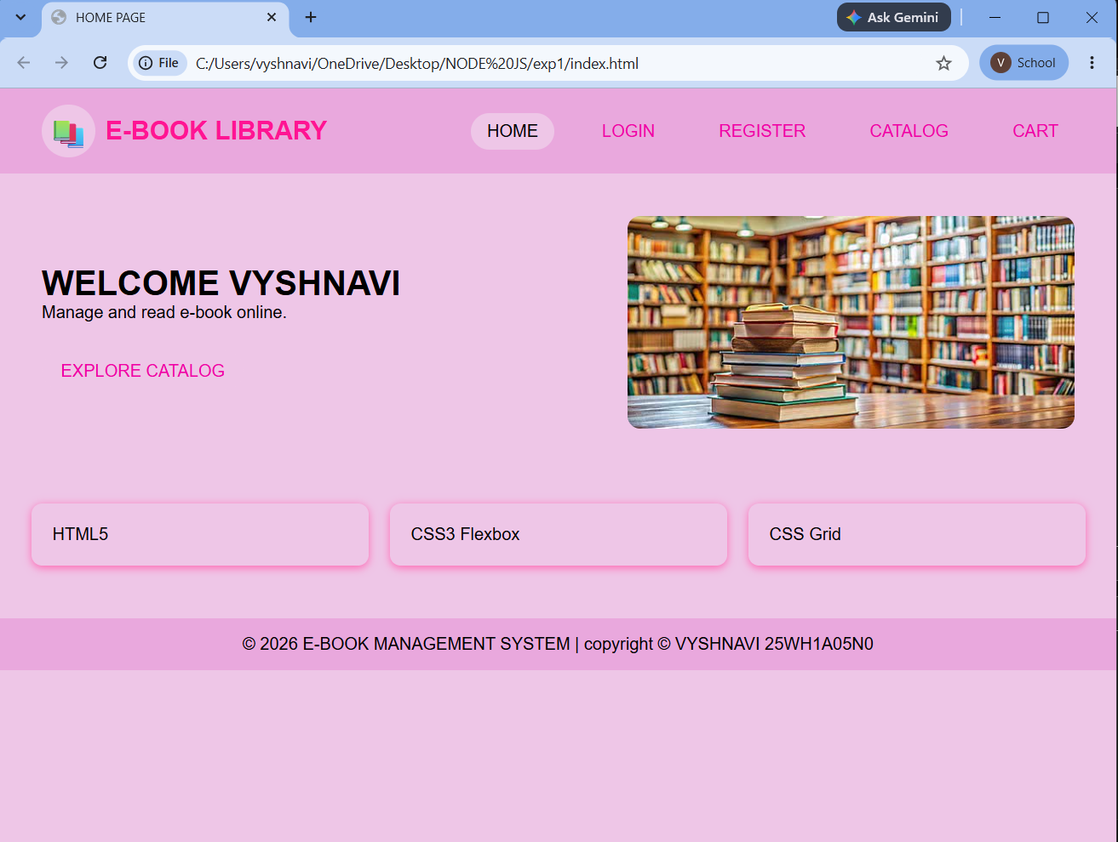
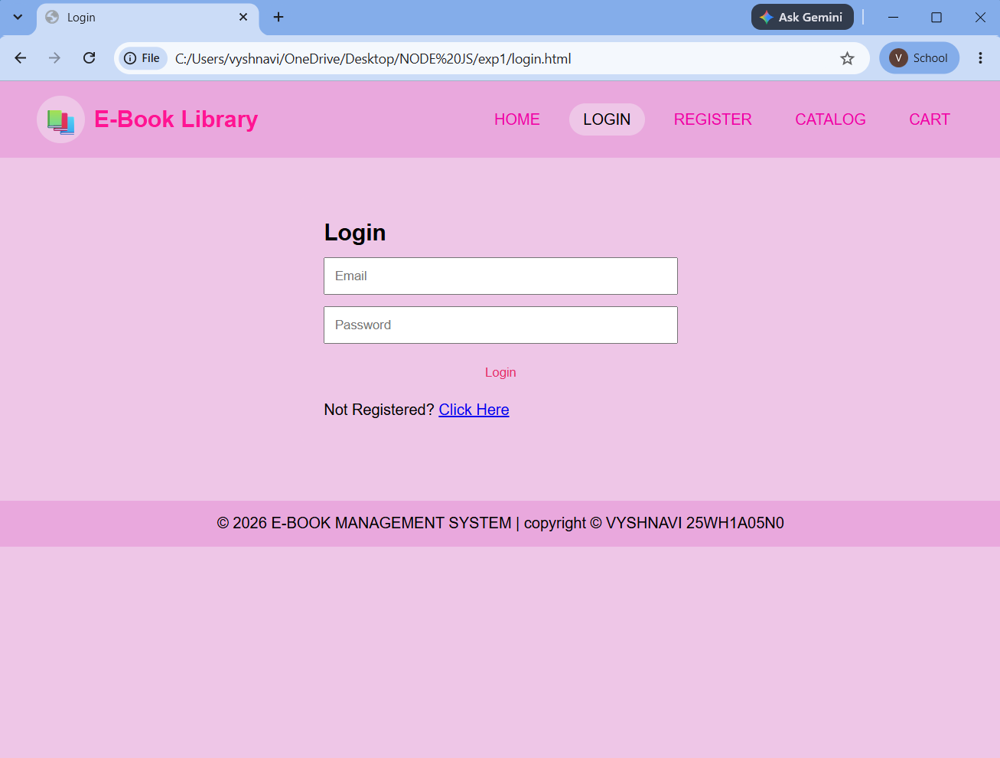

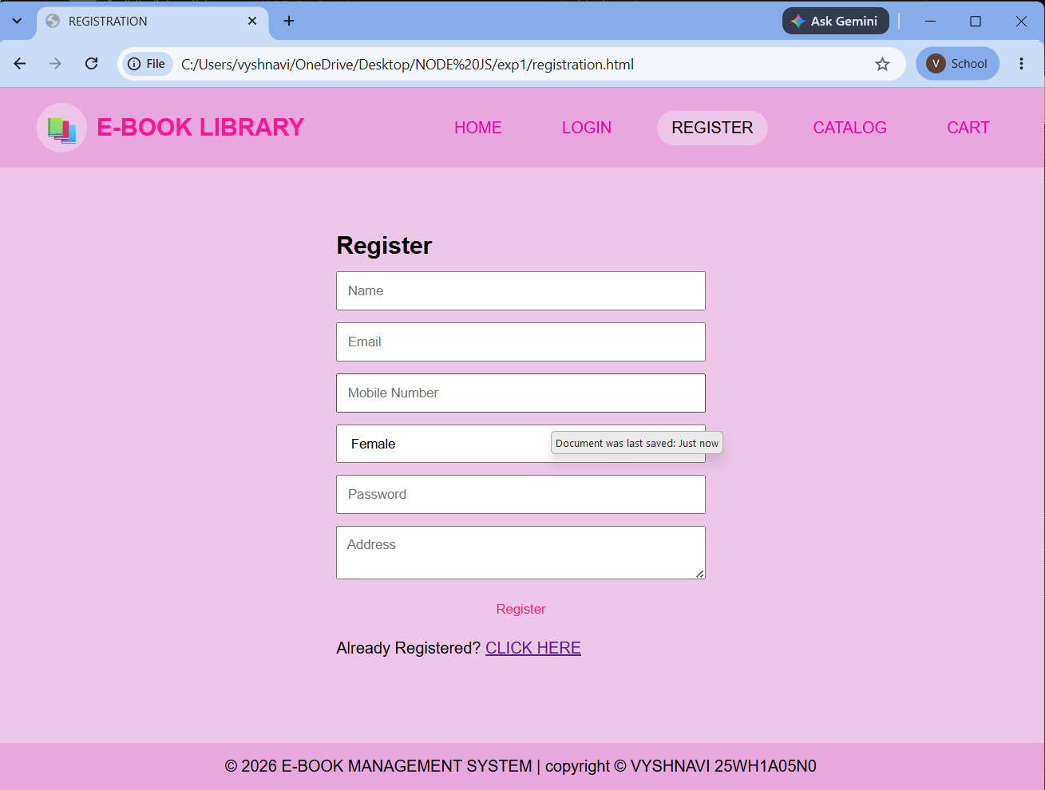

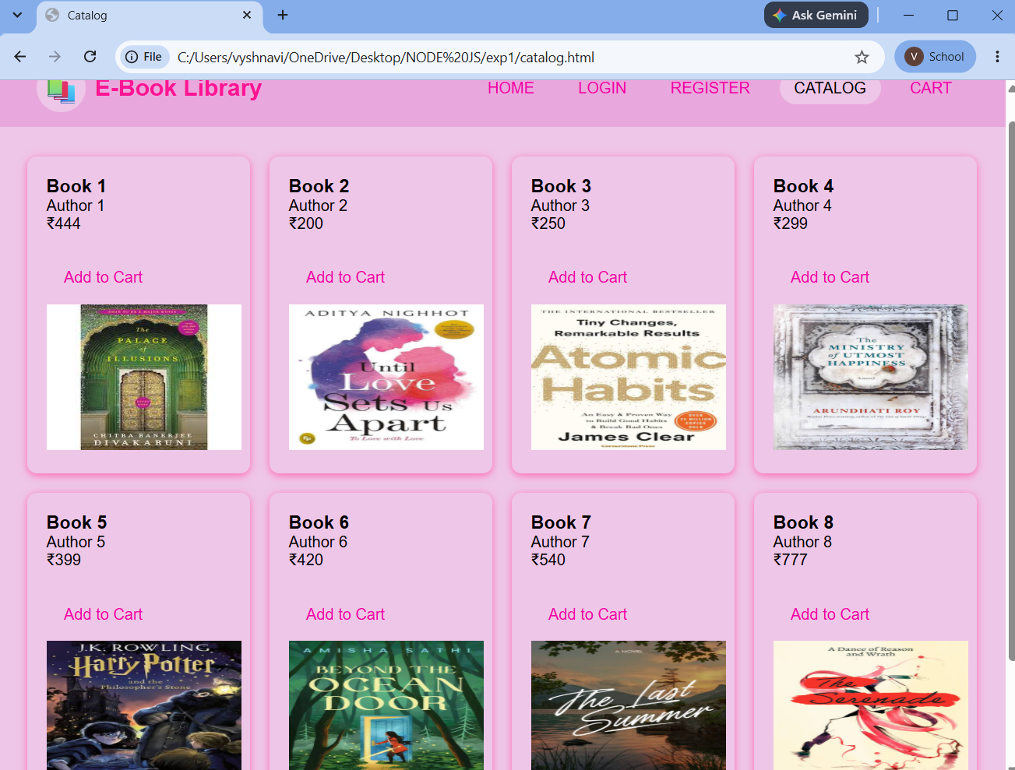

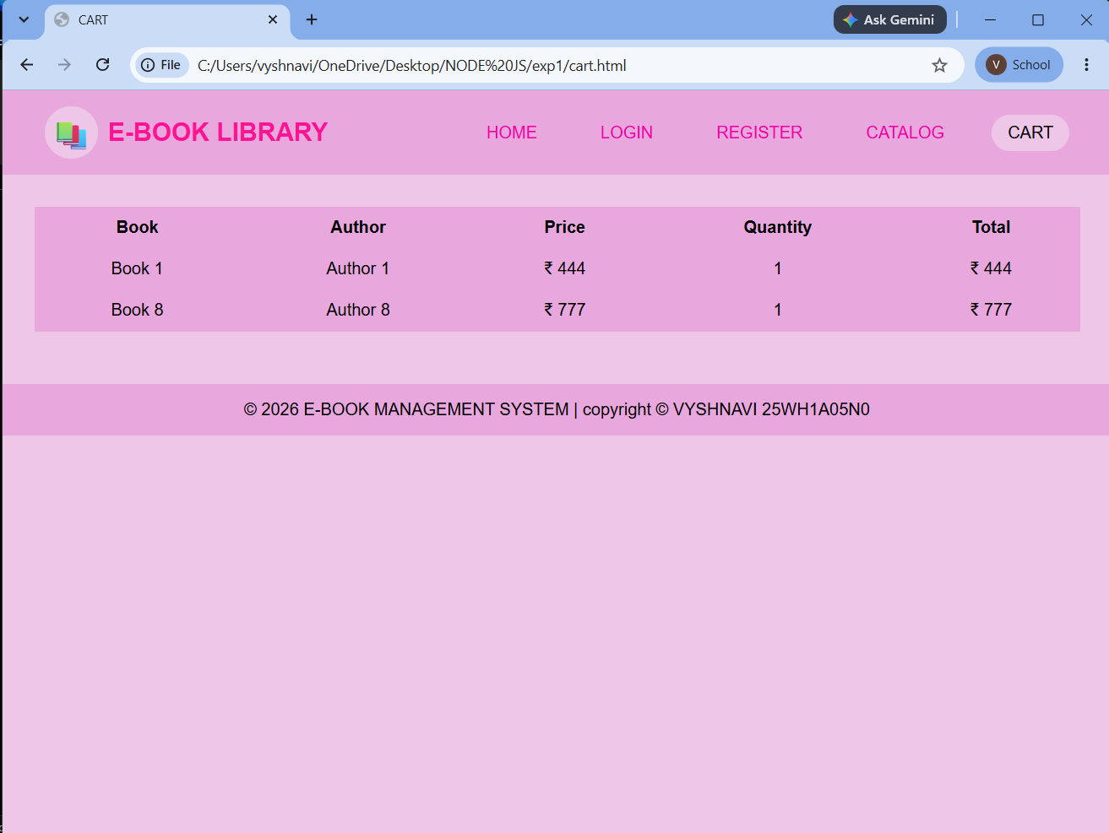

2. Make the above web application responsive web application using Bootstrap framework.
INPUT
INDEX PAGE
<!DOCTYPE html>
<html lang="en">
<head>
<meta charset="UTF-8">
<meta name="viewport" content="width=device-width, initial-scale=1.0">
<title>E-BOOK MANAGEMENT SYSTEM</title>
<!-- Bootstrap CSS -->
<link href="https://cdn.jsdelivr.net/npm/bootstrap@5.3.8/dist/css/bootstrap.min.css"
rel="stylesheet">
</head>
<body>
<nav class="navbar navbar-expand-lg navbar-dark bg-dark">
<div class="container">
<a class="navbar-brand fw-bold" href="index.html">
📚 BVRITH E-LIBRARY STORE
</a>
<button class="navbar-toggler"
type="button"
data-bs-toggle="collapse"
data-bs-target="#navbarNav">
<span class="navbar-toggler-icon"></span>
</button>
<div class="collapse navbar-collapse" id="navbarNav">
<ul class="navbar-nav ms-auto">
<li class="nav-item">
<a class="nav-link active" href="index.html">
HOME</a> </li>
<li class="nav-item">
<a class="nav-link" href="catalog.html">
CATALOG </a> </li>
<li class="nav-item">
<a class="nav-link" href="login.html">
LOGIN </a> </li>
<li class="nav-item">
<a class="nav-link" href="register.html">
REGISTER </a> </li>
<li class="nav-item">
<a class="nav-link" href="cart.html">
CART 🛒 </a> </li>
</ul>
</div>
</div>
</nav>
<section class="bg-light py-5">
<div class="container">
<div class="row align-items-center">
<div class="col-12 col-md-6">
<h1 class="display-5 fw-bold">
BVRIT HYDERABAD<br>E-LIBRARY STORE</br>
</h1>
<p class="lead">
Discover and explore a wide collection of
technology and programming e-books.
</p>
<a href="catalog.html"
class="btn btn-primary btn-lg">
Browse Books
</a>
</div>
<div class="col-12 col-md-6 text-center mt-4 mt-md-0">
<div class="display-1">
<img src="images/logo" alt="logo" height="200" width="200">
</div>
<h3>
Learn. Read. Grow.
</h3>
</div>
</div>
</div>
</section>
<!-- FEATURES -->
<section class="py-5">
<div class="container">
<h2 class="text-center mb-4">
Why Choose Our E-Book Store?
</h2>
<div class="row g-4">
<div class="col-12 col-md-4">
<div class="card h-100 text-center shadow-sm">
<div class="card-body">
<div class="display-5 mb-3">
<img src="images/html.JPG" class="card-img-top" alt="HTML and CSS Book" height="250" width="150">
</div>
<h5 class="card-title">
Large Collection
</h5>
<p class="card-text">
Explore books covering HTML, CSS,
JavaScript, Java and programming.
</p>
</div>
</div>
</div>
<div class="col-12 col-md-4">
<div class="card h-100 text-center shadow-sm">
<div class="card-body">
<div class="display-5 mb-3">
<img src="images/python.JPG" class="card-img-top" alt="HTML and CSS Book" height="250" width="150">
💻
</div>
<h5 class="card-title">
Learn Anywhere
</h5>
<p class="card-text">
Access learning resources from
desktop, tablet and mobile devices.
</p>
</div>
</div>
</div>
<div class="col-12 col-md-4">
<div class="card h-100 text-center shadow-sm">
<div class="card-body">
<div class="display-5 mb-3">
<img src="images/java.JPG" class="card-img-top" alt="HTML and CSS Book" height="250" width="150">
🛒
</div>
<h5 class="card-title">
Easy Shopping
</h5>
<p class="card-text">
Select your favourite books and
add them to your shopping cart.
</p>
</div>
</div>
</div>
</div>
</div>
</section>
<!-- ================= FOOTER ================= -->
<footer class="bg-dark text-white text-center p-3">
<p class="mb-0">
© 2026 E-Book Management System | V.VYSHNAVI 25WH1A05N0.
</p>
</footer>
<!-- Bootstrap JavaScript -->
<script src="https://cdn.jsdelivr.net/npm/bootstrap@5.3.8/dist/js/bootstrap.bundle.min.js">
</script>
</body>
</html>

LOGIN PAGE
<!DOCTYPE html>
<html lang="en">
<head>
<meta charset="UTF-8">
<meta name="viewport"
content="width=device-width, initial-scale=1.0">
<title>LOGIN - E-LIBRARY</title>
<!-- Bootstrap CSS -->
<link href="https://cdn.jsdelivr.net/npm/bootstrap@5.3.8/dist/css/bootstrap.min.css"
rel="stylesheet">
</head>
<body>
<nav class="navbar navbar-expand-lg navbar-dark bg-dark">
<div class="container">
<a class="navbar-brand fw-bold"
href="index.html">
📚 E-Book Store
</a>
<button class="navbar-toggler"
type="button"
data-bs-toggle="collapse"
data-bs-target="#navbarNav">
<span class="navbar-toggler-icon"></span>
</button>
<div class="collapse navbar-collapse"
id="navbarNav">
<ul class="navbar-nav ms-auto">
<li class="nav-item">
<a class="nav-link"
href="index.html">
HOME </a> </li>
<li class="nav-item">
<a class="nav-link"
href="catalog.html">
CATALOG </a> </li>
<li class="nav-item">
<a class="nav-link active"
href="login.html">
LOGIN </a> </li>
<li class="nav-item">
<a class="nav-link"
href="register.html">
REGISTER </a> </li>
<li class="nav-item">
<a class="nav-link"
href="cart.html">
CART 🛒 </a> </li>
</ul>
</div>
</div>
</nav>
<div class="container my-5">
<div class="row justify-content-center">
<div class="col-12 col-sm-10 col-md-6 col-lg-4">
<div class="card shadow">
<div class="card-body p-4">
<h2 class="text-center mb-4">
Login
</h2>
<form>
<div class="mb-3">
<label for="email"
class="form-label">
Email Address
</label>
<input type="email"
id="email"
class="form-control"
placeholder="Enter your email"
required>
</div>
<div class="mb-3">
<label for="password"
class="form-label">
Password
</label>
<input type="password"
id="password"
class="form-control"
placeholder="Enter your password"
required>
</div>
<div class="form-check mb-3">
<input class="form-check-input"
type="checkbox"
id="remember">
<label class="form-check-label"
for="remember">
Remember Me
</label>
</div>
<button type="submit"
class="btn btn-primary w-100">
Login
</button>
</form>
<p class="text-center mt-3">
New user?
<a href="register.html">
Create an account
</a> </p>
</div>
</div>
</div>
</div>
</div>
<footer class="bg-dark text-white text-center p-3">
<p class="mb-0">
© 2026 E-Book Management System | V.VYSHNAVI 25WH1A05N0 </p>
</footer>
<script src="https://cdn.jsdelivr.net/npm/bootstrap@5.3.8/dist/js/bootstrap.bundle.min.js">
</script>
</body>
</html>
REGISTRATION PAGE
<!DOCTYPE html>
<html lang="en">
<head>
<meta charset="UTF-8">
<meta name="viewport"
content="width=device-width, initial-scale=1.0">
<title>REGISTRATION - E-LIBRARY</title>
<!-- Bootstrap CSS -->
<link href="https://cdn.jsdelivr.net/npm/bootstrap@5.3.8/dist/css/bootstrap.min.css"
rel="stylesheet">
</head>
<body>
<!-- ================= NAVBAR ================= -->
<nav class="navbar nabar-expand-lg navbar-dark bg-dark">
<div class="container">
<a class="navbar-brand fw-bold"
href="index.html">
📚 E-Book Store
</a>
<button class="navbar-toggler"
type="button"
data-bs-toggle="collapse"
data-bs-target="#navbarNav">
<span class="navbar-toggler-icon"></span>
</button>
<div class="collapse navbar-collapse"
id="navbarNav">
<ul class="navbar-nav ms-auto">
<li class="nav-item">
<a class="nav-link"
href="index.html">
HOME </a> </li>
<li class="nav-item">
<a class="nav-link"
href="catalog.html">
CATALOG </a> </li>
<li class="nav-item">
<a class="nav-link"
href="login.html">
LOGIN </a> </li>
<li class="nav-item">
<a class="nav-link active"
href="register.html">
REGISTER </a> </li>
<li class="nav-item">
<a class="nav-link"
href="cart.html">
CART 🛒 </a> </li>
</ul>
</div>
</div>
</nav>
<!-- ================= REGISTRATION ================= -->
<div class="container my-5">
<div class="row justify-content-center">
<div class="col-12 col-md-10 col-lg-8">
<div class="card shadow">
<div class="card-body p-4">
<h2 class="text-center mb-4">
Create Account
</h2>
<form>
<!-- Name -->
<div class="row">
<div class="col-12 col-md-6 mb-3">
<label for="firstName"
class="form-label">
First Name
</label>
<input type="text"
id="firstName"
class="form-control"
placeholder="Enter first name"
required>
</div>
<div class="col-12 col-md-6 mb-3">
<label for="lastName"
class="form-label">
Last Name
</label>
<input type="text"
id="lastName"
class="form-control"
placeholder="Enter last name"
required>
</div>
</div>
<!-- Email -->
<div class="mb-3">
<label for="email"
class="form-label">
Email Address
</label>
<input type="email"
id="email"
class="form-control"
placeholder="Enter email"
required>
</div>
<!-- Mobile -->
<div class="mb-3">
<label for="mobile"
class="form-label">
Mobile Number
</label>
<input type="tel"
id="mobile"
class="form-control"
placeholder="Enter mobile number"
required>
</div>
<!-- Gender -->
<div class="mb-3">
<label class="form-label">
Gender
</label>
<div>
<div class="form-check form-check-inline">
<input class="form-check-input"
type="radio"
name="gender"
id="male"
value="male">
<label class="form-check-label"
for="male">
Male
</label>
</div>
<div class="form-check form-check-inline">
<input class="form-check-input"
type="radio"
name="gender"
id="female"
value="female">
<label class="form-check-label"
for="female">
Female
</label>
</div>
<div class="form-check form-check-inline">
<input class="form-check-input"
type="radio"
name="gender"
id="other"
value="other">
<label class="form-check-label"
for="other">
Other
</label>
</div>
</div>
</div>
<!-- Date of Birth -->
<div class="mb-3">
<label for="dob"
class="form-label">
Date of Birth
</label>
<input type="date"
id="dob"
class="form-control">
</div>
<!-- Course -->
<div class="mb-3">
<label for="course"
class="form-label">
Course
</label>
<select id="course"
class="form-select">
<option selected> Select Course </option>
<option> B.Tech </option>
<option> M.Tech </option>
<option> MCA </option>
<option> MBA </option>
</select>
</div>
<!-- Password -->
<div class="row">
<div class="col-12 col-md-6 mb-3">
<label for="password"
class="form-label">
Password
</label>
<input type="password"
id="password"
class="form-control"
placeholder="Enter password"
required>
</div>
<div class="col-12 col-md-6 mb-3">
<label for="confirmPassword"
class="form-label">
Confirm Password
</label>
<input type="password"
id="confirmPassword"
class="form-control"
placeholder="Confirm password"
required>
</div>
</div>
<!-- Terms -->
<div class="form-check mb-3">
<input class="form-check-input"
type="checkbox"
id="terms"
required>
<label class="form-check-label"
for="terms">
I agree to the terms and conditions.
</label>
</div>
<button type="submit"
class="btn btn-success w-100">
Register
</button>
</form>
<p class="text-center mt-3">
Already have an account?
<a href="login.html">
Login here </a> </p>
</div>
</div>
</div>
</div>
</div>
<footer class="bg-dark text-white text-center p-3">
<p class="mb-0">
© 2026 E-Book Management System | V.VYSHNAVI 25WH1A05N0. </p>
</footer>
<script src="https://cdn.jsdelivr.net/npm/bootstrap@5.3.8/dist/js/bootstrap.bundle.min.js">
</script>
</body>
</html>

CATALOG PAGE
<!DOCTYPE html>
<html lang="en">
<head>
<meta charset="UTF-8">
<meta name="viewport"
content="width=device-width, initial-scale=1.0">
<title>CATALOG - E-LIBRARY</title>
<!-- Bootstrap CSS -->
<link href="https://cdn.jsdelivr.net/npm/bootstrap@5.3.8/dist/css/bootstrap.min.css"
rel="stylesheet">
</head>
<body>
<!-- ================= NAVBAR ================= -->
<nav class="navbar navbar-expand-lg navbar-dark bg-dark">
<div class="container">
<a class="navbar-brand fw-bold"
href="index.html">
📚 E-Book Store
</a>
<button class="navbar-toggler"
type="button"
data-bs-toggle="collapse"
data-bs-target="#navbarNav">
<span class="navbar-toggler-icon"></span>
</button>
<div class="collapse navbar-collapse"
id="navbarNav">
<ul class="navbar-nav ms-auto">
<li class="nav-item">
<a class="nav-link"
href="index.html">
HOME </a> </li>
<li class="nav-item">
<a class="nav-link active"
href="catalog.html">
CATALOG </a> </li>
<li class="nav-item">
<a class="nav-link"
href="login.html">
LOGIN </a> </li>
<li class="nav-item">
<a class="nav-link"
href="register.html">
REGISTER </a> </li>
<li class="nav-item">
<a class="nav-link"
href="cart.html">
CART 🛒 </a> </li>
</ul>
</div>
</div>
</nav>
<!-- ================= CATALOG ================= -->
<div class="container my-5">
<h1 class="text-center mb-2">
E-Book Catalog
</h1>
<p class="text-center text-muted mb-5">
Explore our collection of programming and
technology books.
</p>
<!-- ================= BOOK GRID ================= -->
<div class="row g-4">
<!-- BOOK 1 -->
<div class="col-12 col-sm-6 col-lg-4 col-xl-3">
<div class="card h-100 shadow-sm">
<img src="images/html.JPG"
class="card-img-top"
alt="HTML and CSS Book" height="200" width="50">
<div class="card-body d-flex flex-column">
<h5 class="card-title">
HTML & CSS
</h5>
<p class="card-text">
Learn the fundamentals of
HTML5 and CSS3 for web development.
</p>
<h5 class="text-primary">
₹399
</h5>
<button class="btn btn-primary mt-auto">
Add to Cart
</button>
</div>
</div>
</div>
<!-- BOOK 2 -->
<div class="col-12 col-sm-6 col-lg-4 col-xl-3">
<div class="card h-100 shadow-sm">
<img src="images/clang.png"
class="card-img-top"
alt="C-language Book" height="200" width="50">
<div class="card-body d-flex flex-column">
<h5 class="card-title">
C-Language
</h5>
<p class="card-text">
Basic programming language for
basic desktop development
</p>
<h5 class="text-primary">
₹499
</h5>
<button class="btn btn-primary mt-auto">
Add to Cart
</button>
</div>
</div>
</div>
<!-- BOOK 3 -->
<div class="col-12 col-sm-6 col-lg-4 col-xl-3">
<div class="card h-100 shadow-sm">
<img src="images/java.JPG"
class="card-img-top"
alt="Java Programming Book" height="200" width="50">
<div class="card-body d-flex flex-column">
<h5 class="card-title">
Java Programming
</h5>
<p class="card-text">
Learn object-oriented programming
using Java.
</p>
<h5 class="text-primary">
₹599
</h5>
<button class="btn btn-primary mt-auto">
Add to Cart
</button>
</div>
</div>
</div>
<!-- BOOK 4 -->
<div class="col-12 col-sm-6 col-lg-4 col-xl-3">
<div class="card h-100 shadow-sm">
<img src="images/python.JPG"
class="card-img-top"
alt="Python Programming Book" height="200" width="50">
<div class="card-body d-flex flex-column">
<h5 class="card-title">
Python Programming
</h5>
<p class="card-text">
Learn Python programming
from basics to advanced concepts.
</p>
<h5 class="text-primary">
₹549
</h5>
<button class="btn btn-primary mt-auto">
Add to Cart
</button>
</div>
</div>
</div>
</div>
</div>
<!-- ================= FOOTER ================= -->
<footer class="bg-dark text-white text-center p-3">
<p class="mb-0">
© 2026 E-Book Management System | V.VYSHNAVI 25WH1A05N0.</p>
</footer>
<!-- Bootstrap JavaScript -->
<script src="https://cdn.jsdelivr.net/npm/bootstrap@5.3.8/dist/js/bootstrap.bundle.min.js">
</script>
</body>
</html>

CART PAGE
<!DOCTYPE html>
<html lang="en">
<head>
<meta charset="UTF-8">
<meta name="viewport"
content="width=device-width, initial-scale=1.0">
<title>SHOPPING CART - E-LIBRARY</title>
<!-- Bootstrap CSS -->
<link href="https://cdn.jsdelivr.net/npm/bootstrap@5.3.8/dist/css/bootstrap.min.css"
rel="stylesheet">
</head>
<body>
<!-- ================= NAVBAR ================= -->
<nav class="navbar navbar-expand-lg navbar-dark bg-dark">
<div class="container">
<a class="navbar-brand fw-bold"
href="index.html">
📚 E-Book Store
</a>
<button class="navbar-toggler"
type="button"
data-bs-toggle="collapse"
data-bs-target="#navbarNav">
<span class="navbar-toggler-icon"></span>
</button>
<div class="collapse navbar-collapse"
id="navbarNav">
<ul class="navbar-nav ms-auto">
<li class="nav-item">
<a class="nav-link"
href="index.html">
HOME </a> </li>
<li class="nav-item">
<a class="nav-link"
href="catalog.html">
CATALOG </a> </li>
<li class="nav-item">
<a class="nav-link"
href="login.html">
LOGIN </a> </li>
<li class="nav-item">
<a class="nav-link"
href="register.html">
REGISTER </a> </li>
<li class="nav-item">
<a class="nav-link active"
href="cart.html">
CART 🛒 </a> </li>
</ul>
</div>
</div>
</nav>
<!-- ================= CART ================= -->
<div class="container my-5">
<h1 class="text-center mb-5">
SHOPPING CART
</h1>
<div class="row g-4">
<!-- ================= CART TABLE ================= -->
<div class="col-12 col-lg-8">
<div class="card shadow-sm">
<div class="card-body">
<h4 class="mb-4">
Selected Books
</h4>
<div class="table-responsive">
<table class="table table-bordered
table-hover align-middle">
<thead class="table-dark">
<tr> <th> Book </th>
<th> Price </th>
<th> Quantity </th>
<th> Total </th> </tr>
</thead> <tbody>
<tr> <td> HTML & CSS </td>
<td> ₹399 </td>
<td> 1 </td>
<td> ₹399 </td> </tr>
<tr> <td> JavaScript </td>
<td> ₹499 </td>
<td> 2 </td>
<td> ₹998 </td> </tr>
<tr> <td> Python Programming </td>
<td> ₹549 </td>
<td> 1 </td>
<td> ₹549 </td> </tr> </tbody>
</table>
</div>
</div>
</div>
</div>
<!-- ================= ORDER SUMMARY ================= -->
<div class="col-12 col-lg-4">
<div class="card shadow-sm">
<div class="card-body">
<h4 class="card-title mb-4">
Order Summary
</h4>
<div class="d-flex justify-content-between mb-2">
<span>
Subtotal
</span>
<span>
₹1,946
</span>
</div>
<div class="d-flex justify-content-between mb-2">
<span>
Discount
</span>
<span class="text-success">
- ₹100
</span>
</div>
<hr>
<div class="d-flex justify-content-between">
<strong>
Total
</strong>
<strong>
₹1,846
</strong>
</div>
<button class="btn btn-success w-100 mt-4">
Proceed to Checkout
</button>
<a href="catalog.html"
class="btn btn-outline-primary w-100 mt-2">
Continue Shopping
</a>
</div>
</div>
</div>
</div>
</div>
<!-- ================= FOOTER ================= -->
<footer class="bg-dark text-white text-center p-3">
<p class="mb-0">
© 2026 E-Book Management System | V.VYSHNAVI 25WH1A05N0.</p>
</footer>
<!-- Bootstrap JavaScript -->
<script src="https://cdn.jsdelivr.net/npm/bootstrap@5.3.8/dist/js/bootstrap.bundle.min.js">
</script>
</body>
</html>

OUTPUT
