**Solution Sheet**

1. Which model have you used for Covid Cases prediction? Explain your model.

We have used Logistic Regression, KNN-classifier, Gaussian-Naive Bayes, Ridge, Support Vector Machine.

From the above five algorithms, we have chosen the best algorithm i.e. Ridge algorithm. Initial we have used all the preprocessing techniques to fill the null values and dropped one of the columns named- ‘Population [2001]’.

Later converted the categorical values into integer values using Label Encoder. Then we have split the data to training and testing data and applied the above algorithms to it.

The best-fit algorithm is Ridge. When we tried to predict the test values using the Ridge algorithm, we got some appropriate values in different ranges whereas all the other algorithms got the values in the same range.

Also, we have predicted the values of test data. Where we have trained the machine by using the training dataset and got approximate output. Here we have joined the data frame of column name ‘City’ from the test dataset with the predicted output i.e. Array of Test Data.

The final output which we got is being converted to a CSV file from the data frame. 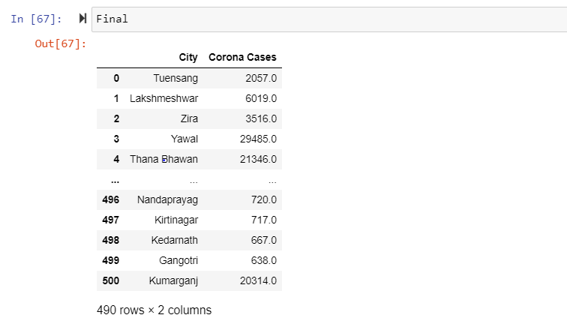 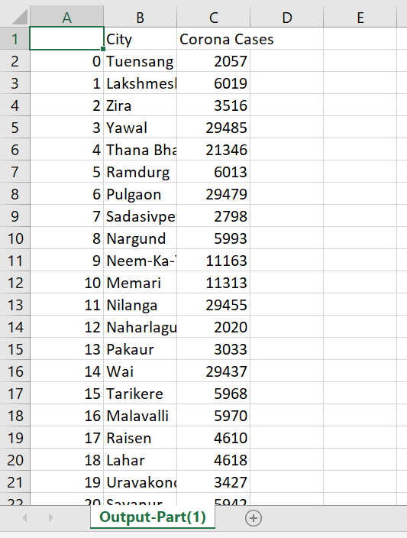

1. Which model have you used for Foreign Visitors Time series prediction? Explain your model.

We have just filled the missing values of the data. We have also tried to predict the foreign visitors for the month of September but it’s not completely done.