FOODORBIT

A Smarter Circle of Food Sharing
“Every Surplus Has a Purpose.”

FINAL PROJECT REPORT
Submitted in partial fulfilment of the academic project requirements

TEAM MEMBER | ROLL NUMBER
Gurram Hasini Reddy | 25MVCSMR0647
Gurram Bhavya Sri | 25MVCSMRO0646
Naidu Jahnavi | 25MVCSMR0663
Moola Sri Vyshnavi | 25MVCSMR0662

Department: CSE-AIML
College: Malla Reddy Vishwavidyapeeth-Technical Campus
Project Guide: Mrs. Sathwika Vaddepalli
Academic Year: 2026–2027

Implementation Note

This report has been prepared using the FOODORBIT project source archive supplied with the request. The source code currently uses React with TypeScript and Vite for the frontend, and Supabase for authentication and database access. The database migration defines PostgreSQL tables and row-level security policies. Therefore, the supplied implementation is not currently a traditional MERN implementation (MongoDB, Express.js, React.js, Node.js), even though the original problem statement asks for MERN. This distinction should be mentioned accurately during evaluation. If the college requires strict MERN compliance, the backend and database layer would need to be migrated to Node.js/Express.js and MongoDB.
Some dashboard metrics and listing/network examples are defined in local mock-data files. They are demonstration values and should not be represented as verified live impact statistics.

2. Abstract & Introduction

2.1 Abstract
FOODORBIT is a web-based food donation marketplace concept designed to connect organizations and individuals with surplus food to non-governmental organizations (NGOs) and volunteers who can help redistribute it. Food businesses, colleges, event organizers, and other donors may have food remaining after daily operations or events. At the same time, NGOs and community kitchens may have difficulty discovering suitable donations within a limited collection window. FOODORBIT provides a shared platform for publishing surplus food information, browsing available listings, coordinating claims and pickups, and monitoring donation progress.
The application interface includes a landing page, donation listings, a dashboard, a community/network page, and an impact page. The data model in the supplied source includes profiles, pickup addresses, donations, claims, donation status history, and NGO food requests. It also accounts for split-share allocations, expiry information, food safety details, and pickup verification. The current source integrates Supabase services rather than the full MERN stack, so the implementation status of each function must be evaluated according to the supplied code and configured backend.

2.2 Introduction
Food waste and food insecurity can exist at the same time. Food that remains unused at restaurants, hotels, grocery stores, college events, or community gatherings may be discarded when a suitable recipient cannot be found quickly. NGOs and community kitchens may need food but may not have a single place to discover nearby surplus or coordinate collection.
FOODORBIT proposes a digital platform to improve the communication between donors and recipients. Donors can publish information about the food available, including its category, quantity, expiry deadline, storage instructions, allergens, and pickup arrangements. NGOs can discover donations and express their needs. Volunteers can support the collection process. The platform aims to make food redistribution easier to track and more transparent.

2.3 Problem Background
- Surplus food information is often scattered across messages, phone calls, or separate community groups.
- NGOs may not learn about a donation before its collection deadline.
- Large donations may exceed the immediate capacity of a single recipient.
- Incomplete preparation, storage, allergen, or expiry information can make safe handling harder.
- Donors and recipients need a clear way to coordinate and record pickup status.

2.4 Proposed Solution
FOODORBIT provides a centralized marketplace where food donations and NGO requirements can be displayed and managed. The concept includes searchable food listings, role-aware user profiles, donation status tracking, NGO food requests, split-share allocations, pickup details, and impact summaries. Features such as Smart Food Matching and Rescue Relay can be developed around clear eligibility rules to help prioritize suitable recipients and recover eligible donations after a cancellation.

2.5 Purpose of the Project
The purpose is to demonstrate how a web application can support community food redistribution, practise full-stack application concepts, organize records digitally, and create a foundation for future features such as automated matching, notifications, pickup coordination, and forecasting.

3. Problem Statement, Objectives & Scope

3.1 Problem Statement
Build a food donation marketplace that enables donors to list excess food and allows NGOs to discover suitable donations. The system should maintain food name, quantity, pickup location, date/time, donor details, and donation status. It should support record management, clear user interaction, and appropriate authentication and access control. The original academic problem statement specifies a MERN stack, while the supplied prototype currently uses React/TypeScript and Supabase; the stack should be aligned with the final submission requirements.

3.2 Project Objectives
- Provide a simple interface for listing and browsing surplus food.
- Represent donor, NGO, and volunteer roles in the application.
- Organize donation details, pickup addresses, claims, and food requests.
- Support the key record operations needed for donation management.
- Track the progress of a donation through defined statuses.
- Capture food safety information such as allergens, storage instructions, and expiry time.
- Explore split-share allocations so one donation can be distributed to more than one NGO.
- Present donation activity and impact indicators in a clear dashboard.
- Apply authentication and database access policies to protect user-owned records.

3.3 Project Scope
The project scope covers a web-based prototype for food listing, discovery, profile roles, NGO food requests, claims, pickup information, and impact presentation. The supplied database schema includes structures for donation status history and split allocations. Advanced ideas such as AI-based prediction, live messaging, maps, real-time notifications, and automated cancellation recovery are future enhancements unless they are fully configured and demonstrated in the running application.

3.4 Target Users
User Type | Role in FOODORBIT
Donors | Restaurants, hotels, shops, colleges, event organizers, or individuals listing surplus food.
NGOs | Organizations that browse available donations, state food requirements, and claim suitable quantities.
Volunteers | People who can assist with collection or delivery coordination.
Platform administrators (future/operational role) | Review platform activity, respond to reports, and help maintain trustworthy records; administrative tools depend on implementation.

3.5 Assumptions and Constraints
- Users provide accurate donation, quantity, preparation, storage, and expiry information.
- A recipient must be able to collect the donation within the available time window.
- The platform is a coordination tool and does not itself guarantee food safety.
- Live authentication and database operations require valid Supabase project settings and deployed schema policies.
- Displayed mock-data statistics are illustrative unless generated from persisted records.

4. Features & Functional Requirements

4.1 Main Features
Feature | Description / Functional Requirement
Food listings | Display food category, description, quantity/servings, donor, location, urgency, and remaining time.
Search and filters | Allow users to search listings and filter by category and status; listing UI also includes sort options.
Role-aware profiles | Represent donors, NGOs, and volunteers with profile information.
Donation records | Create, read, update, and manage donation records through data operations.
NGO food requests | Store the category and quantity required by an NGO, urgency, city, and request status.
Claims and split-share | Record NGO claims and allocated quantities; the schema includes an allocation limit check.
Pickup coordination | Store pickup addresses, instructions, time slots, deadlines, and relevant statuses.
Food safety information | Capture allergens, temperature/storage information, dietary details, preparation time, expiry, and a safety-verification field.
Status tracking | Maintain donation statuses and a status-history timeline.
Impact presentation | Display meals rescued, donor/community indicators, charts, and category or city breakdowns; supplied examples include static demo data.
Network page | Present NGO and volunteer profile cards with capacity and contribution indicators using the current sample data.

4.2 User Functionalities

Donor
- Register or sign in, maintain profile information, and save pickup addresses.
- Create donation listings with quantity, category, expiry, safety information, and pickup instructions.
- Review claims and follow the donation status.

NGO
- Browse and search available donations.
- Create food requests describing needed categories and quantities.
- Claim an eligible quantity and coordinate collection.

Volunteer
- Maintain a volunteer profile and support collection coordination where the relevant workflow is available.

4.3 CRUD Operations
Operation | Meaning | FOODORBIT Example
Create | Add a new record. | A donor publishes a surplus-food listing.
Read | Retrieve and display records. | An NGO browses available donations.
Update | Modify an existing record. | A listing's details or status are updated.
Delete | Remove a record where permitted. | A donor removes an eligible listing.

CRUD operations must be checked against the live application and backend configuration. The source archive contains database API functions and SQL tables, but the availability of each operation in the deployed demo depends on the connected project and implemented screen actions.

4.4 Authentication and Validation
- The supplied authentication context uses Supabase Auth for sign-up, sign-in, sign-out, and session handling.
- The profile role values defined in the source are donor, NGO, and volunteer.
- The SQL migration enables row-level security (RLS) on database tables and defines ownership-based policies.
- Input validation should check required fields, positive quantities, valid dates, and pickup deadlines.
- Donation allocation should not exceed the available donation quantity.

4.5 System Requirements
Category | Requirement
Hardware | Laptop/desktop computer, modern browser, internet connection for hosted services.
Frontend | React 18, TypeScript, Vite, Tailwind CSS, lucide-react icons.
Backend/data service | Supabase JavaScript client, Supabase Auth, PostgreSQL database, SQL migration and RLS policies.
Development tools | Node.js and npm, code editor, web browser, terminal, Git (recommended).
Configuration | Valid VITE_SUPABASE_URL and VITE_SUPABASE_ANON_KEY values in the environment.

5. Algorithms & Methodology

5.1 System Workflow
- A user opens FOODORBIT and browses the available sections.
- A user signs in or creates an account using the supported authentication flow.
- A donor enters the food information, quantity, deadline, and pickup details.
- The application validates the data and submits it to the data service.
- An NGO browses and filters the available listings and reviews the donation details.
- An eligible NGO creates a claim for the required quantity.
- The donation and claim statuses are updated as pickup is arranged and completed.
- The application can display status history and summarize impact data.

5.2 Algorithms and Rules

Listing Search and Filtering
The listings page filters the sample listing data by a case-insensitive search across title, donor name, and location, along with category and status filters. Sorting options are provided in the interface for urgency, distance, recency, and number of servings. This is a straightforward filtering approach suitable for a prototype.

Donation Eligibility
A future or extended matching routine can reject donations that are expired or unavailable and compare food category, quantity, location, deadline, dietary requirements, and pickup availability. The most suitable candidates can be ranked using a weighted score. The actual scoring formula should be documented if implemented; the report does not claim that a trained AI model exists.

Split-Share Allocation
For a donation with total quantity Q and NGO allocations q1, q2, …, qn, the system should enforce: q1 + q2 + … + qn ≤ Q. The supplied SQL migration describes a claims table for split-share allocations and a database constraint intended to prevent over-allocation.

Donation Status Tracking
The source defines statuses including listed, claimed, pickup scheduled, ready for collection, picked up, handover completed, cancelled, and expired. Status transitions should follow valid workflow rules, and status-history records can provide an audit trail.

5.3 Development Methodology
An iterative development approach is suitable for FOODORBIT. The project can be divided into requirements analysis, interface design, data modelling, implementation, testing, and refinement. Each iteration should deliver a demonstrable function—for example, browsing listings first, followed by authentication, donation records, claims, and dashboards.

5.4 Data Flow
Step | Data Flow
1. User interface | The React/TypeScript frontend gathers user input and renders pages.
2. Client requests | Application functions call the Supabase JavaScript client.
3. Authentication | Supabase Auth manages account sessions and identity.
4. Database operations | The client accesses PostgreSQL tables subject to configured row-level security policies.
5. Response | Returned data or errors are handled by the frontend and displayed to the user.

Note: this data flow describes the supplied source archive. It does not show a Node.js/Express REST API or MongoDB database because those are not the backend technologies in the provided implementation.

6. Technologies & Implementation

6.1 Frontend Technologies
- React.js: component-based UI and interactive pages.
- TypeScript: typed data structures for profiles, donations, claims, food requests, and statuses.
- Vite: local development server and frontend build tool.
- Tailwind CSS: utility-based styling and responsive layout.
- lucide-react: icons used in interface components.

6.2 Backend and Database Technologies
- Supabase JavaScript client: used by the supplied API functions to read and write application data.
- Supabase Auth: supports account registration, login, session persistence, and logout.
- PostgreSQL: relational database defined in the supplied Supabase migration.
- Row-Level Security: policies are defined to restrict operations according to authenticated identity and record ownership.

6.3 Data Model
Table | Purpose
profiles | User profile, role, display name, organization, phone, city, and bio.
pickup_addresses | Saved pickup location, address fields, coordinates, and collection instructions.
donations | Food listing, category, quantity, servings, safety details, expiry, pickup details, and status.
claims | NGO claims against donations, allocated quantity, pickup scheduling, and verification status.
status_history | Records donation status changes, the actor, notes, and timestamp.
food_requests | NGO requests with food category, required quantity, urgency, city, and status.

6.4 Implementation Details
The source project is organized into page components, reusable UI components, context providers, data/API functions, shared type definitions, and a SQL migration. The primary page components include LandingPage, ListingsPage, DashboardPage, NetworkPage, and ImpactPage. Authentication logic is centralized in an AuthContext, while data types define the structure of donations, claims, requests, and profiles.
The API module uses Supabase queries for records such as pickup addresses and donations. The SQL migration creates core tables and defines row-level security policies. The data folder contains sample listing, network, and impact values to make the interface visually demonstrable.

6.5 Tools and APIs
Tool / Service | Use
Vite | Run the frontend locally and create a production build.
Supabase | Authentication, database access, and row-level security.
TypeScript | Type checking and clearer data contracts.
Tailwind CSS | Responsive visual design.
lucide-react | Interface icons.
Git (recommended) | Version control and collaboration.

6.6 Stack Alignment with Original Requirement
The academic problem statement requests MongoDB, Express.js, React.js, and Node.js. The supplied code instead includes React, TypeScript, Vite, and Supabase/PostgreSQL, with no Express server or MongoDB dependency visible in the package manifest. Supabase is a valid backend-as-a-service choice for a prototype, but it is not the MERN stack. If strict MERN compliance is required, implement Express REST endpoints, move data to MongoDB, and connect the React frontend to those endpoints. The report should not claim MERN compliance until that work is completed.

7. Results, Testing & Performance

7.1 Project Results
The supplied project provides a designed food-sharing interface with a landing page, searchable donation listings, a donor dashboard, a community network page, and an impact page. It includes data types and database definitions for profiles, donations, pickup addresses, claims, status history, and NGO food requests. The interface uses sample data to demonstrate donation categories, urgency, rescue activity, network profiles, and impact metrics.
The current source archive demonstrates the structure and visual prototype. Live behaviour such as creating a donation, claiming it, persisting updates, and showing updated impact metrics should be verified against the configured Supabase project before the report is submitted as a completed end-to-end system.

7.2 Suggested Test Cases
Test ID | Test Scenario | Expected Result | Status to Record
TC-01 | Open landing page | Home page and navigation render without errors. | Pass/Fail after execution
TC-02 | Browse donation listings | Listing cards display food details and status. | Pass/Fail after execution
TC-03 | Search by food/donor/location | Only matching listings remain visible. | Pass/Fail after execution
TC-04 | Filter by category/status | Listings match the selected filters. | Pass/Fail after execution
TC-05 | Register with valid details | Account is created according to configured Supabase Auth settings. | Pass/Fail after execution
TC-06 | Sign in with valid credentials | Session is established and profile is fetched. | Pass/Fail after execution
TC-07 | Submit invalid donation data | Invalid or missing required fields are rejected. | Pass/Fail after execution
TC-08 | Claim an unavailable donation | The system rejects the claim or prevents duplicate allocation. | Pass/Fail after execution
TC-09 | Split a donation across NGOs | Total allocated quantity does not exceed available quantity. | Pass/Fail after execution
TC-10 | Attempt unauthorized record access | Database policy denies disallowed access. | Pass/Fail after execution
TC-11 | Check expiry handling | Expired donation is not offered for a new claim. | Pass/Fail after execution
TC-12 | Open impact page | Charts and summary indicators render; demo values are identified as sample data. | Pass/Fail after execution

7.3 Testing Methods
- UI testing: check navigation, layout, forms, filters, loading states, and error messages.
- Functional testing: verify the expected behaviour of each user action.
- Authentication testing: test registration, login, logout, and session persistence.
- Database/security testing: verify row-level security and ownership restrictions using separate test accounts.
- Boundary testing: test zero or negative quantities, expired deadlines, missing fields, and over-allocation.
- Regression testing: repeat core workflows after changes to ensure earlier functions still work.

7.4 Performance Analysis
The prototype uses a modern component-based frontend and performs simple filtering over the available listing collection. Actual response times and scalability depend on the hosting environment, database configuration, network latency, dataset size, and query design. No measured performance benchmarks were included in the supplied archive, so this report does not claim specific response times or throughput figures. Performance can be evaluated by measuring page load time, database query latency, and behaviour with increasing numbers of donation records.

7.5 Screenshots / Output
Insert screenshots captured from the running application in the spaces below. Use screenshots from the actual deployed or local prototype rather than illustrative images.

Figure 7.1 — Landing Page
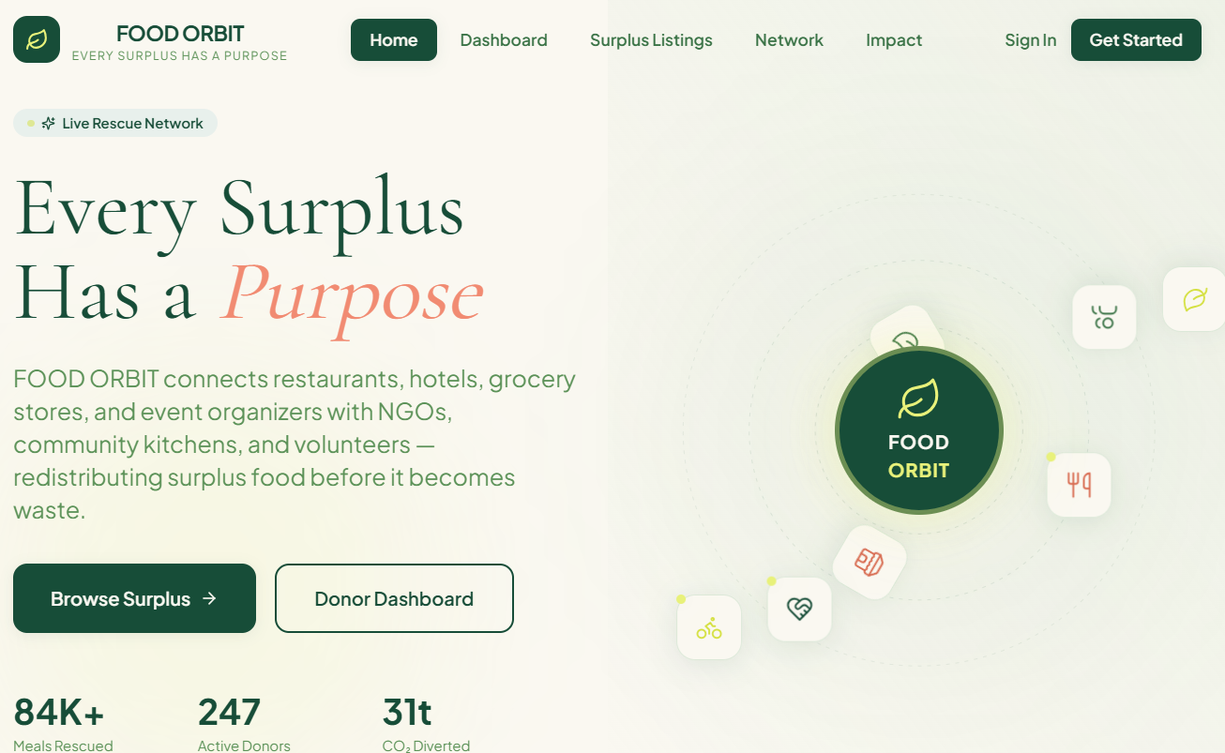

Figure 7.2 — Donation Listings
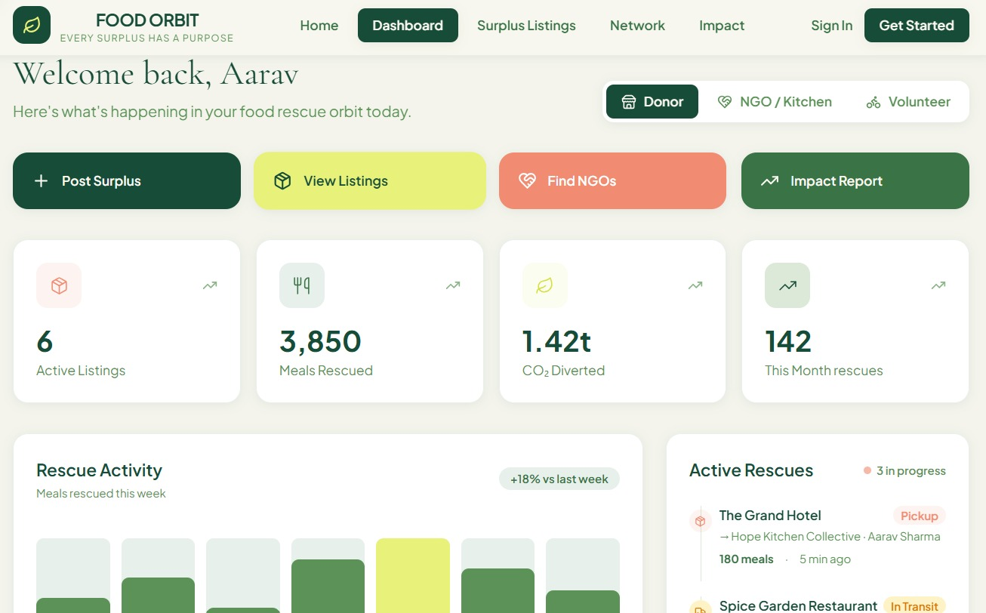

Figure 7.3 — Dashboard

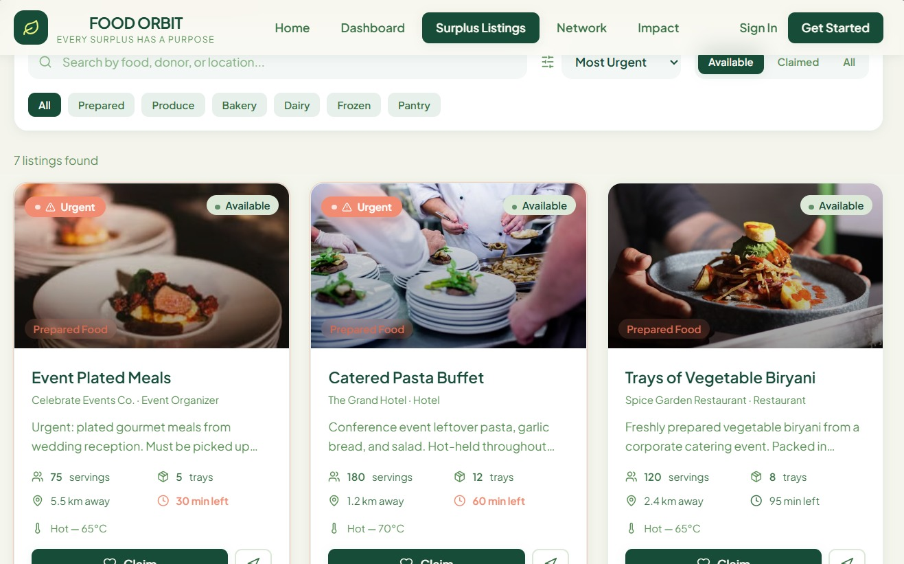
.

Figure 7.4 — Community Network

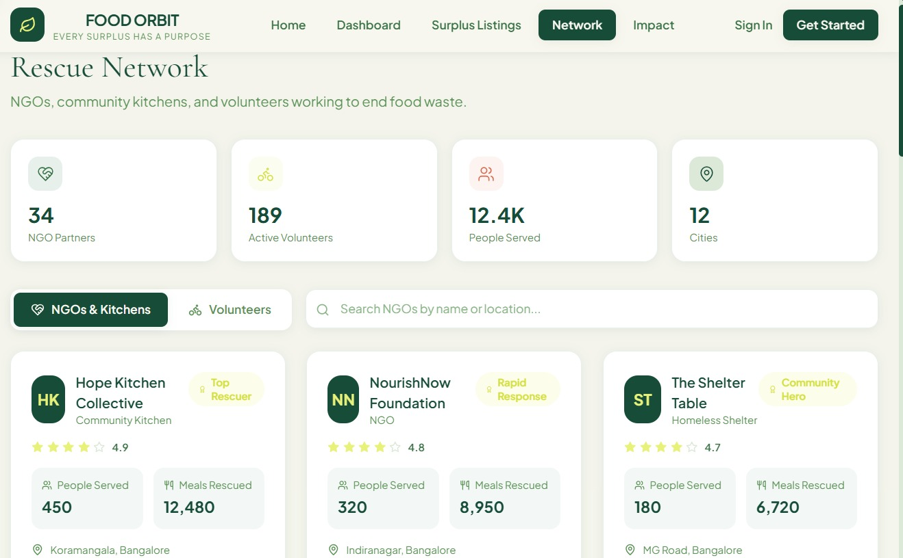
.

Figure 7.5 — Impact Dashboard

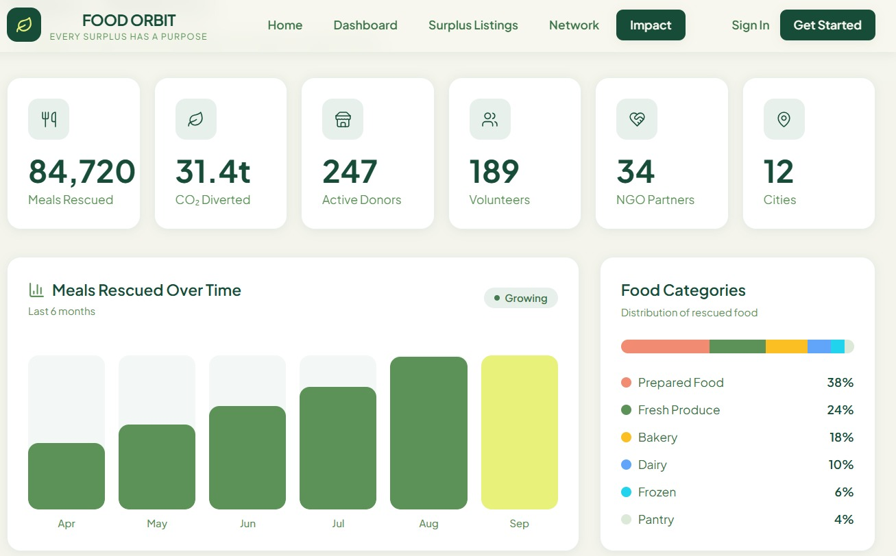
.

8. Conclusion, Future Scope & References

8.1 Conclusion
FOODORBIT proposes a practical digital approach to reducing avoidable food waste by connecting donors, NGOs, and volunteers through a shared food donation marketplace. The supplied prototype includes a polished React/TypeScript interface and a Supabase/PostgreSQL data design for profiles, donations, pickup addresses, claims, status history, and NGO food requests. It also models important workflow considerations such as expiry, food safety information, pickup tracking, and split-share allocation.
The project demonstrates how web technologies can support community coordination and structured record management. Before claiming production readiness, the team should test all workflows with the configured backend, verify access-control policies, replace demonstration statistics with data-derived metrics, and clearly align the final technology stack with the college's stated requirements.

8.2 Future Scope
- Migrate to a strict MERN architecture using Node.js, Express.js, and MongoDB if required by the project specification.
- Implement and test Smart Food Matching with documented eligibility rules and explainable scores.
- Add a complete Rescue Relay workflow for cancelled or failed pickups.
- Add notifications for new matches, pickup reminders, and status changes.
- Integrate maps and route estimates for pickup coordination.
- Improve offline draft support and safe synchronization after connectivity returns.
- Add a secure pickup OTP flow and auditable collection confirmation.
- Develop surplus prediction using historical records only after sufficient reliable data is available.
- Add verified NGO onboarding and reporting/moderation tools.
- Measure impact using completed, persisted donation records and transparent calculation methods.

8.3 References / Documentation
- React Documentation — https://react.dev/
- TypeScript Documentation — https://www.typescriptlang.org/docs/
- Vite Documentation — https://vite.dev/guide/
- Supabase Documentation — https://supabase.com/docs
- PostgreSQL Documentation — https://www.postgresql.org/docs/
- Tailwind CSS Documentation — https://tailwindcss.com/docs
- Lucide Icons — https://lucide.dev/
- Project source archive supplied for FOODORBIT (FOOD_ORBIT.zip), including application source, TypeScript types, API functions, and Supabase SQL migration.
Submission Checklist
- ☐ Fill in department, college, guide name, and academic year details if they differ from the cover page.
- ☐ Confirm the team member names and roll numbers are correct.
- ☐ Insert screenshots captured from the running FOODORBIT application.
- ☐ Run and record the test cases in Section 7; replace the status placeholders with actual results.
- ☐ Clearly label sample dashboard statistics as demo data.
- ☐ Confirm whether the project must strictly use MERN. The supplied archive currently uses Supabase/PostgreSQL, not MongoDB/Express/Node.
- ☐ Remove this checklist before final submission if your institution expects only the eight report sections.

