Task 2 : API Data Fetching Project (Weather, News, Crypto)
Objective: Fetch real-time data from multiple public APIs using Python, parse JSON responses, and display results in a clean, readable format.
Technologies Used: - Python 3.x - requests library - REST APIs (Open-Meteo, Hacker News Search, CoinGecko)
Project Files: - multi_api_project.py - README.md - weather_output.png - news_output.png - crypto_output.png
Code Snippet:
import requests
# Example: Fetch weather data
def fetch_weather(city):
geo_url = f"https://geocoding-api.open-meteo.com/v1/search?name={city}&count=1"
geo_res = requests.get(geo_url)
location = geo_res.json()["results"][0]
lat, lon = location["latitude"], location["longitude"]
weather_url = f"https://api.open-meteo.com/v1/forecast?latitude={lat}&longitude={lon}&current_weather=true"
weather_res = requests.get(weather_url)
data = weather_res.json()["current_weather"]
print(f"City: {city}, Temperature: {data['temperature']}°C")
Sample Output:
Weather:
City : Hyderabad
Temperature : 29.4°C
Wind Speed : 11.2 km/h
News:
Title : Open-source AI tools are transforming software development
Author : johndoe
URL : https://example.com/article
Crypto:
Name : Bitcoin
Price : $42650
Market Cap : $835000000000
Screenshots: - 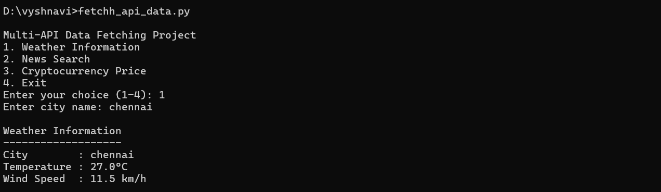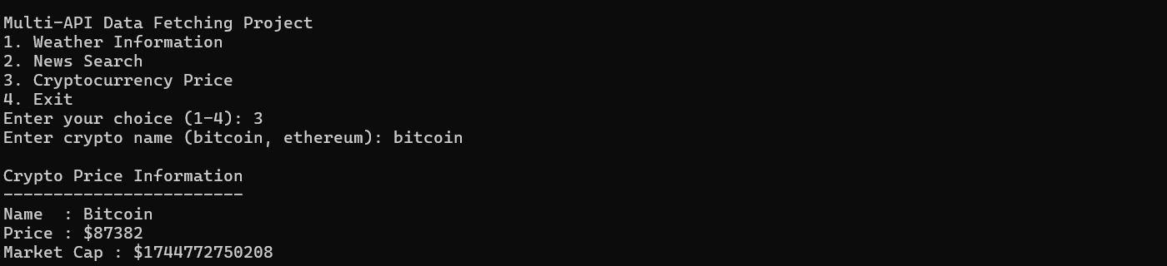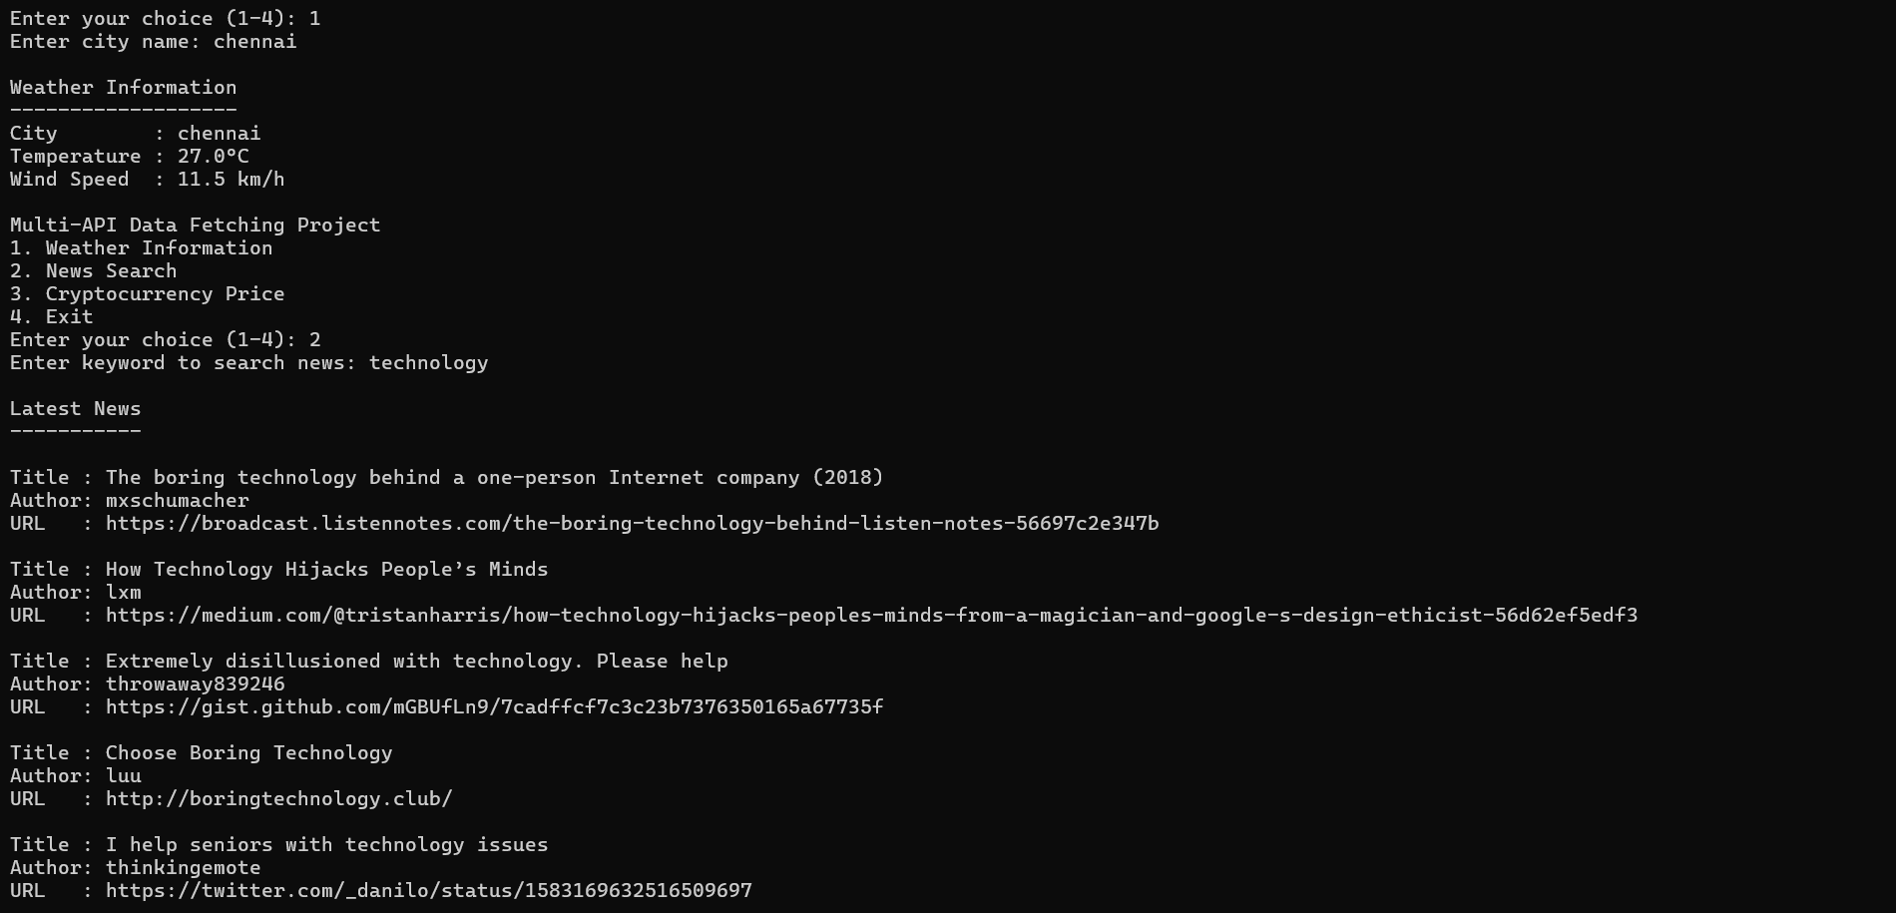
GitHub Repository:https://github.com/vyshnavijana90/Fetch_api_data
Conclusion: This project demonstrates practical API integration using Python, including real-time data fetching, JSON parsing, and keyword-based filtering. It highlights skills useful for backend development, automation, and data analysis.
Future Enhancements: - Export results to CSV or JSON - Add GUI or web interface - Support additional APIs - Improve error handling and logging

