Task : Python File Automation Script

1. Task Overview
Task Name: File Automation using Python
Objective: To automate the organization of files in a directory by sorting them into folders based on file type (extensions) using Python.
This task demonstrates basic automation skills, file handling, and practical usage of Python for real-world scenarios.

2. Tools & Technologies Used
- Python 3
- OS Module (os)
- Shutil Module (shutil)
- Operating System: Windows
No external libraries were required.

3. Problem Statement
Manually organizing files in a directory is time-consuming and inefficient. The goal of this task is to create a Python script that automatically sorts files into appropriate folders based on their file extensions.

4. Solution Description
A Python script named automation.py was developed to: - Scan all files in a selected directory - Identify file types based on extensions - Create folders dynamically if they do not exist - Move files into corresponding folders (e.g., Images, Documents, Videos)
This improves productivity and reduces manual effort.

5. Code Snippet (Key Logic)
import os
import shutil
path = "your_directory_path"
for file in os.listdir(path):
name, ext = os.path.splitext(file)
if ext:
folder = ext[1:].upper() + " Files"
folder_path = os.path.join(path, folder)
if not os.path.exists(folder_path):
os.makedirs(folder_path)
shutil.move(os.path.join(path, file), os.path.join(folder_path, file))

6. Output
After executing the script: - Files were successfully organized into folders based on their extensions - The directory became clean and well-structured

Screenshots to Attach:
- Before running the script (unorganized files)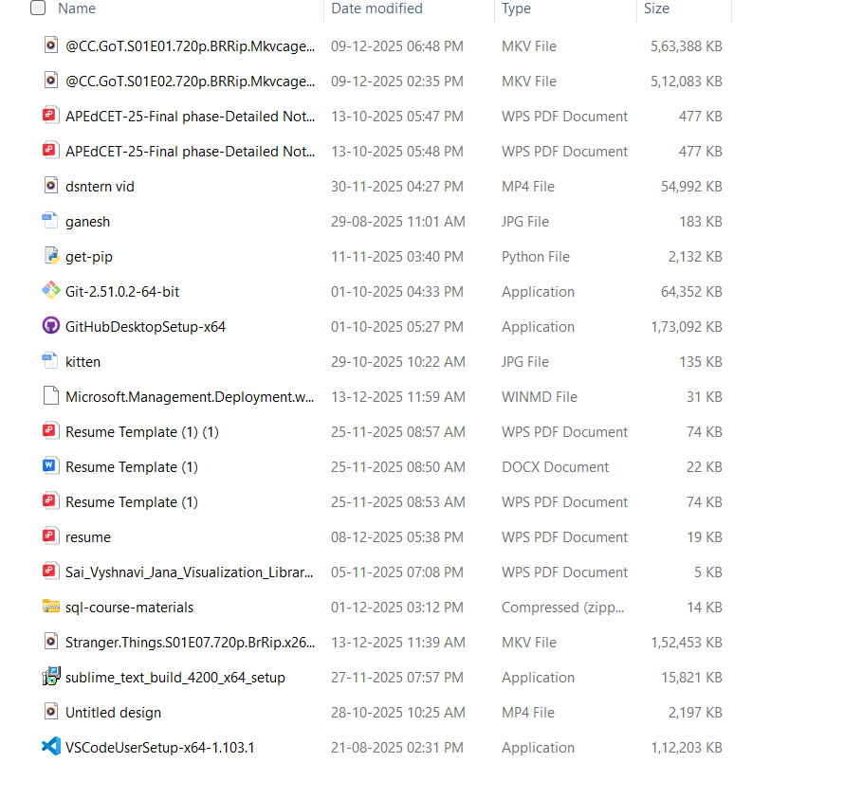
- After running the script (organized folders)
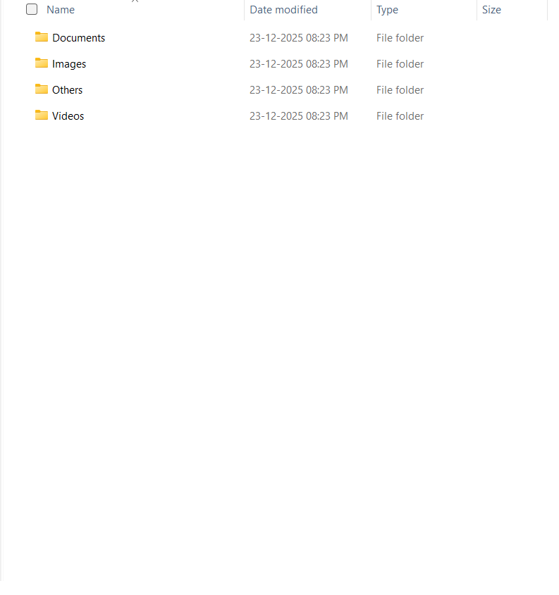

7. GitHub Repository Link
Provide the public GitHub repository link below:
https://github.com/vyshnavijana90/python_automation_script

8. Conclusion
This task helped in understanding Python file handling, directory operations, and automation concepts. The script can be further enhanced by adding logging, user input, or GUI support.
Status: Task Completed Successfully

