1. AIM
To write a LEX program to identify the word "hello", print "hi" in its place, and echo all other characters.

2. LEX PROGRAM
%{
#include <stdio.h>
%}
%%
hello { printf("hi"); }
. { ECHO; }
\n { ECHO; }
%%
int yywrap(void)
{
return 1;
}
int main(void)
{
yylex();
return 0;
}

3. PSEUDOCODE
BEGIN
READ input characters
WHILE input is not finished
IF the next input matches "hello" THEN
PRINT "hi"
ELSE
PRINT the character unchanged
END IF
END WHILE
END

4. ALGORITHM
- Start the program.
- Read input from the keyboard or standard input.
- If the word "hello" is found, print "hi".
- Print all other characters unchanged.
- Continue until the input ends.
- Stop the program.

5. SAMPLE INPUT
hello world

6. COMPILATION AND EXECUTION
Save the source as hello.l, then run:
lex hello.l
gcc lex.yy.c -o hello
./hello
Type: hello world
Press Enter. To finish input in a terminal, use Ctrl+D (Linux/macOS).

7. EXPECTED OUTPUT
hi world
OUTPUT:
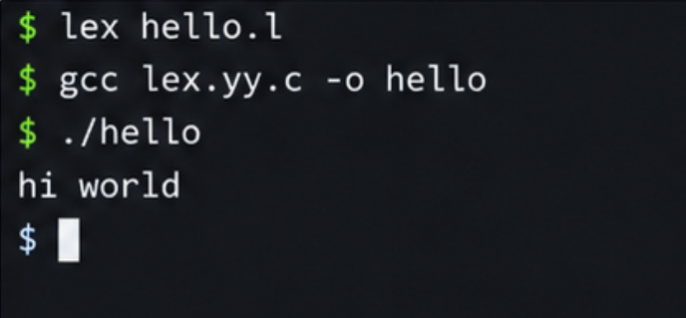

8. RESULT
Thus, the LEX program replaces the word "hello" with "hi" and echoes the remaining input characters.

