LEX PROGRAM:
AIM :
To write a LEX program to identify and print all assignment operators (=, +=, -=, *=, /=) used in the given C program.
LEX PROGRAM :
%{
#include <stdio.h>
%}
%%
("+="|"-="|"*="|"/="|"=") {
printf("Assignment Operator: %s\n", yytext);
}
.|\n ;
%%
int yywrap(void)
{
return 1;
}
int main(int argc, char *argv[])
{
if (argc != 2)
{
printf("Usage: %s input.txt\n", argv[0]);
return 1;
}
FILE *fp = fopen(argv[1], "r");
if (fp == NULL)
{
printf("Error opening file\n");
return 1;
}

yyin = fp;
yylex();
fclose(fp);
return 0;
}
PSEUDO CODE:
BEGIN
OPEN the input text file
WHILE not end of file
SCAN the input for assignment operators
IF an assignment operator is found THEN
PRINT the operator
END IF
END WHILE
CLOSE the input text file
END
ALGORITHM :
- Start the program.
- Open and read the input text file.
- Scan the input using the LEX rules.
- Recognize =, +=, -=, *=, and /= operators.
- Print each assignment operator found.
- Stop the program.

INPUT FILES:
Create a file named input.txt and enter the following C statements:
Input:
a=10;
b+=5;
c*=2;
d-=1;

OUTPUT IMAGE:
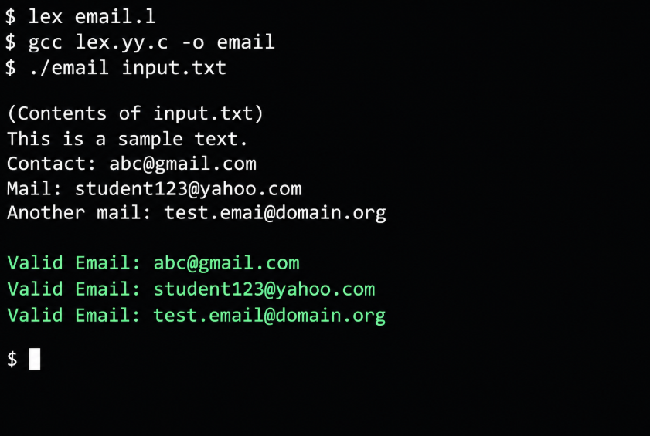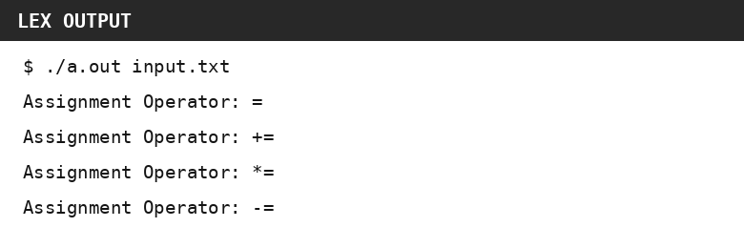
OUTPUT:
Assignment Operator: =
Assignment Operator: +=
Assignment Operator: *=
Assignment Operator: -=
RESULT:
Thus, the LEX program successfully identifies and prints all assignment operators found in the given C program.

