
NATIONAL INSTITUTE OF TECHNOLOGY PUDUCHERRY

(An Institution of National Importance under MoE, Govt. of India)
KARAIKAL – 609 609

DEPARTMENT OF COMPUTER SCIENCE AND ENGINEERING

Roll Number: CS22B1062 Name: Vyshnav Raj C
Semester: 6th semester Class: CSE
Subject Code: CS1702 Subject Name: NETWORK SECURITY

Assignment - 1 Date: 25-04-2025
RSA Encryption and Decryption
1. Introduction
In the modern digital world, the confidentiality and integrity of information are important. Encryption is a method used to secure data by converting it into a format that is unreadable without the appropriate key. RSA (Rivest-Shamir-Adleman) is one of the most widely used asymmetric encryption algorithms. Unlike symmetric encryption, which uses the same key for both encryption and decryption, RSA uses a pair of keys: a public key to encrypt and a private key to decrypt.
2. RSA Encryption and Decryption
RSA is an asymmetric cryptographic algorithm based on the mathematical difficulty of factoring large prime numbers. The key features include:
- Public Key: Used for encryption; shared openly.
- Private Key: Used for decryption; kept secret.
- Security: Based on the computational difficulty of factoring the product of two large primes.
Steps in RSA:
- Key Generation:
  - Select two large prime numbers.
  - Compute their product (modulus) and a totient.
  - Choose a public exponent and calculate the private exponent.
- Encryption:
  - Message is encrypted using the recipient’s public key.
  - Only the corresponding private key can decrypt it.
- Decryption:
  - The recipient uses their private key to retrieve the original message.

4. Implementation
Generate RSA Key Pair
private_key = rsa.generate_private_key(
public_exponent=65537,
key_size=2048,
)
public_key = private_key.public_key()

Encrypt a Message with the Public Key
message = b"Hello, this is a secret message!"
ciphertext = public_key.encrypt(
message,
padding.OAEP(
mgf=padding.MGF1(algorithm=hashes.SHA256()),
algorithm=hashes.SHA256(),
label=None
))
Encrypts the message using:
- The recipient's public key.
- OAEP padding (secure, modern padding scheme).
- MGF1 + SHA256 as the hashing functions for the padding.

Decrypt the Message with the Private Key
decrypted = private_key.decrypt(
ciphertext,
padding.OAEP(
mgf=padding.MGF1(algorithm=hashes.SHA256()),
algorithm=hashes.SHA256(),
label=None
))
Decrypts the encrypted message using:
- The receiver’s private key.
- The same OAEP padding and hash as used for encryption.

5. Output
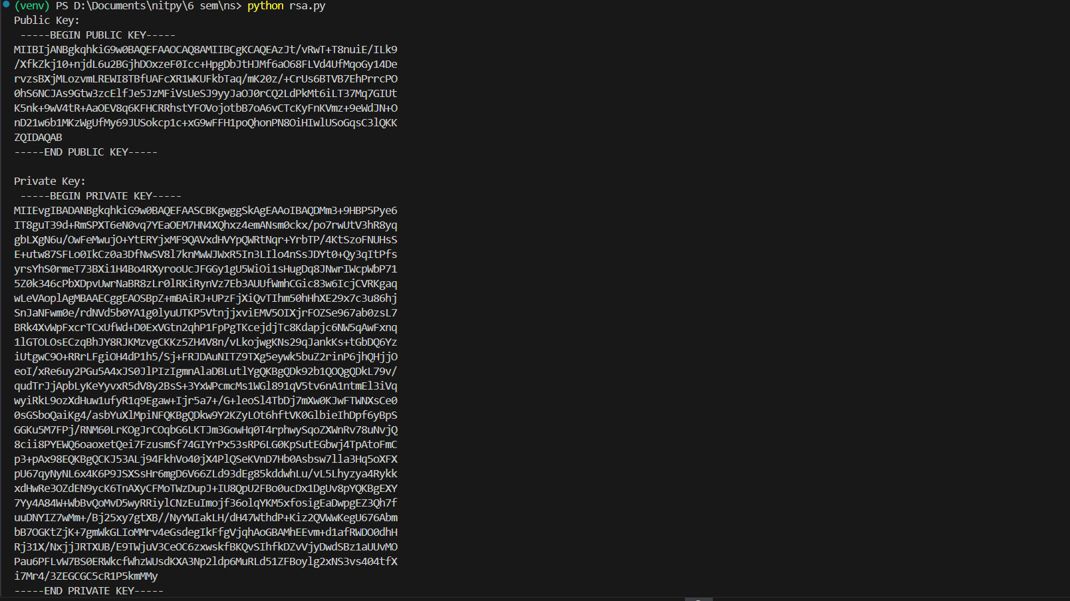
6. Conclusion
RSA allows people to send secure messages using a public key, while only the person with the matching private key can read it. This means there’s no need to share a secret password ahead of time, which makes communication more secure. In this report, we explained how RSA works and showed how to use it in Python with the cryptography library.

