**12.Design DFA using simulator to accept the input string “a” ,”ac”,and ”bac”.**

**Aim:** To Design DFA using simulator to accept the input string “a” ,”ac”,and ”bac”.

**Diagram:**

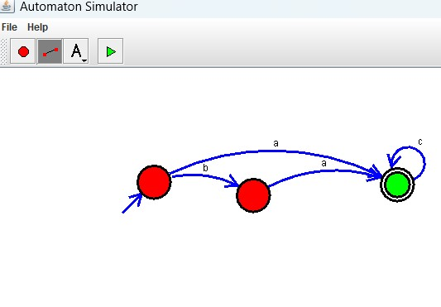

**Result:** Hence**,** Sucessfully Designed DFA using simulator to accept the input string “a” ,”ac”,and ”bac”.