**13. Design PDA using simulator to accept the input string aabb.**

**Aim:** To Design PDA using simulator to accept the input string aabb

**Diagram:**

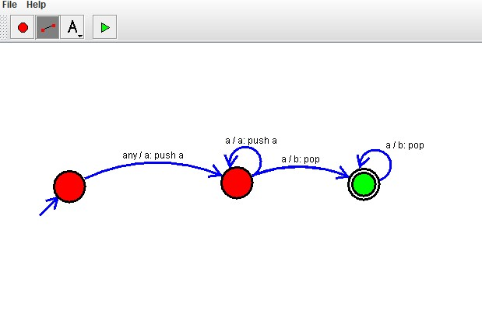**Result:**

The simulator is accepted the given input string aabb by using the above PDA diagram