**14.Design PDA using simulator to accept the input string anb2n**

**Aim:** Design PDA using simulator to accept the input string anb2n.

**Diagram:**

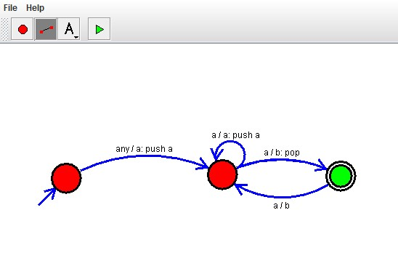

**Result :**

The simulator is accepted the given input string anb2n by using the above PDA diagram