**15.Design TM using simulator to accept the input string anbn.**

**Aim:** To Design TM using simulator to accept the input string anbn.

**Diagram:**

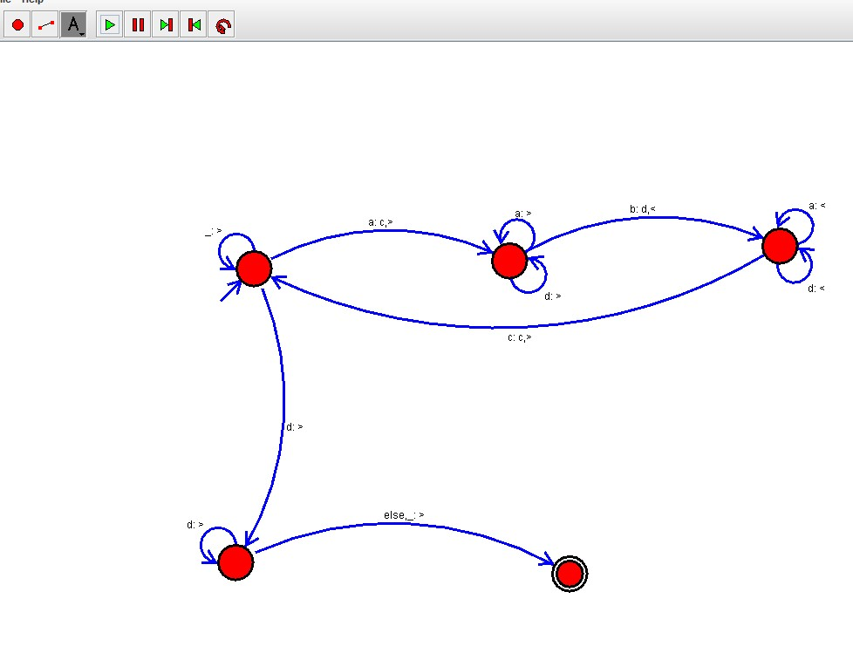

**Result :**

The simulator is accepted the given input string anbn  by using the above TM diagram.