**16.Design TM using simulator to accept the input string anb2n.**

**Aim:** To Design TM using simulator to accept the input string anb2n.

**Diagram:**

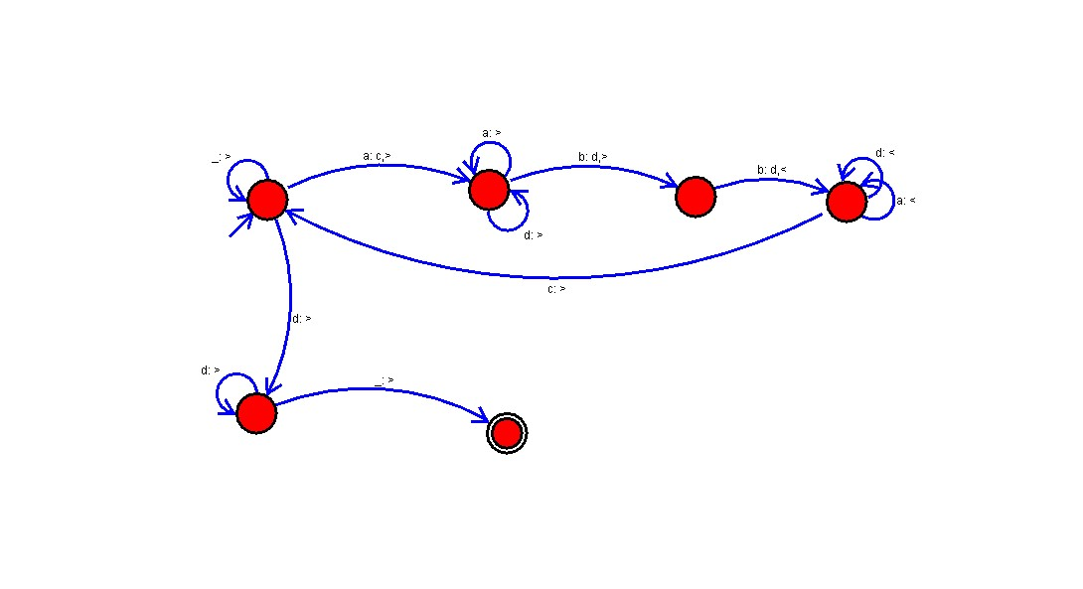

**Result :**

The simulator is accepted the input string anb2n by using the above TM diagram.