**17.Design TM using simulator to accept the input string Palindrome ababa.**

**Aim**: Design TM using simulator to accept the input string Palindrome ababa.

**Diagram:**

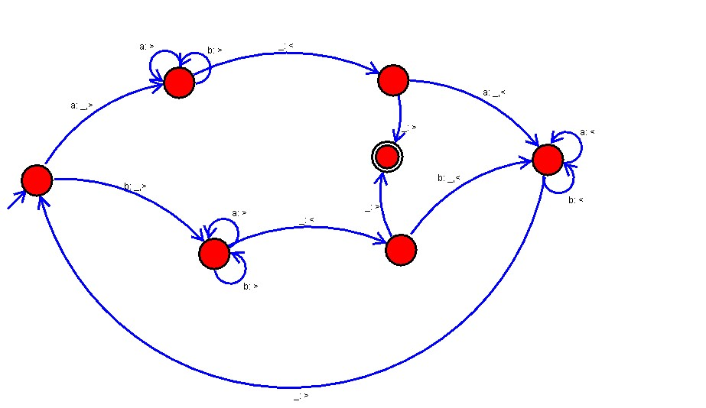

**Result :**

The simulator is accepted the input string Palindrome ababa by using the above TM diagram