**18.Design TM using simulator to accept the input string ww.**

**Aim:** Design TM using simulator to accept the input string ww.

**Diagram:**

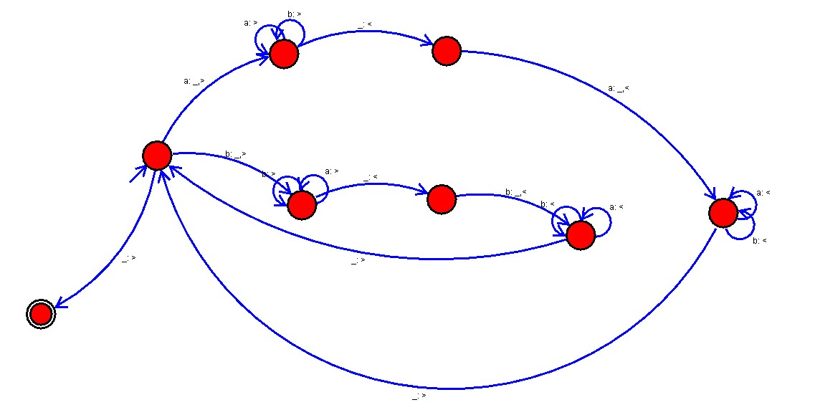

**Result:**

Hence, successfully designed TM using simulator to accept the input string ww.