**19.Design TM using simulator to perform addition of ‘aa’ and ‘aaa’.**

**Aim:** Design TM using simulator to perform addition of ‘aa’ and ‘aaa’.

**Diagram:**

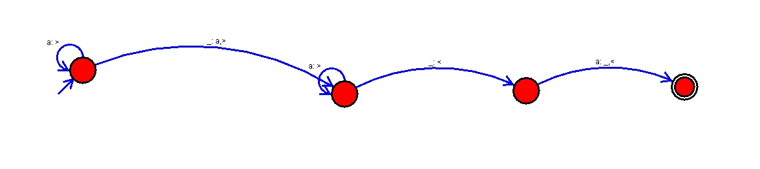

**Result :**

The simulator is accepted to perform addition for the strings of aa and aaa by using the above TM diagram.