**20.Design TM using simulator to perform subtraction of aaa-aa.**

**Aim:** To design TM using simulator to perform subtraction of aaa-aa.

**Diagram:**

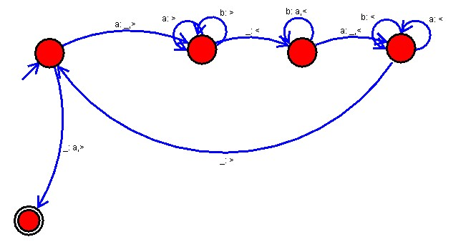

**Result :**

The simulator is accepted the performance of subtraction of aaa-aa by using the above TM diagram.