**21.Design DFA using simulator to accept even number of a’s.**

**Aim:** Design DFA using simulator to accept even number of a’s.

**Diagram:**

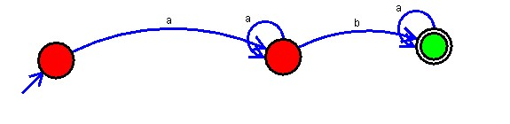

**Result:** Hence, We designed a DFA using simulator to accept even number of a’s.