**22.Design DFA using simulator to accept odd number of a’s.**

**Aim:**To design DFA using simulator to accept odd number of a’s.

**Diagram:**

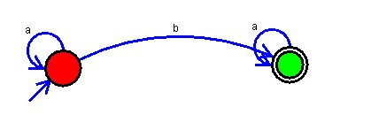

**Result:** Hence, we Designed DFA using simulator to accept odd number of a’s.