**23.Design DFA using simulator to accept the string the end with ab over set {a,b) W= aaabab,**

**Aim:** Design DFA using simulator to accept the string the end with ab over set {a,b)

W= aaabab

**Diagram:**

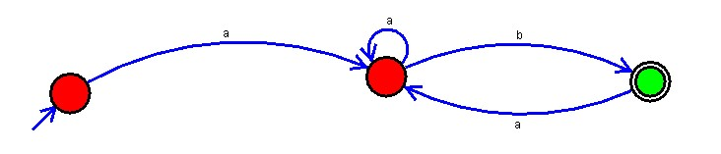

**Result:** Hence, we Designed DFA using simulator to accept the string the end with ab over set {a,b) W= aaabab.