**24.Design DFA using simulator to accept the string having ‘ab’ as substring over the set {a,b}**

**Aim:** Design DFA using simulator to accept the string having ‘ab’ as substring over the set {a,b}

**Diagram:**

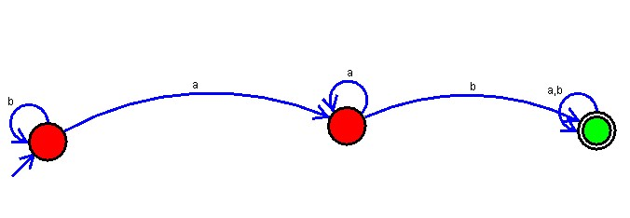

**Result:** Hence, we Designed DFA using simulator to accept the string having ‘ab’ as substring over the set {a,b}