**25.Design DFA using simulator to accept the string start with a or b over the set {a,b}.**

**Aim:** Design DFA using simulator to accept the string start with a or b over the set {a,b}.

**Diagram:**

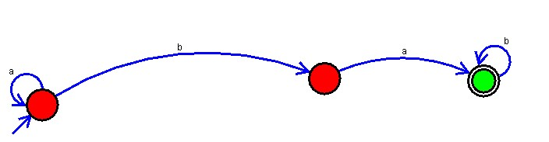

**Result:** Hence, we designed DFA using simulator to accept the string start with a or b over the set {a,b}