**26.Design TM using simulator to accept the input string Palindrome bbabb.**

**Aim:** Design TM using simulator to accept the input string Palindrome bbabb.

**Diagram:**

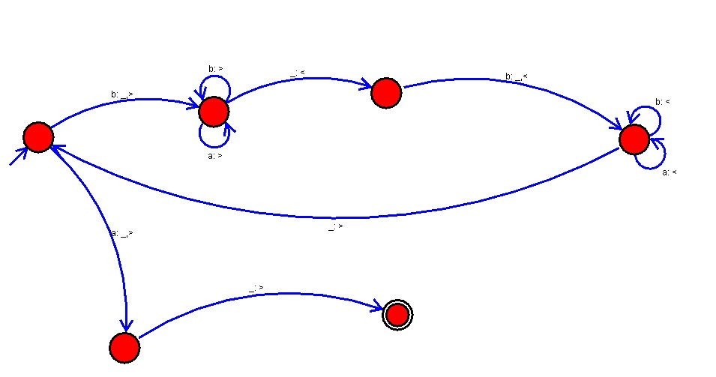

**Result:**

Accepted the string palindrome using the Turing machine simulator.