**27.Design TM using simulator to accept the input string wcw.**

**Aim:** To Design TM using simulator to accept the input string wcw.

**Diagram:**

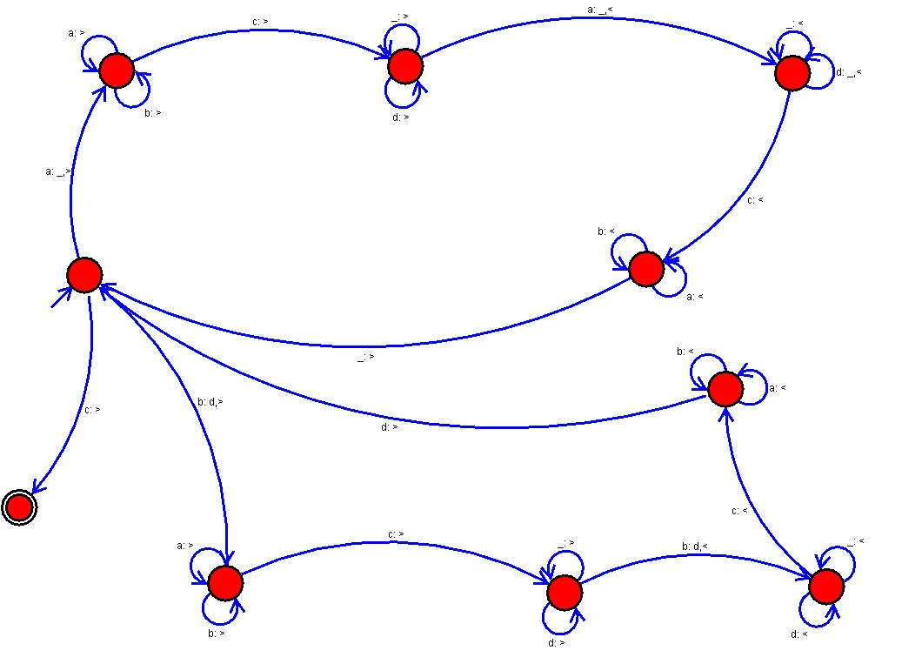

**Result:**

Hence it has accepted the input string wcw by using Turing machine simulator