**28.Design DFA using simulator to accept the string the end with ab over set {a,b) W= abbaabab.**

**Aim:** To design DFA using simulator to accept the string the end with ab over set {a,b) W= abbaabab.

**Diagram:**

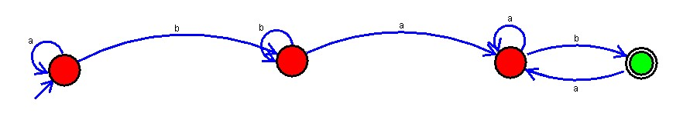

**Result:**

Finally accepted the input string the end with ab over set{a,b} by using DFA simulator