**29.Design DFA using simulator to accept the input string “bc” ,”c”,and ”bcaaa”.**

**Aim:** To design DFA using simulator to accept the input string “bc” ,”c”,and ”bcaaa”.

**Diagram:**

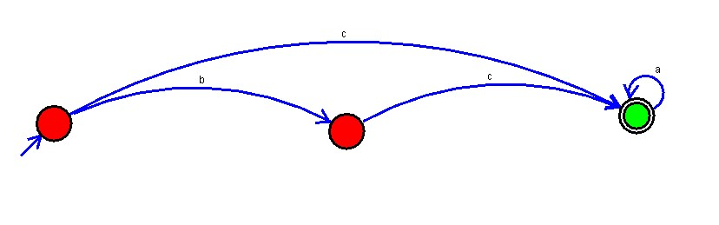

**Result:**

The given input string is accepted (“b,c”,”c”,”bcaaa”) by using the above DFA simulator.