**30.Design NFA to accept any number of a’s where input={a,b}.**

**Aim:** Design NFA to accept any number of a’s where input={a,b}.

**Diagram:**

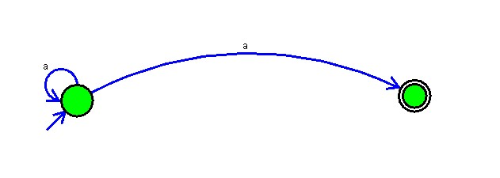

**Result:**

The given input string is accepted by the simulator by using the above NFA diagram