**31.Design PDA using simulator to accept the input string anbn.**

**Aim:**To design PDA using simulator to accept the input string anbn.

**Diagram:**

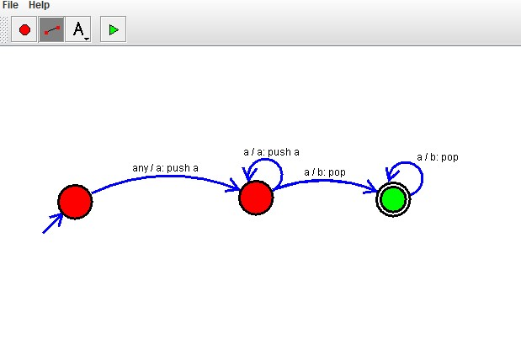

**Result:**

The given input string is accepted by the simulator by using the above PDA diagram.