**32.Design TM using simulator to perform string comparison where w={aba aba}.**

**Aim:** To design TM using simulator to perform string comparison where w={aba aba}.

**Diagram:**

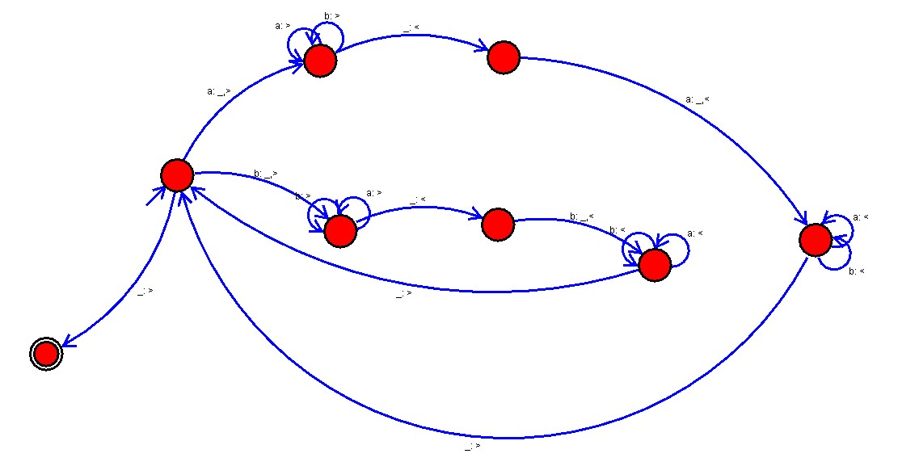

**Result :**

The given string comparision is performed well by the simulator by the above turing machine diagram.