**33.Design DFA using simulator to accept the string having ‘abc’ as substring over the set {a,b,c}.**

**Aim:** To design DFA using simulator to accept the string having ‘abc’ as substring over the set {a,b,c}.

**Diagram:**

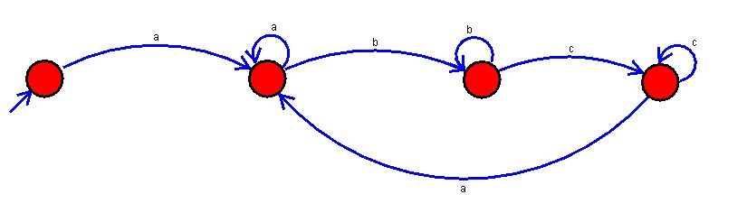

**Result :**

The given string and substring accepted by the simulator by using the above DFA diagram