**34.Design DFA using simulator to accept even number of c’s over the set {a,b,c}.**

**Aim:** To design DFA using simulator to accept even number of c’s over the set **{a,b,c}.**

**Diagram:**

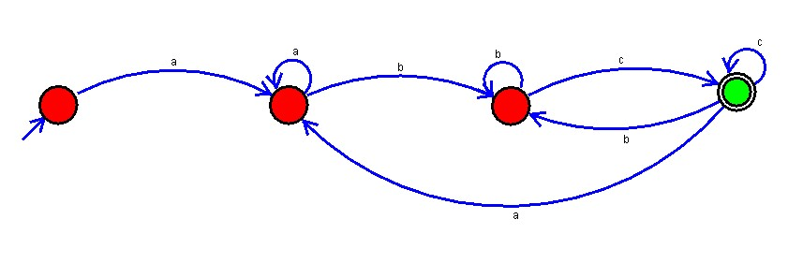

**Result :**

The simulator is accepted the even number of c’s over the set {a,b,c} by using the above DFA diagram