**35.Design DFA using simulator to accept strings in which a’s always appear tripled over input {a,b}.**

**Aim:** To design DFA using simulator to accept strings in which a’s always appear tripled over input {a,b}.

**Diagram:**

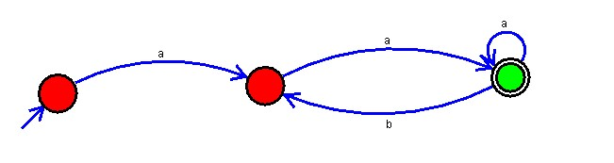

**Result :**

The simulator accepted strings in which a’s always appear tripled over input {a,b} by using the above DFA diagram .