**36.Design NFA using simulator to accept the string the start with a and end with b over set {a,b} and check W= abaab is accepted or not.**

**Aim:**Todesign NFA using simulator to accept the string the start with a and end with b over set {a,b} and check W= abaab is accepted or not.

**Diagram:**

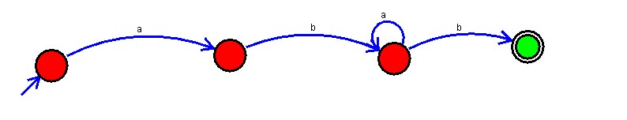

**Result :**

The simulator is accepted the string that start with a and end with b over set {a,b} and check W= abaab by using the above NFA diagram.