**37.Design NFA using simulator to accept the string that start and end with different symbols over the input {a,b}.**

**Aim:** To design NFA using simulator to accept the string that start and end with different symbols over the input {a,b}.

**Diagram:**

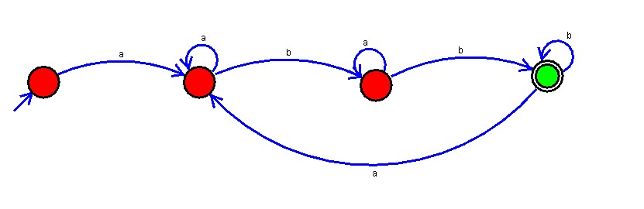

**Result :**

The simulator is accepted the string that start and end with different symbols over the input {a,b}by using the above NFA diagram.