**38.Design NFA using simulator to accept the input string “bbc” ,”c”,and ”bcaaa”.**

**Aim:** To Design NFA using simulator to accept the input string “bbc” ,”c”,and ”bcaaa”.

**Diagram:**

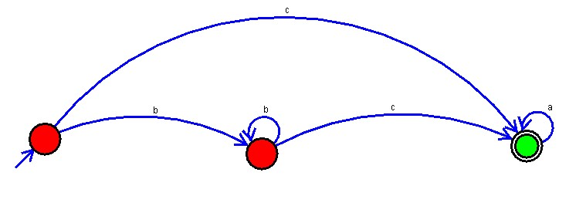

**Result :**

The simulator is accepted the input string “bbc” ,”c”,and ”bcaaa” by using the above NFA diagram