**39.Design DFA using simulator to accept the string the end with abc over set {a,b,c) W= abbaababc.**

**Aim:**To design DFA using simulator to accept the string the end with abc over set {a,b,c) W= abbaababc.

**Diagram:**

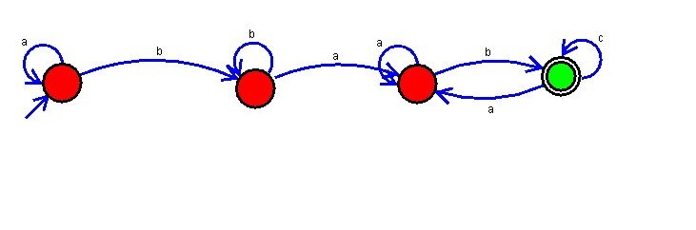

**Result :**

The simulator is accepted accept the string the end with abc over set {a,b,c) W=abbaababc by using the above DFA diagram