**40.Design NFA to accept any number of b’s where input={a,b}.**

**Aim:**To design NFA to accept any number of b’s where input={a,b}.

**Diagram:**

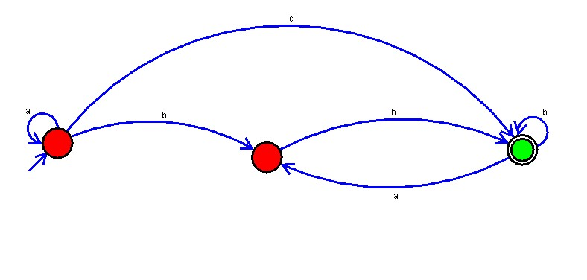  
  
**Result:**

The simulator is accepted the any number of b’s where input = {a,b} by using the above NFA diagram.