Communication
· Interprocess communication fundamental to all distributed systems.
· Communication in distributed systems is always based on low-level message passing as offered by the underlying network.
· Expressing communication through message passing is harder than using primitives based on shared memory
· Modern distributed systems often consist of thousands or even millions of processes scattered across a network with unreliable communication.
· Unless the primitive communication facilities of computer networks are replaced by something else, development of large-scale distributed applications is extremely difficult.

Interprocess Communication
A process of exchanging data between two or more independent processes in a distributed environment is called as Inter process communication.

The basic principles of the how IPC works are:
- Identification of the recipient process: The sender process must identify the recipient process that it wishes to communicate with. This can be achieved through various methods, such as IP addresses, port numbers, process IDs, or other identifiers.
- Encapsulation of the message: The message to be sent is encapsulated with the necessary metadata, such as the destination address, message type, and any additional information needed for the recipient to process the message.
- Transmission of the message: The message is then transmitted from the sender to the recipient using a communication channel, such as a socket or a message queue.
- Decapsulation of the message: Upon receiving the message, the recipient extracts the metadata and message content from the encapsulated message and processes it accordingly.

Types of Interprocess Communication in Distributed Systems
- Message Passing:
  - Definition: Message passing involves processes communicating by sending and receiving messages. Messages can be structured data packets containing information or commands.
  - Characteristics: It is a versatile method suitable for both synchronous and asynchronous communication. Message passing can be implemented using various protocols such as TCP/IP, UDP, or higher-level messaging protocols like AMQP (Advanced Message Queuing Protocol) or MQTT (Message Queuing Telemetry Transport).
- Remote Procedure Calls (RPC):
  - Definition: RPC allows one process to invoke a procedure (or function) in another process, typically located on a different machine over a network.
  - Characteristics: It abstracts the communication between processes by making it appear as if a local procedure call is being made. RPC frameworks handle details like parameter marshalling, network communication, and error handling.
- Sockets:
  - Definition: Sockets provide a low-level interface for network communication between processes running on different computers.
  - Characteristics: They allow processes to establish connections, send data streams (TCP) or datagrams (UDP), and receive responses. Sockets are fundamental for implementing higher-level communication protocols.
- Message Queuing Systems:
  - Description: Message queuing systems facilitate asynchronous communication by allowing processes to send messages to and receive messages from queues.
  - Characteristics: They decouple producers (senders) and consumers (receivers) of messages, providing fault tolerance, scalability, and persistence of messages. Examples include Apache Kafka, RabbitMQ, and AWS SQS.
- Publish-Subscribe Systems:
  - Description: Publish-subscribe (pub-sub) systems enable communication between components without requiring them to directly know each other.
  - Characteristics: Publishers publish messages to topics, and subscribers receive messages based on their interest in specific topics. This model supports one-to-many communication and is scalable for large-scale distributed systems. Examples include MQTT and Apache Pulsar.

Fundamentals
Layered Protocols
· Due to the absence of shared memory, all communication in distributed systems is based on sending and receiving (low level) messages.
· When process A wants to communicate with process B, it first builds a message in its own address space.
· Then it executes a system call that causes the operating system to send the message over the network to B.
International Standards Organization (ISO) reference model: Open Systems Interconnection (OSI) Reference Model (Day and Zimmerman, 1983).
· Protocols that were developed as part of the OSI model were never widely used. · Underlying model useful for understanding computer networks.
· OSI model is designed to allow open systems to communicate.
· An open system is one that is prepared to communicate with any other open system by using standard rules that govern the format, contents, and meaning of the messages sent and received.
· Rules are formalized into protocols.
· Groups of computers communicate over a network by agreeing on the protocols to be used.
Two general types of protocols:
- Connection oriented protocols o Before exchanging data the sender and receiver first explicitly establish a connection, and possibly negotiate the protocol to use.
  - When done coomunicating, the connection is terminated.
  - e.g. telephone is a connection-oriented communication system.
- Connectionless protocols o No advance setup. o The sender transmits the first message when it is ready. o e.g. Dropping a letter in a mailbox is an example of connectionless communication.
The OSI model –
· Communication is divided up into seven levels or layers.
· Each layer deals with one specific aspect of the communication.
· Each layer provides an interface to the one above it.
· The interface consists of a set of operations that together define the service the layer is prepared to offer its users.
(from wikipedia)
OSI Model
 | Data unit | Layer |  | Function
Host Layers | Data | Application  Presentation  Session | 7  6  5 | Network process to application  Data representation and encryption  Interhost communication
 | Segments | Transport | 4 | End-to-end connections and reliability
Media Layers | Packets  Frames | Network  Data link | 3  2 | Path determination and logical addressing (IP)  Physical addressing (MAC & LLC)
 | Bits | Physical | 1 | Media, signal and binary transmission
Layer 7: Application Layer
· Provides means for the user to access information on the network through an application.
· This layer is the main interface for the user(s) to interact with the application and therefore the network.
· Some examples of application layer protocols include Telnet, applications which use File Transfer Protocol (FTP), applications which use Simple Mail Transfer Protocol (SMTP) and applications which use Hypertext Transfer Protocol (HTTP).
Layer 6: Presentation Layer
· Transforms data to provide a standard interface for the Application layer.
· MIME encoding, data compression, data encryption and similar manipulation of the presentation is done at this layer to present the data as a service or protocol developer sees fit.
· Examples: converting an EBCDIC-coded text file to an ASCII-coded file, or serializing objects and other data structures into and out of, e.g., XML.
Layer 5: Session Layer
· Controls the dialogues (sessions) between computers.
· It establishes, manages, and terminates the connections between the local and remote application.
· It provides for either duplex or half-duplex operation and establishes checkpointing, adjournment, termination, and restart procedures.
· The OSI model made this layer responsible for "graceful close" of sessions, which is a property of TCP, and also for session checkpointing and recovery, which is not usually used in the Internet protocols suite.
Layer 4: Transport Layer
· Provides transparent transfer of data between end users, thus relieving the upper layers from any concern while providing reliable data transfer.
· Controls the reliability of a given link through flow control, segmentation/desegmentation, and error control.
· Some protocols are state and connection oriented.
- This means that the transport layer can keep track of the packets and retransmit those that fail.
· Best known example of a layer 4 protocol is the Transmission Control Protocol (TCP).
- The transport layer is the layer that converts messages into TCP segments or User Datagram Protocol (UDP), Stream Control Transmission Protocol (SCTP), etc. packets.
Layer 3: Network Layer
· Provides the functional and procedural means of transferring variable length data sequences from a source to a destination via one or more networks while maintaining the quality of service requested by the Transport layer.
· The Network layer performs network routing functions.
· Routers operate at this layer—sending data throughout the extended network and making the Internet possible (also existing at layer 3 (or IP) are switches).
- This is a logical addressing scheme – values are chosen by the network engineer.
- The addressing scheme is hierarchical.
· The best known example of a layer 3 protocol is the Internet Protocol (IP).
Layer 2: Data Link Layer
· Provides the functional and procedural means to transfer data between network entities and to detect and possibly correct errors that may occur in the Physical layer.
· Best known example of this is Ethernet.
· On IEEE 802 local area networks, and some non-IEEE 802 networks such as FDDI, this layer may be split into a Media Access Control (MAC) layer and the IEEE 802.2 Logical Link Control (LLC) layer. It arranges bits from physical layer into logical chunks of data, known as frames.
· This is the layer at which the bridges and switches operate.
· Connectivity is provided only among locally attached network nodes forming layer 2 domains for unicast or broadcast forwarding.
· Other protocols may be imposed on the data frames to create tunnels and logically separated layer 2 forwarding domains.
Layer 1: Physical Layer
· Defines all the electrical and physical specifications for devices.
- This includes the layout of pins, voltages, and cable specifications. Hubs, repeaters, network adapters and Host Bus Adapters (HBAs used in Storage Area Networks) are physical-layer devices.
· The major functions and services performed by the physical layer are:
- Establishment and termination of a connection to a communications medium. o Participation in the process whereby the communication resources are effectively shared among multiple users.
- Modulation or conversion between the representation of digital data in user equipment and the corresponding signals transmitted over a communications channel.
· Parallel SCSI buses operate in this layer.
· Various physical-layer Ethernet standards are also in this layer; o Ethernet incorporates both this layer and the data-link layer.
· The same applies to other local-area networks, such as Token ring, FDDI, and IEEE 802.11, as well as personal area networks such as Bluetooth and IEEE 802.15.4.
Sending a Message
When process A on machine 1 wants to communicate with process B on machine 2:
- it builds a message and passes the message to the application layer on its machine.
· This layer might be a library procedure, for example, but it could also be implemented in some other way (e.g., inside the operating system, on an external network processor, etc.).
- The application layer software then adds a header to the front of the message and passes the resulting message across the layer 6/7 interface to the presentation layer.
- The presentation layer adds its own header and passes the result down to the session layer, and so on.
· Some layers add not only a header to the front, but also a trailer to the end.
- When it hits the bottom, the physical layer transmits the message) by putting it onto the physical transmission medium. · A typical message as it appears on the network.
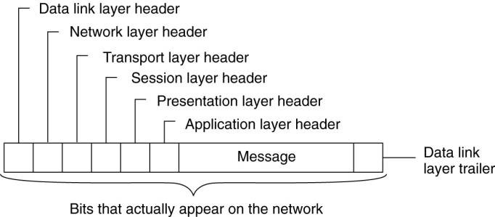
- When the message arrives at machine 2, it is passed upward, with each layer stripping off and examining its own header.
- Finally, the message arrives at the receiver, process B, which may reply to it using the reverse path. · The information in the layer n header is used for the layer n protocol.

Middleware Protocols
· Middleware is an application that logically lives (mostly) in the application layer, but contains many general-purpose protocols that warrant their own layers, independent of other, more specific applications.
· Middleware communication protocols support high-level communication services.
· Adapted reference model for communication
· Compared to the OSI model, the session and presentation layer have been replaced by a single middleware layer that contains application-independent protocols.
Types of Communication
View middleware as an additional service in client-server computing,
· Viewing middleware as an intermediate (distributed) service in application-level communication.
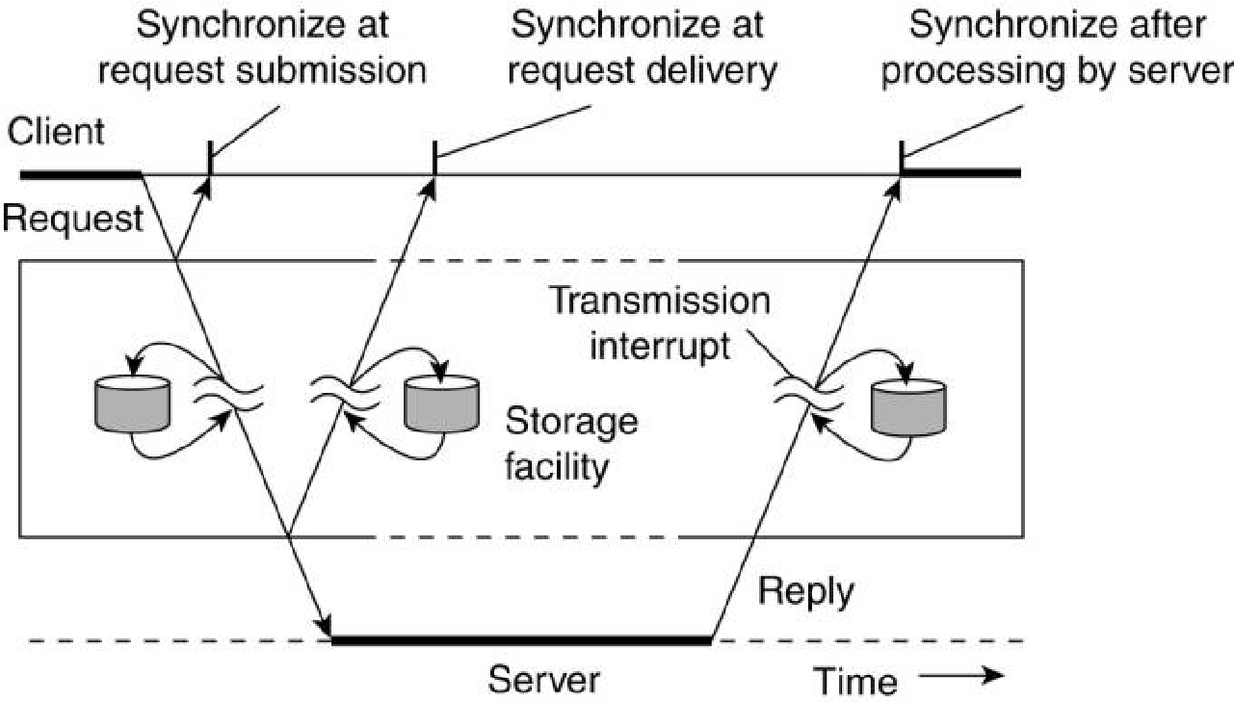
Example: An electronic mail system.
· The core of the mail delivery system viewed as a middleware communication service.
· Each host runs a user agent allowing users to compose, send, and receive e-mail.
· A sending user agent passes such mail to the mail delivery system, expecting it, to deliver the mail to the intended recipient.
· The user agent at the receiver's side connects to the mail delivery system to see whether any mail has arrived.
- If so, the messages are transferred to the user agent so that they can be displayed and read by the user.
Persistent Communication
An electronic mail system is a typical example of communication persistent communication.
· With persistent communication, a message that has been submitted for transmission is stored by the communication middleware as long as it takes to deliver it to the receiver.
· The middleware will store the message at one or several of the storage facilities (above figure).
- Not necessary for the sending application to continue execution after submitting the message. o The receiving application need not be executing when the message is submitted.
Transient Communication
A message is stored by the communication system only as long as the sending and receiving application are executing.
· The middleware cannot deliver a message if there is a transmission interrupt or the recipient is currently not active -it will discard the message.
· All transport-level communication services offer only transient communication.
o The communication system consists of traditional store-and-forward routers. o If a router cannot deliver a message to the next one or the destination host, it will drop the message.
Asynchronous Communication
A sender continues executing immediately after it has submitted its message for transmission.
· This means that the message is (temporarily) stored by the middleware immediately upon submission.
Synchronous Communication
A sender is blocked until its request is known to be accepted.
· Three points where synchronization can take place:
- The sender may be blocked until the middleware notifies that it will take over transmission of the request.
- The sender may synchronize until its request has been delivered to the intended recipient.
- Synchronization may take place by letting the sender wait until its request has been fully processed, that is, up the time that the recipient returns a response.
Distributed Communications Classifications
- Persistent asynchronous communication.
- Persistent synchronous communication.
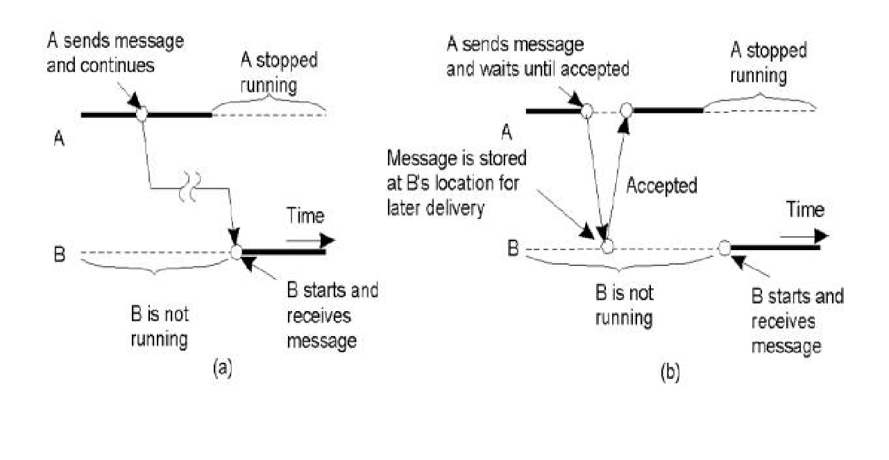
- Transient asynchronous communication.
- Receipt-based transient synchronous communication.
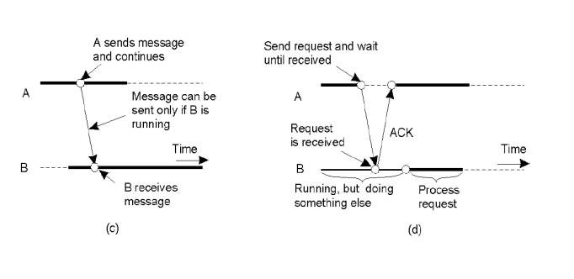
- Delivery-based transient synchronous communication at message delivery.
- Response-based transient synchronous communication.
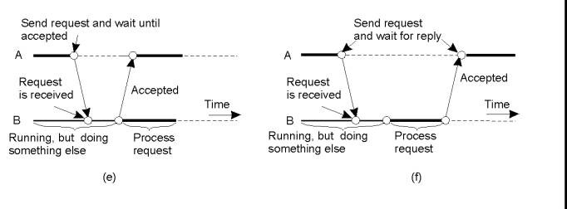

Remote Procedure Call
Issue:
· Many distributed systems have been based on explicit message exchange between processes.
· These procedures do not conceal communication mitigating access transparency in distributed systems.
Solution:
· Birrell and Nelson suggested allowing programs to call procedures located on other machines.
· When a process on machine A calls a procedure on machine B, the calling process on A is suspended, and execution of the called procedure takes place on B.
· Information can be transported from the caller to the callee in the parameters and be returned in the procedure result.
· No message passing is visible to the programmer.
· This method is known as Remote Procedure Call, or often just RPC.
Basic RPC Operation
Conventional Procedure Call
· Consider a call in C like
count = read(fd, buf, nbytes);
where fd is an integer indicating a file
buf is an array of characters into which data are read nbytes is another integer telling how many bytes to read
· If the call is made from the main program, the stack will be as shown in Figure(a) before the call.
· To make the call, the caller pushes the parameters onto the stack in order, last one first, as shown in Figure (b).
· After the read procedure has finished running, it puts the return value in a register, removes the return address, and transfers control back to the caller.
· The caller then removes the parameters from the stack, returning the stack to the original state it had before the call.
- Parameter passing in a local procedure call: the stack before the call to read.
- The stack while the called procedure is active.
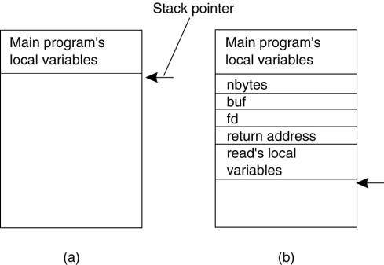
Note:
· In C, parameters can be call-by-value or call-by-reference.
· A value parameter, such as fd or nbytes, is simply copied to the stack as shown in Figure(b).
· To the called procedure, a value parameter is just an initialized local variable.
· The called procedure may modify it, but such changes do not affect the original value at the calling side.
· A reference parameter in C is a pointer to a variable (i.e., the address of the variable), rather than the value of the variable.
· In the call to read( ), the second parameter is a reference parameter because arrays are always passed by reference in C.
· What is actually pushed onto the stack is the address of the character array.
· If the called procedure uses this parameter to store something into the character array, it does modify the array in the calling procedure.
· The difference between call-by-value and call-by-reference is quite important for RPC.

Client and Server Stubs
· RPC makes a remote procedure call look as much as possible like a local call.
· When read( ) is a remote procedure (e.g., one that will run on the file server's machine), a different version of read, called a client stub, is put into the library.
· Like the original read( ):
· it is called using the calling sequence.
· it makes a call to the local operating system.
· Unlike the original one read( ), it does not ask the operating system to provide data - it packs the parameters into a message and requests that message to be sent to the server as illustrated below.
· Following the call to send, the client stub calls receive, blocking itself until the reply comes back.
Principle of RPC between a client and server program.
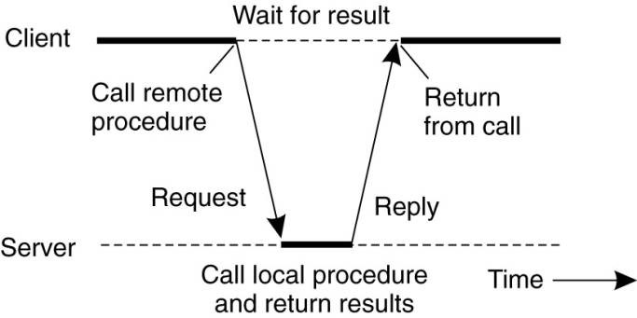
· When the message arrives at the server, the server's operating system passes it up to a server stub.
§ A server stub is the server-side equivalent of a client stub: it is a piece of code that transforms requests coming in over the network into local procedure calls.
§ The server stub will have called receive and be blocked waiting for incoming messages.
§ The server stub unpacks the parameters from the message and then calls the server procedure in the usual way (figure above).
§ From the server's point of view, it is as though it is being called directly by the client—the parameters and return address are all on the stack where they belong.
§ The server performs its work and then returns the result to the caller in the usual way.
· When the server stub gets control back after the call has completed, it packs the result (the buffer) in a message and calls send to return it to the client.
· After that, the server stub usually does a call to receive again, to wait for the next incoming request.
· When the message gets back to the client machine, the client's operating system sees that it is addressed to the client process (or actually the client stub, but the operating system cannot see the difference).
· The message is copied to the waiting buffer and the client process is unblocked.
· The client stub inspects the message, unpacks the result, copies it to its caller, and returns in the usual way.
· When the caller gets control following the call to read( ),, all it knows is that its data are available. · It has no idea that the work was done remotely instead of by the local operating system.
· Remote services are accessed by making ordinary (i.e., local) procedure calls.
· All the details of the message passing are hidden away in the two library procedures, just as the details of actually making system calls are hidden away in traditional libraries.
A remote procedure call occurs in the following steps:
- The client procedure calls the client stub in the normal way.
- The client stub acts a proxy and builds a message and calls the local operating system.
- The client's OS sends the message to the remote OS (via TCP/UDP).
- The remote OS gives the message to the server stub.
- The server stub unpacks the parameters and calls the server.
- The server does the work and returns the result to the stub.
- The server stub packs it in a message and calls its local OS.
- The server's OS sends the message to the client's OS.
- The client's OS gives the message to the client stub.
- The client stub unpacks the result and returns to the client.
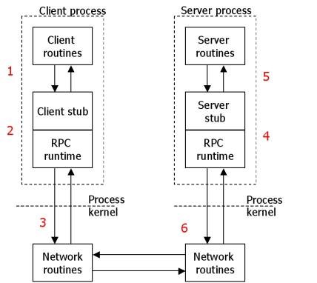

Parameter Passing
Passing Value Parameters
Parameter marshaling: There’s more than just wrapping parameters into a message:
· Packing parameters into a message is called parameter marshaling.
· Client and server machines may have different data representations (think of byte ordering) · Wrapping a parameter means transforming a value into a sequence of bytes · Client and server have to agree on the same encoding:
· How are basic data values represented (integers, floats, characters)
· How are complex data values represented (arrays, unions)
· Client and server need to properly interpret messages, transforming them into machine-dependent representations. The steps involved in a doing a remote computation through RPC.
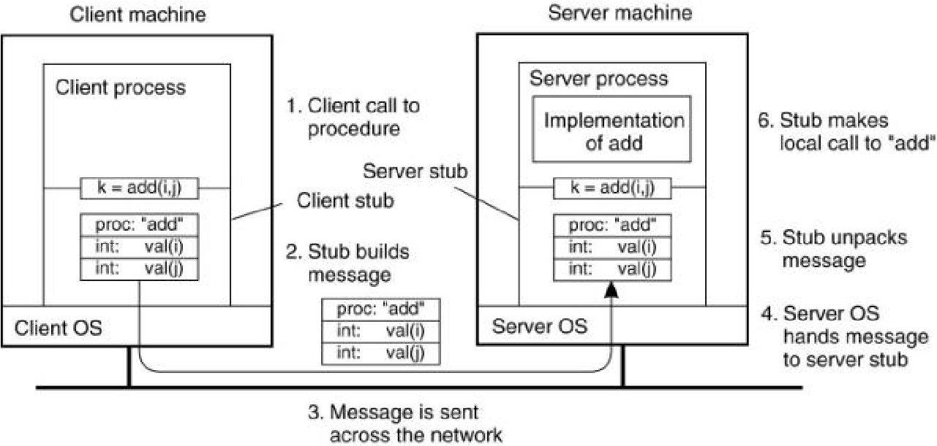
· When the message arrives at the server, the stub examines the message to see which procedure is needed and then makes the appropriate call.
· The actual call from the stub to the server looks like the original client call, except that the parameters are variables initialized from the incoming message.
· When the server has finished, the server stub gains control again.
· It takes the result sent back by the server and packs it into a message.
· This message is sent back to the client stub, which unpacks it to extract the result and returns the value to the waiting client procedure.
XDR (External data representation)
Some machines, such as the Intel Pentium, number their bytes from right to left, whereas others, such as the Sun SPARC, number them the other way.
§ The Intel format is called little endian and the SPARC format is called big endian, after the politicians in Gulliver's Travels who went to war over which end of an egg to break .
· e.g., a procedure with two parameters: an integer and a four-character string.
o Each parameter requires one 32-bit word.
- The original message on the Pentium.
- The message after receipt on the SPARC.
- The message after being inverted.
The little numbers in boxes indicate the address of each byte.
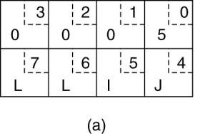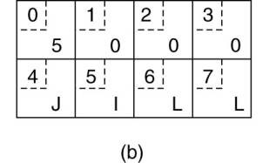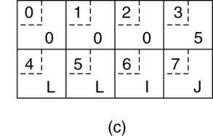
Passing Reference Parameters
How are pointers, or in general, references passed?
· Only with the greatest of difficulty, if at all.
· A pointer is meaningful only within the address space of the process in which it is being used.
Solution: copy/restore
· Copy the array into the message and send it to the server.
· The server stub can then call the server with a pointer to this array, even though this pointer has a different address than the second parameter of read.
· Changes the server makes using the pointer (e.g., storing data into it) directly affect the message buffer inside the server stub.
· When the server finishes, the original message can be sent back to the client stub, which then copies it back to the client.
· In effect, call-by-reference has been replaced by copy/restore.
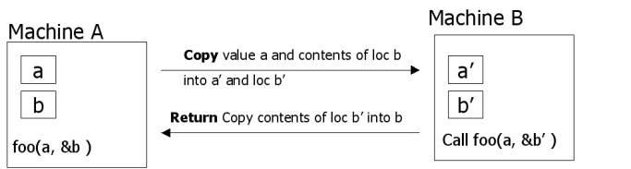
Asynchronous RPC
Conventional (Synchronous) RPC - the client will block until a reply is returned.
Asynchronous RPC - client continues after issuing the RPC request.
· The server immediately sends a reply back to the client the moment the RPC request is received, after which it calls the requested procedure.
· The reply acts as an acknowledgment to the client that the server is going to process the RPC.
· The client will continue without further blocking as soon as it has received the server's acknowledgment.
(a) Client -server interaction in traditional RPC. (b) The interaction using asynchronous RPC.
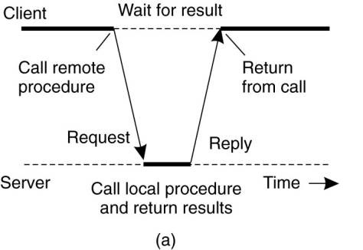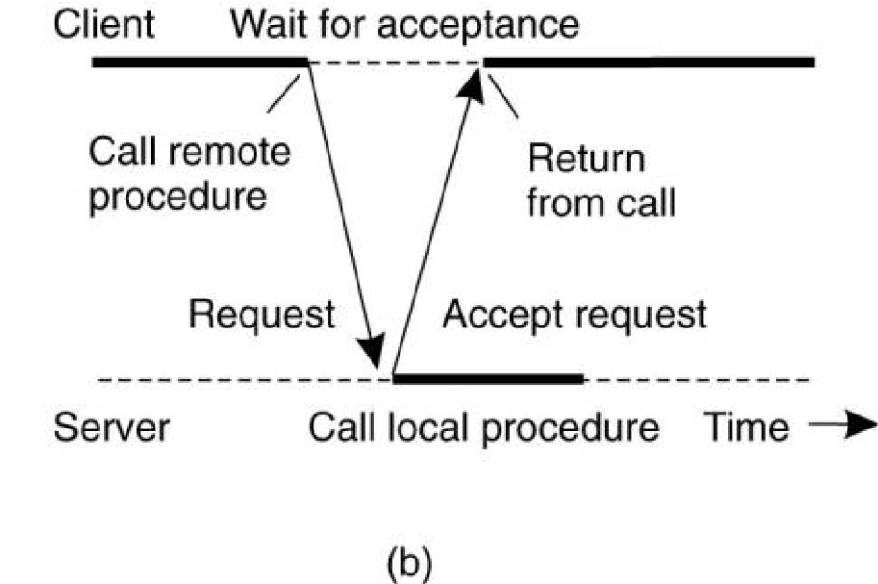
Example: DCE RPC
· Distributed Computing Environment (DCE) - developed by the Open Software Foundation (OSF)
· Representative of RPC systems
· Specifications adopted in Microsoft's base system for distributed computing, DCOM.
· DCE is a true middleware system in that it is designed to execute as a layer of abstraction between existing (network) operating systems and distributed applications.
Take a collection of existing machines, add the DCE software, and then run distributed applications, all without disturbing existing (nondistributed) applications.
· Client-server model is DCE programming model
· All communication between clients and servers takes place by means of RPCs.
DCE Services:
Distributed file service - worldwide file system that provides a transparent way of accessing any file in the system in the same way. Directory service - keeps track of the location of all resources in the system (e.g. machines, printers, servers, data, etc.) Security service - provides access restrictions.
Distributed time service - attempts to keep clocks on the different machines globally synchronized.
Writing a Client and a Server
· The steps in writing a client and a server in DCE RPC.

Interface Definition Language (IDL)
· An Interface Definition Language (IDL) is a language that is used to define the interface between a client and server process in a distributed system.
· Each interface definition language has a set of associated IDL compilers, one per supported target language.
· An IDL compiler compiles the interface specifications, listed in an IDL input file, into source code (e.g., C/C++, Java) that implements the low-level communication details required to support the defined interfaces.
§ The output of the IDL compiler consists of three files:
- A header file (e.g., interface.h, in C terms).
- The client stub.
- The server stub.

Binding a Client to a Server Client-to-server binding in DCE.
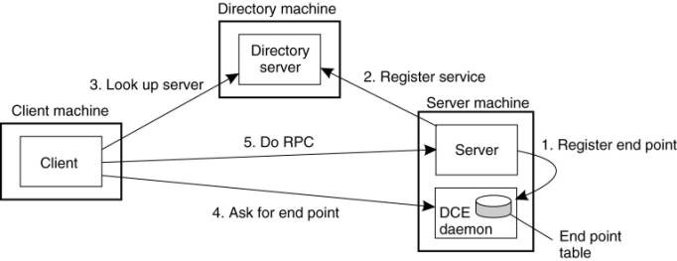
Remote Method Invocation
- The RMI (Remote Method Invocation) is an API that provides a mechanism to create distributed application in java.
- It is a mechanism that allows an object residing in one system (JVM) to access/invoke an object running on another JVM.
- The RMI provides remote communication between the applications using two objects stub and skeleton.

RMI Architecture
The RMI system consists of 3 layers in the architecture:
    - stub/skeleton layer.
    - Remote Reference layer
    - Transport layer.

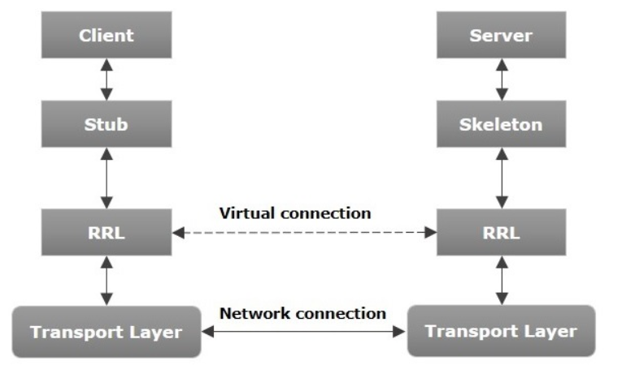
Figure:RMI architecutre
- RMI uses stub and skeleton object for communication with the remote object.
- A remote object is an object whose method can be invoked from another JVM.
Stub:
- The stub is an object, acts as a gateway for the client side.
- All the outgoing requests are routed through it.
- It resides at the client side and represents the remote object.
- When the caller invokes method on the stub object, it does the following tasks:
    - It initiates a connection with remote Virtual Machine (JVM),
    - It writes and transmits (marshals) the parameters to the remote Virtual Machine (JVM),
    - It waits for the result
    - It reads (unmarshals) the return value or exception, and
    - It finally, returns the value to the caller.
Skeleton
- The skeleton is an object, acts as a gateway for the server side object.
- All the incoming requests are routed through it.
- When the skeleton receives the incoming request, it does the following tasks:
    - It reads the parameter for the remote method
    - It invokes the method on the actual remote object, and
    - It writes and transmits (marshals) the result to the caller.

Remote Reference Layer
It is responsible for providing ability to support varying remote reference or invocation protocols independent of client stubs and server skeletons.
Transport Layer
Low level layer that ships the marshal streams between different address spaces. Responsible for managing connection:
  - Setting up connections
  - Listening to incoming calls
  - Maintaining table of remote objects that reside in same address space
Working of an RMI Application
- When the client makes a call to the remote object, it is received by the stub which eventually passes this request to the RRL.
- When the client-side RRL receives the request, it invokes a method called invoke() of the object remoteRef. It passes the request to the RRL on the server side.
- The RRL on the server side passes the request to the Skeleton (proxy on the server) which finally invokes the required object on the server.
- The result is passed all the way back to the client.

RMI Registry
- RMI registry is a namespace on which all server objects are placed.
- Each time the server creates an object, it registers this object with the RMIregistry (using bind() or reBind() methods).
- These are registered using a unique name known as bind name.
- To invoke a remote object, the client needs a reference of that object. At that time, the client fetches the object from the registry using its bind name (using lookup() method).
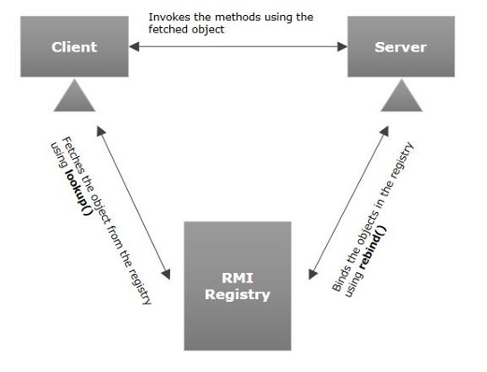

Message-Oriented Communication
Message-Oriented Transient Communication
· Message-oriented model using transport layer - transport-level sockets
Socket - communication end point to which an application can write data that are to be sent out over the underlying network, and from which incoming data can be read.
Berkeley Sockets
· Developed in the early 1980s at the University of California at Berkeley.
· It is an API.
· Its implementation is usually requires kernel code.
· It is the de facto standard for communications programming.
· Used for point-to-point communications between computers through an inter-systems pipe. Namely can use the UNIX read, write, close, select, etc. system calls.
· There are higher level tools for programs that span more than one machine. (e.g. RPC, DCOM ).
· Supports broadcast.
· Available on every UNIX system that I know of and somewhat available in WIN32.
· Built for client/server development.
· Supports two types of communications that sit on top of the TCP Internet datagrams.
§ TCP - connection oriented, stream, reliable.
§ UDP - connectionless, record oriented, unreliable.
The socket primitives for TCP/IP.
Primitive Meaning

Socket | Create a new communication end point
Bind | Attach a local address to a socket
Listen | Announce willingness to accept connections
Accept | Block caller until a connection request arrives
Connect | Actively attempt to establish a connection
Send | Send some data over the connection
Receive | Receive some data over the connection
Close | Release the connection
Write | Send data on the connection
Read | Get data that was sent on the connection

Servers execute the first four primitives - in the order given.
Connection-oriented communication pattern using sockets.
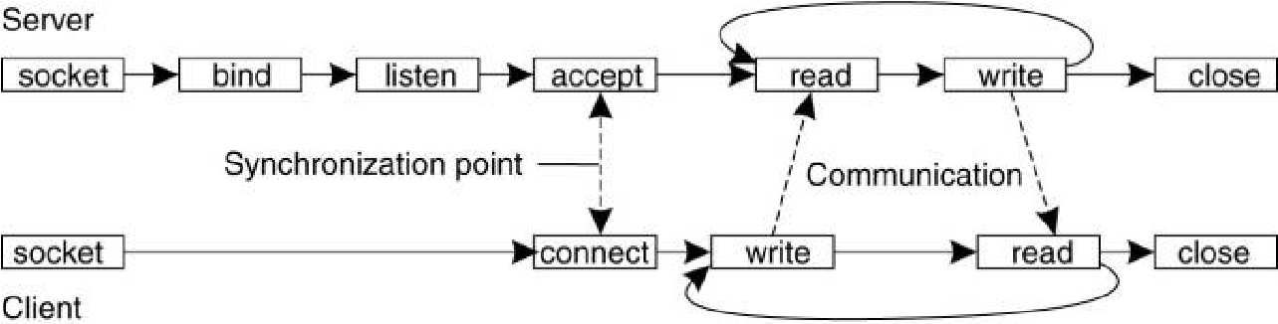

The Message-Passing Interface (MPI)
· The Message Passing Interface (MPI) is a library specification for message passing.
· It is a standard API that can be used to create applications for high-performance multicomputers.
· Specific network protocols (not TCP/IP)
Message-based communication
· Primitives for all 4 forms of transient communication (+ variations)
· Over 100 functions
· Vendors + Open Source
-- IBM, Intel, TMC, Meiko, Cray, Convex, Ncube, OpenMPI
Some of the message-passing primitives of MPI.
Primitive Meaning

MPI_bsend | Append outgoing message to a local send buffer
MPI_send | Send a message and wait until copied to local or remote buffer
MPI_ssend | Send a message and wait until receipt starts
MPI_sendrecv | Send a message and wait for reply
MPI_isend | Pass reference to outgoing message, and continue
MPI_issend | Pass reference to outgoing message, and wait until receipt starts
MPI_recv | Receive a message; block if there is none
MPI_irecv | Check if there is an incoming message, but do not block

Further Reading:
MPI Standard
Website
Message-Oriented Persistent Communication
- Known as: “Message-queuing systems” or “Message-Oriented Middleware (MOM)”.
- They support persistent, asynchronous communications.
- Typically, transport can take minutes (hours?) as opposed to seconds/milliseconds.
- The basic idea: applications communicate by putting messages into and taking messages out of “message queues”.
- Only guarantee: your message will eventually make it into the receiver’s message queue.
- This leads to “loosely-coupled” communications.
Four combinations for loosely-coupled communications using queues.
Basic interface to a queue in a message-queuing system.
Primitive Meaning

Put Append a message to a specified queue
Get Block until the specified queue is nonempty, and remove the first message
Poll Check a specified queue for messages, and remove the first. Never block
Notify Install a handler to be called when a message is put into the specified queue

General Architecture of a Message-Queuing System
Message-Queuing System Architecture
· Messages are “put into” a source queue.
· They are then “taken from” a destination queue.
· Queues are managed by queue managers
§ They move a message from a source queue to a destination queue.
§ Special queue managers operate as routers or relays: they forward incoming messages to other queue managers. · The general organization of a message-queuing system with routers.
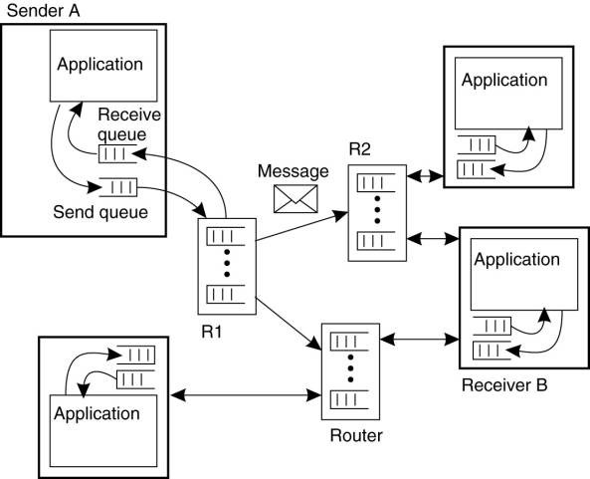
The Role of Message Brokers
· Often, there’s a need to integrate new/existing apps into a “single, coherent Distributed Information System (DIS)”.
· Problem: different message formats exist in legacy systems (cooperation and adherence to open standards was not how things were done in the past).
§ It may not be convenient to “force” legacy systems to adhere to a single, global message format (cost!?).
§ It is often necessary to live with diversity (there’s no choice). · Solution: the “Message Broker”.
Message Brokers (aka “Interface engine”)
· In message-queuing systems, conversions are handled by special nodes in a queuing network, known as message brokers.
· A message broker acts as an application-level gateway in a message-queuing system.
· Purpose - convert incoming messages so that they can be understood by the destination application.
§ Note: a message broker is just another application - not considered to be an integral part of the queuing system.
o Message brokers can be simple ( reformat messages) or complex (find associated applications, convert data) · The general organization of a message broker in a message-queuing system.
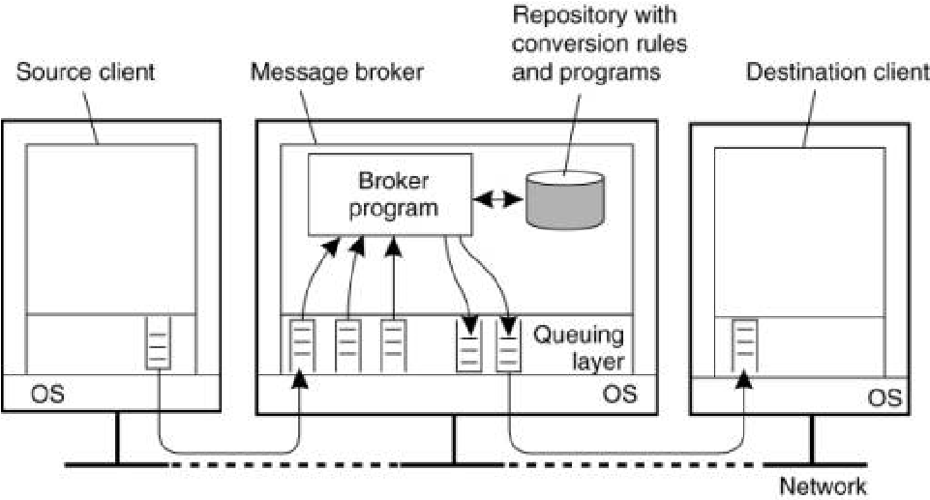
Message-Queuing (MQ) Applications
· General-purpose MQ systems support a wide range of applications, including: – Electronic mail.
- Workflow.
- Groupware.
- Batch Processing.
· Most important MQ application area:
- Integration of a widely dispersed collection of database applications (which is all but impossible to do with traditional RPC/RMI techniques).

Stream-Oriented Communication
· With RPC, RMI and MOM, the effect that time has on correctness is of little consequence.
However, audio and video are time-dependent data streams – if the timing is off, the resulting “output” from the system will be incorrect.
· Time-dependent information – known as “continuous media” communications.
- Example: voice: PCM: 1/44100 sec intervals on playback.
- Example: video: 30 frames per second (30-40 msec per image). · KEY MESSAGE: Timing is crucial!
Transmission Modes
· Asynchronous transmission mode – the data stream is transmitted in order, but there’s no timing constraints placed on the actual delivery (e.g., File Transfer).
· Synchronous transmission mode – the maximum end-to-end delay is defined (but data can travel faster).
· Isochronous transmission mode – data transferred “on time” – there’s a maximum and minimum end-to-end delay (known as “bounded jitter”).
- Known as “streams” – isochronous transmission mode is very useful for multimedia systems.
Two Types of Streams o Simple Streams – one single sequence of data, for example: voice.
- Complex Streams – several sequences of data (substreams) that are “related” by time. · Think of a lip synchronized movie, with sound and pictures, together with sub-titles … · This leads to data synchronization problems … which are not at all easy to deal with.
A general architecture for streaming stored multimedia data over a network.
[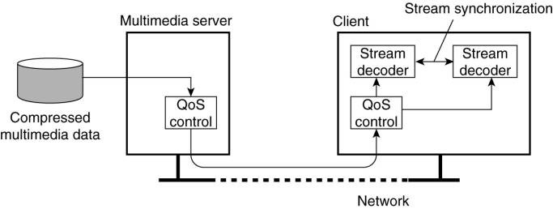
Quality of Service
- Definition: “ensuring that the temporal relationships in the stream can be preserved”.
- QoS is all about three things:
    - Timeliness,
    - Volume and
    - Reliability.
- Most current operating systems and networks do not include the QoS management facilities
- Bleeding edge of the discipline
Must specifying the following :
  - The required bit rate at which data should be transported.
  - The maximum delay until a session has been set up (i.e., when an application can start sending data).
  - The maximum end-to-end delay (i.e., how long it will take until a data unit makes it to a recipient).
  - The maximum delay variance, or jitter.
  - The maximum round-trip delay.

Overlay Networks
An overlay network is a virtual network of nodes and logical links that is built on top of an existing network with the purpose to implement a network service that is not available in the existing network.

Applications of Overlays
- Routing
- Addressing
- Security
- Multicast
- Mobility

Advantages / Disadvantges
· Do not have to deploy new equipment, or modify existing software/protocols
- probably have to deploy new software on top of existing software
- e.g., adding IP on top of Ethernet does not require modifying Ethernet protocol or driver
- allows bootstrapping
  - expensive to develop entirely new networking hardware/software
  - all networks after the telephone have begun as overlay networks
· Do not have to deploy at every node
- Not every node needs/wants overlay network service all the time
  - e.g., QoS guarantees for best-effort traffic
- Overlay network may be too heavyweight for some nodes
  - e.g., consumes too much memory, cycles, or bandwidth
- Overlay network may have unclear security properties
  - e.g., may be used for service denial attack
- Overlay network may not scale (not exactly a benefit)
  - e.g. may require n2 state or communication
Organization
Two approaches to organization:
- nodes may organize themselves into a tree, meaning that there is a unique (overlay) path between every pair of nodes.
- nodes organize into a mesh network in which every node will have multiple neighbors and there exist multiple paths between every pair of nodes. -> more robust
Example: Multicasting
· Multicasting is the process whereby a source host or protocol entity sends a packet to multiple destinations simultaneously using a single, local 'transmit' operation.
o Unicasting and Broadcasting may be considered to be special cases of Multicasting (with the packet delivered to one destination, or 'all' destinations, respectively).
· Multicast communications refers to one-to-many or many-to many communications. · Multicast implements a one-to-many send operation:
Where to Implement Multicast?
· Network Layer (IP)
· Application Layer
Need for Multicast at Network Layer (IP Multicast):
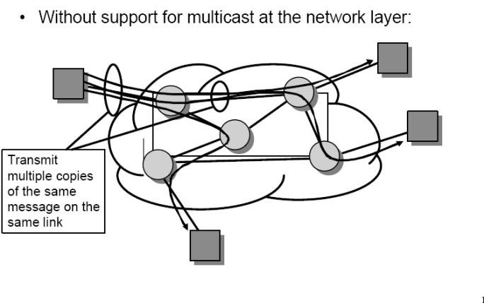

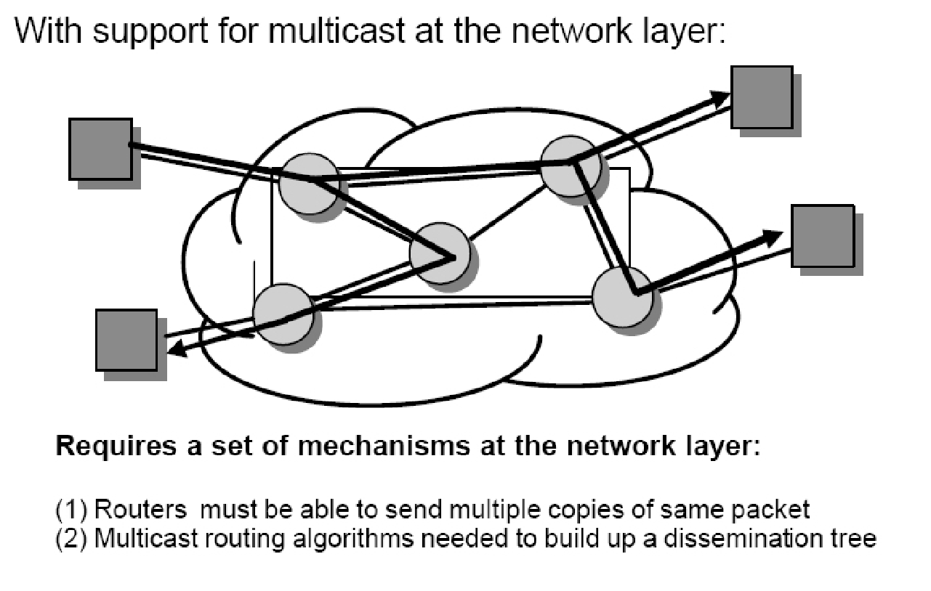
Multicast works at IP Level
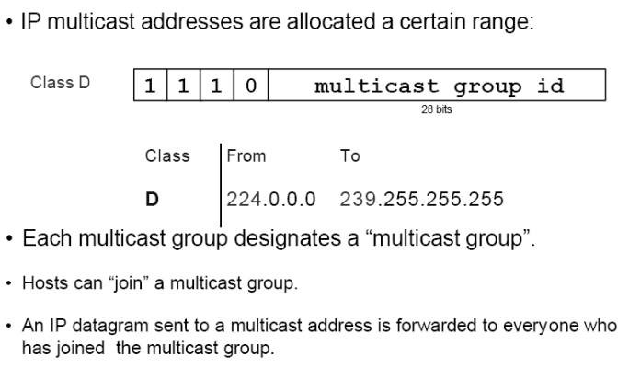
Multicast at Application Layer - overlay network
· Provide multicast functionality above IP layer
· Data is transmitted between neighbors in the overlay
· No multicast needed in overlay network
Advantages
· Scalability o Routers do not maintain per-group state o End systems do, but they participate in very few groups
· Easier to deploy o Only requires adding software to end hosts
· Potentially simplifies support for higher level functionality o Use hop-by-hop approach, but end hosts are routers o Leverage computation and storage of end systems o e.g., packet buffering, transcoding of media streams o Leverage solutions for unicast congestion control and reliability

Overlay Construction Problems
· Dynamic changes in group membership
- Members may join and leave dynamically
- Members may die
· Dynamic changes in network conditions and topology
- Delay between members may vary over time due to congestion, routing changes
· Knowledge of network conditions is member specific
- Each member must determine network conditions for itself
What is the best overlay?
Evaluation criteria:
- Properties of the overlay graph
- Mapping of the overlay to the layer-3 network
- Properties of protocol that maintains the overlay topology

Overlay-based approaches for multicasting
· Build an overlay mesh network and embed trees into the mesh:
· Build a shared tree:
· Build a graph with well-known properties
- N-dimensional torus: CAN
- Hypercube inspired: Chord
- Triangulation: Delaunay Triangulation
Properties of the overlay graph
· • Number of neighbors (routing table size) o Many Distributed Hash Tables (DHTs), hypercubes: O(log N) (max.) o Triangulation graphs: O(N) (max.), 6 (avg.)
  - Meshes, trees: no a priori bound, but bounds can be enforced
· • Path lengths in the overlay o Many DHTs, hypercubes: O(log N) (max.)
  - Triangulation graphs: O(N) (max.), O(vN) (best case avg.) o Meshes, trees: no a priori bound

Metrics
Three performance metrics (see Chu et. al):
· link stress - defined per-link as the number of identical packets flowing over a single link
· stretch or relative delay penalty (RDP) - defined per-member as the ratio of the distance between two members along the overlay and the corresponding direct unicast distance
· tree cost - tree cost is defined per-tree as the sum of the cost of the overlay tree links typically measured in terms of delay

Mapping of the overlay to the OSI layer-3 network
· Compare overlay multicast to network-layer multicast:
- “Stretch”: Ratio of delay to shortest path delay
- “Stress”: Number of duplicate transmissions over a physical link
· Overlays that provide a good mapping need to be aware of the underlying layer-3 network
· Experiments described in Helder and Jamin (2002) show that the resulting tree is indeed close to a minimal spanning one. · Tan et al. (2003) provide an extensive overview and evaluation of various solutions to this problem

