Practical Assignment 2

NAME: Vaishnavi Gosavi

SEM: 7TH SEM I.T

DIV: A

ROLL NO: 24

SUBJECT: APPLICATION DEVELOPMENT USING FULL STACK [705]

OUTPUT 1

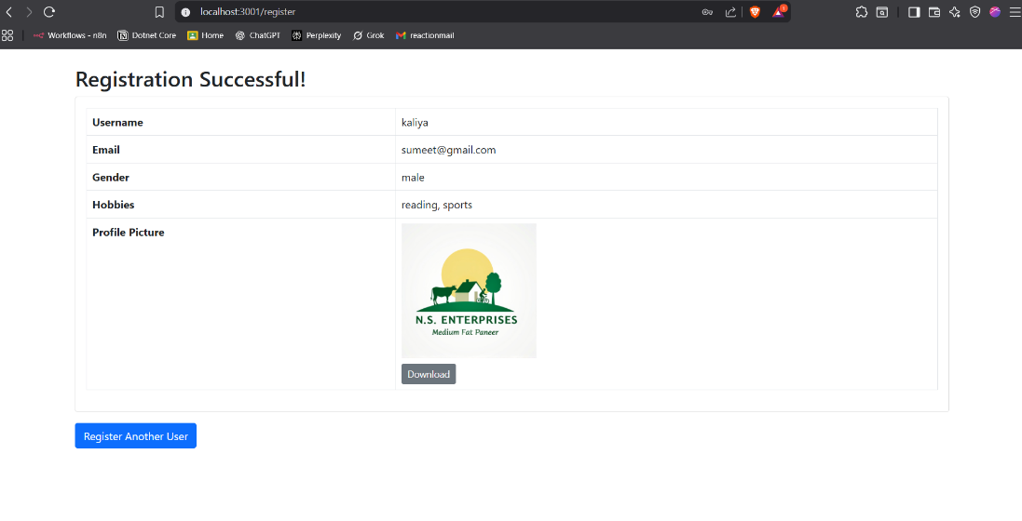

Output 2

jptwn

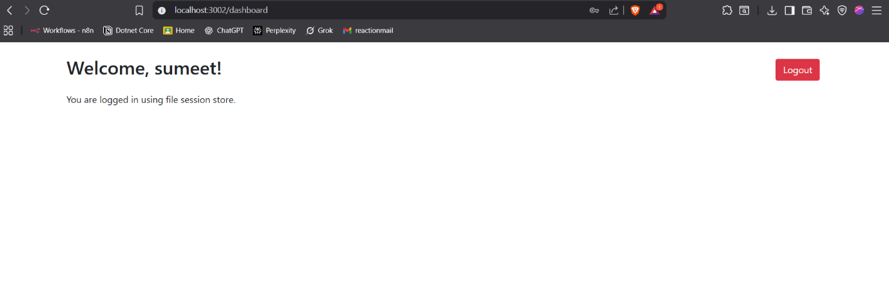

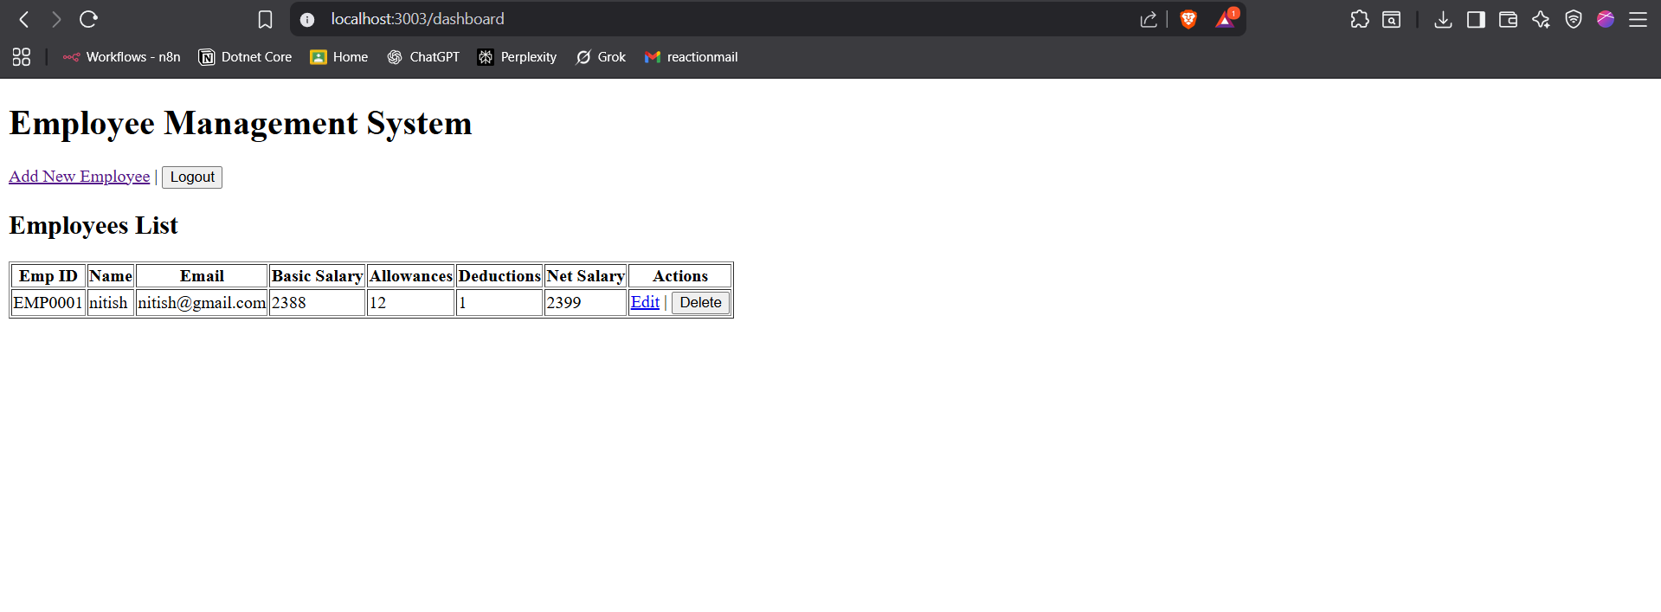OUTPUT 4

OUTPUT 5

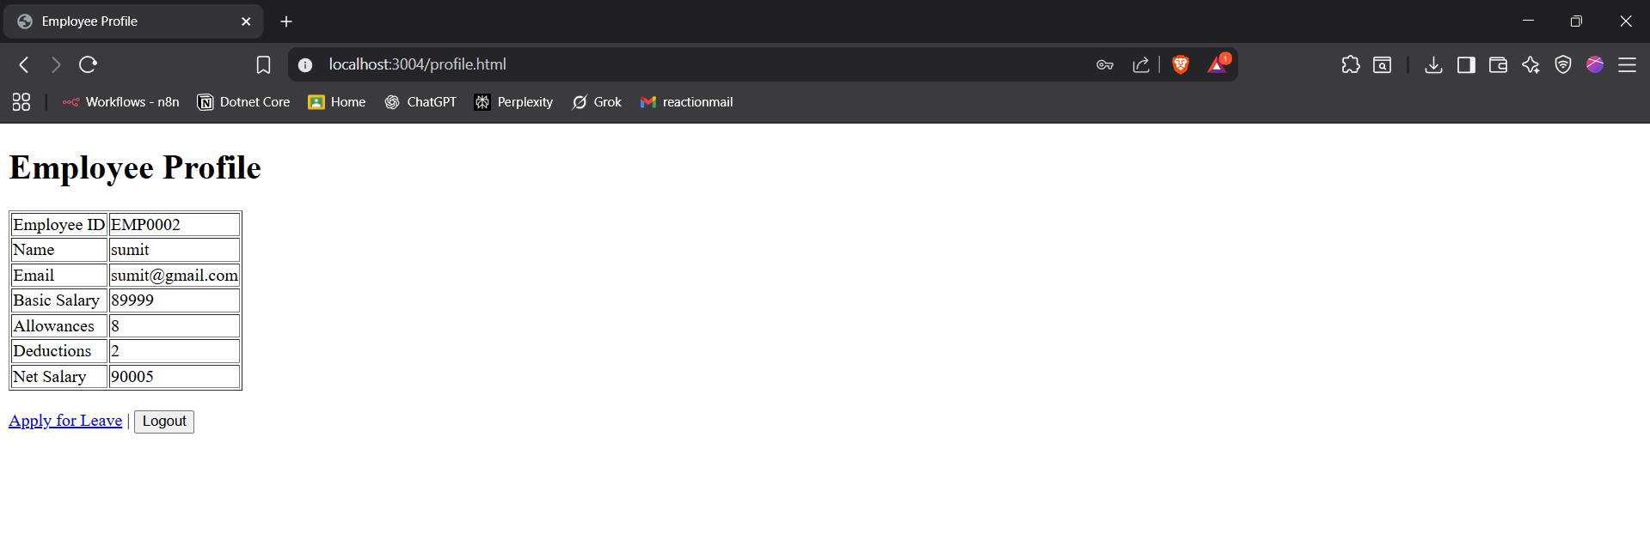

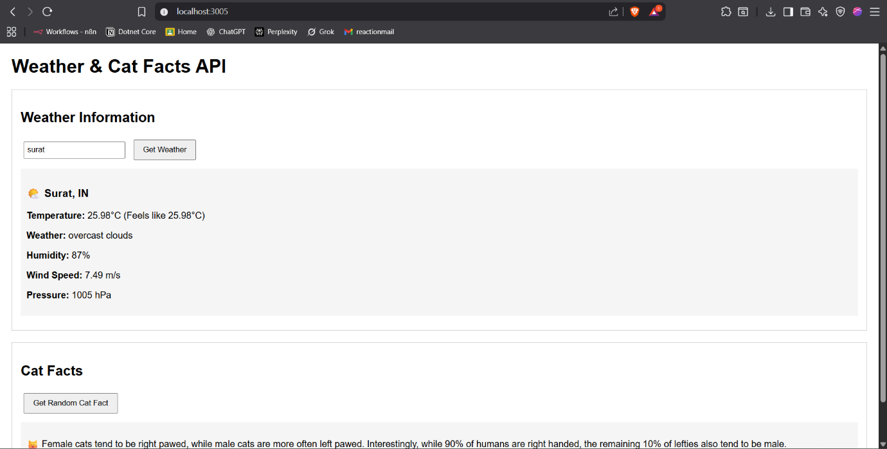Output 6

Output 7

