**Exercise 1: Implementing the Singleton Pattern**

***Logger.java***

public class Logger {

private static Logger singleInstance;

private Logger() {

System.out.println("Logger Initialized");

}

public static Logger getInstance() {

if (singleInstance == null) {

singleInstance = new Logger();

}

return singleInstance;

}

public void msg(String message) {

System.out.println("Log: " + message);

}

}

***Main.java***

public class Main {

public static void main(String[] args) {

Logger logger1 = Logger.getInstance();

Logger logger2 = Logger.getInstance();

logger1.log ("First log message");

logger2.log ("Second log message");

if (logger1 == logger2) {

System.out.println ("Both logger instances are the same (Singleton works)");

} else {

System.out.println ("Different instances (Singleton failed)");

}

}

}

Output:

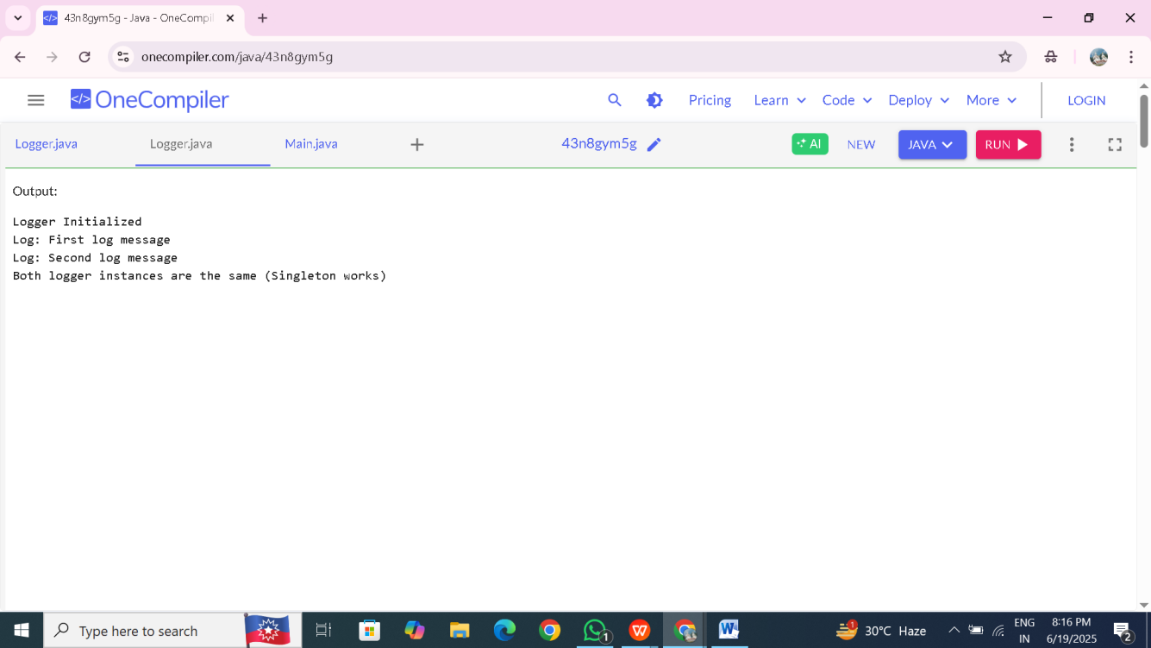

**Exercise 2: Implementing the Factory Method Pattern**

//Document.java

public interface Document {

void open();

}

//WordDocument.java

public class WordDocument implements Document {

@Override

public void open() {

System.out.println("Opening a Word document.");

}

}

//PdfDocument.java

public class PdfDocument implements Document {

@Override

public void open() {

System.out.println("Opening a PDF document.");

}

}

//ExcelDocument.java

public class ExcelDocument implements Document {

@Override

public void open() {

System.out.println("Opening an Excel document.");

}

}

//DocumentFactory.java

public abstract class DocumentFactory {

public abstract Document createDocument();

}

//WordDocumentFactory.java

public class WordDocumentFactory extends DocumentFactory {

@Override

public Document createDocument() {

return new WordDocument();

}

}

//PdfDocumentFactory.java

public class PdfDocumentFactory extends DocumentFactory {

@Override

public Document createDocument() {

return new PdfDocument();

}

}

//ExcelDocumentFactory.java

public class ExcelDocumentFactory extends DocumentFactory {

@Override

public Document createDocument() {

return new ExcelDocument();

}

}

//Main.java

public class Main {

public static void main(String[] args) {

DocumentFactory wordFactory = new WordDocumentFactory();

Document wordDoc = wordFactory.createDocument();

wordDoc.open();

DocumentFactory pdfFactory = new PdfDocumentFactory();

Document pdfDoc = pdfFactory.createDocument();

pdfDoc.open();

DocumentFactory excelFactory = new ExcelDocumentFactory();

Document excelDoc = excelFactory.createDocument();

excelDoc.open();

}

}

**output:**

