4. Git Conflicts
- Move to project folder
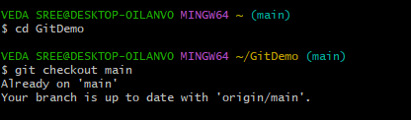

- Create a branch “GitWork”. Add a file “hello.xml”.
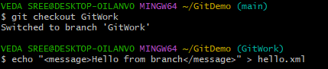

- Update the content of “hello.xml” and observe the status
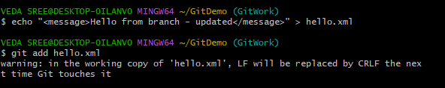
- Commit the changes to reflect in the branch and switch to master
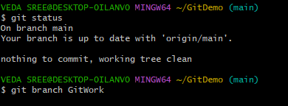

- Add a file “hello.xml” to the master and add some different content than previous and commit the changes to master
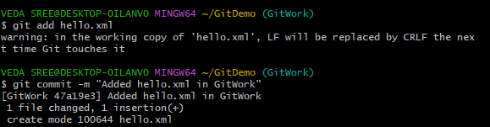
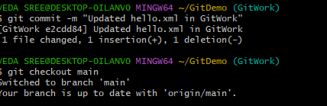

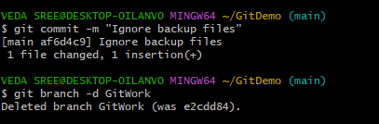


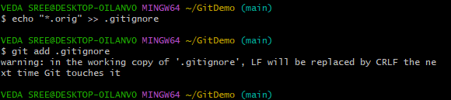
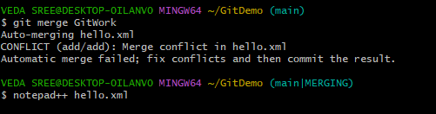
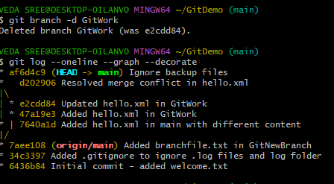

- Commit the changes to the master, once done with conflict

- Observe the git status and add backup file to the .gitignore file.
Commit the changes to the .gitignore
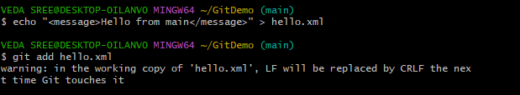
- List out all the available branches
- Delete the branch, which merge to master.
- Observe the log by executing “git log –oneline –graph –decorate”
