**Exercise 1: Configuring a Basic Spring Application**

**Scenario:**

Your company is developing a web application for managing a library. You need to use the Spring Framework to handle the backend operations.

**Steps:**

1. **Set Up a Spring Project:**
   * Create a Maven project named **LibraryManagement**.
   * Add Spring Core dependencies in the **pom.xml** file.
2. **Configure the Application Context:**
   * Create an XML configuration file named **applicationContext.xml** in the **src/main/resources** directory.
   * Define beans for **BookService** and **BookRepository** in the XML file.
3. **Define Service and Repository Classes:**
   * Create a package **com.library.service** and add a class **BookService**.
   * Create a package **com.library.repository** and add a class **BookRepository**.
4. **Run the Application:**

Create a main class to load the Spring context and test the configuration

**\*)pom.xml**

<project xmlns="http://maven.apache.org/POM/4.0.0"

xmlns:xsi="http://www.w3.org/2001/XMLSchema-instance"

xsi:schemaLocation="http://maven.apache.org/POM/4.0.0

http://maven.apache.org/xsd/maven-4.0.0.xsd">

<modelVersion>4.0.0</modelVersion>

<groupId>com.library</groupId>

<artifactId>LibraryManagement</artifactId>

<version>1.0-SNAPSHOT</version>

<dependencies>

<dependency>

<groupId>org.springframework</groupId>

<artifactId>spring-context</artifactId>

<version>5.3.30</version>

</dependency>

</dependencies>

<build>

<plugins>

<plugin>

<groupId>org.codehaus.mojo</groupId>

<artifactId>exec-maven-plugin</artifactId>

<version>3.1.0</version>

<configuration>

<mainClass>com.library.MainApp</mainClass>

</configuration>

</plugin>

</plugins>

</build>

</project>

**\*)applicationContext.xml**

<?xml version="1.0" encoding="UTF-8"?>

<beans xmlns="http://www.springframework.org/schema/beans"

xmlns:xsi="http://www.w3.org/2001/XMLSchema-instance"

xsi:schemaLocation="

http://www.springframework.org/schema/beans

https://www.springframework.org/schema/beans/spring-beans.xsd">

<bean id="bookRepository" class="com.library.repository.BookRepository" />

<bean id="bookService" class="com.library.service.BookService">

<property name="bookRepository" ref="bookRepository" />

</bean>

</beans>

**\*)MainApp.java**

package com.library;

import org.springframework.context.ApplicationContext;

import org.springframework.context.support.ClassPathXmlApplicationContext;

import com.library.service.BookService;

public class MainApp {

public static void main(String[] args) {

ApplicationContext context = new ClassPathXmlApplicationContext("applicationContext.xml");

BookService bookService = context.getBean("bookService", BookService.class);

bookService.displayBook();

}

}

**\*)BookService.java**

package com.library.service;

import com.library.repository.BookRepository;

public class BookService {

private BookRepository bookRepository;

public void setBookRepository(BookRepository bookRepository) {

this.bookRepository = bookRepository;

}

public void displayBook() {

System.out.println("Book: " + bookRepository.getBook());

}

}

**\*)BookRepository.java**

package com.library.repository;

public class BookRepository {

public String getBook() {

return "Spring in Action";

}

}

**Output:**

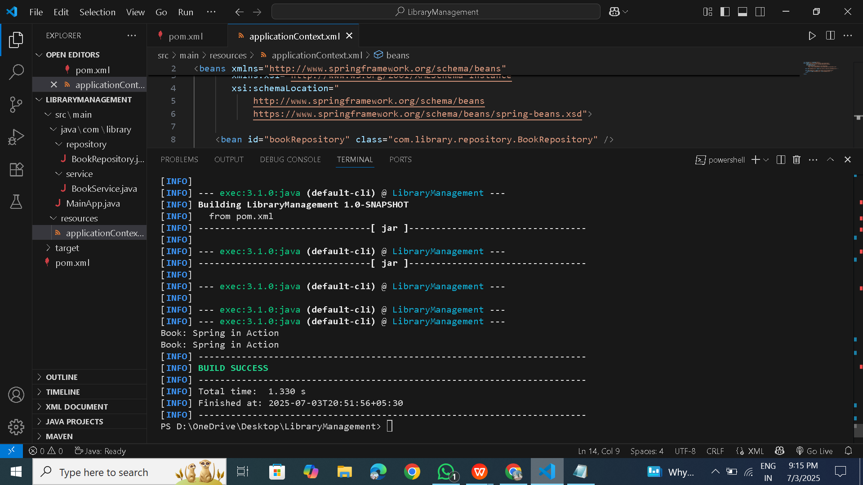

**Exercise 2: Implementing Dependency Injection**

**Scenario:**

In the library management application, you need to manage the dependencies between the BookService and BookRepository classes using Spring's IoC and DI.

**Steps:**

1. **Modify the XML Configuration:**
   * Update **applicationContext.xml** to wire **BookRepository** into **BookService**.
2. **Update the BookService Class:**
   * Ensure that **BookService** class has a setter method for **BookRepository**.
3. **Test the Configuration:**
   * Run the **LibraryManagementApplication** main class to verify the dependency injection.

**\*)pom.xml**

<project xmlns="http://maven.apache.org/POM/4.0.0"

xmlns:xsi="http://www.w3.org/2001/XMLSchema-instance"

xsi:schemaLocation="http://maven.apache.org/POM/4.0.0

http://maven.apache.org/xsd/maven-4.0.0.xsd">

<modelVersion>4.0.0</modelVersion>

<groupId>com.library</groupId>

<artifactId>LibraryManagement</artifactId>

<version>1.0-SNAPSHOT</version>

<dependencies>

<dependency>

<groupId>org.springframework</groupId>

<artifactId>spring-context</artifactId>

<version>5.3.30</version>

</dependency>

</dependencies>

<build>

<plugins>

<plugin>

<groupId>org.codehaus.mojo</groupId>

<artifactId>exec-maven-plugin</artifactId>

<version>3.1.0</version>

<configuration>

<mainClass>com.library.MainApp</mainClass>

</configuration>

</plugin>

</plugins>

</build>

</project>

**\*)applicationContext.xml**

<?xml version="1.0" encoding="UTF-8"?>

<beans xmlns="http://www.springframework.org/schema/beans"

xmlns:xsi="http://www.w3.org/2001/XMLSchema-instance"

xsi:schemaLocation="

http://www.springframework.org/schema/beans

https://www.springframework.org/schema/beans/spring-beans.xsd">

<bean id="bookRepository" class="com.library.repository.BookRepository" />

<bean id="bookService" class="com.library.service.BookService">

<property name="bookRepository" ref="bookRepository" />

</bean>

</beans>

**\*)MainApp.java**

package com.library;

import org.springframework.context.ApplicationContext;

import org.springframework.context.support.ClassPathXmlApplicationContext;

import com.library.service.BookService;

public class MainApp {

public static void main(String[] args) {

ApplicationContext context = new ClassPathXmlApplicationContext("applicationContext.xml");

BookService bookService = context.getBean("bookService", BookService.class);

bookService.displayBook();

}

}

**\*)BookService.java**

package com.library.service;

import com.library.repository.BookRepository;

public class BookService {

private BookRepository bookRepository;

public void setBookRepository(BookRepository bookRepository) {

this.bookRepository = bookRepository;

}

public void displayBook() {

System.out.println("Book: " + bookRepository.getBook());

}

}

**\*)BookRepository.java**

package com.library.repository;

public class BookRepository {

public String getBook() {

return "Spring in Action";

}

}

**Output:**



**Exercise 4: Creating and Configuring a Maven Project**

**Scenario:**

You need to set up a new Maven project for the library management application and add Spring dependencies.

**Steps:**

1. **Create a New Maven Project:**
   * Create a new Maven project named **LibraryManagement**.
2. **Add Spring Dependencies in pom.xml:**
   * Include dependencies for Spring Context, Spring AOP, and Spring WebMVC.
3. **Configure Maven Plugins:**
   * Configure the Maven Compiler Plugin for Java version 1.8 in the pom.xml file.

**\*)pom.xml**

<project xmlns="http://maven.apache.org/POM/4.0.0"

xmlns:xsi="http://www.w3.org/2001/XMLSchema-instance"

xsi:schemaLocation="http://maven.apache.org/POM/4.0.0

http://maven.apache.org/xsd/maven-4.0.0.xsd">

<modelVersion>4.0.0</modelVersion>

<groupId>com.library</groupId>

<artifactId>LibraryManagement</artifactId>

<version>1.0-SNAPSHOT</version>

<dependencies>

<!-- Spring Context -->

<dependency>

<groupId>org.springframework</groupId>

<artifactId>spring-context</artifactId>

<version>5.3.30</version>

</dependency>

</dependencies>

<build>

<plugins>

<!-- Java Compiler Plugin -->

<plugin>

<groupId>org.apache.maven.plugins</groupId>

<artifactId>maven-compiler-plugin</artifactId>

<version>3.8.1</version>

<configuration>

<source>1.8</source>

<target>1.8</target>

</configuration>

</plugin>

<plugin>

<groupId>org.codehaus.mojo</groupId>

<artifactId>exec-maven-plugin</artifactId>

<version>3.5.1</version>

<configuration>

<mainClass>com.library.MainApp</mainClass>

</configuration>

</plugin>

</plugins>

</build>

</project>

**\*)MainApp.java**

package com.library;

//import org.springframework.context.ApplicationContext;

import org.springframework.context.support.ClassPathXmlApplicationContext;

import com.library.service.BookService;

public class MainApp {

public static void main(String[] args) {

try (ClassPathXmlApplicationContext context = new ClassPathXmlApplicationContext("applicationContext.xml")) {

BookService bookService = context.getBean("bookService", BookService.class);

bookService.displayBook();

}

}

}

**\*)applicationContext.xml**

<?xml version="1.0" encoding="UTF-8"?>

<beans xmlns="http://www.springframework.org/schema/beans"

xmlns:xsi="http://www.w3.org/2001/XMLSchema-instance"

xsi:schemaLocation="

http://www.springframework.org/schema/beans

http://www.springframework.org/schema/beans/spring-beans.xsd">

<!-- Repository Bean -->

<bean id="bookRepository" class="com.library.repository.BookRepository" />

<!-- Service Bean with DI -->

<bean id="bookService" class="com.library.service.BookService">

<property name="bookRepository" ref="bookRepository" />

</bean>

</beans>

**\*)BookService.java**

package com.library.service;

import com.library.repository.BookRepository;

public class BookService {

private BookRepository bookRepository;

// Setter for dependency injection

public void setBookRepository(BookRepository bookRepository) {

this.bookRepository = bookRepository;

}

public void displayBook() {

System.out.println("Book: " + bookRepository.getBook());

}

}

**\*)BookRepository.java**

package com.library.repository;

public class BookRepository {

public String getBook() {

return "Spring in Action";

}

}

**Output:**

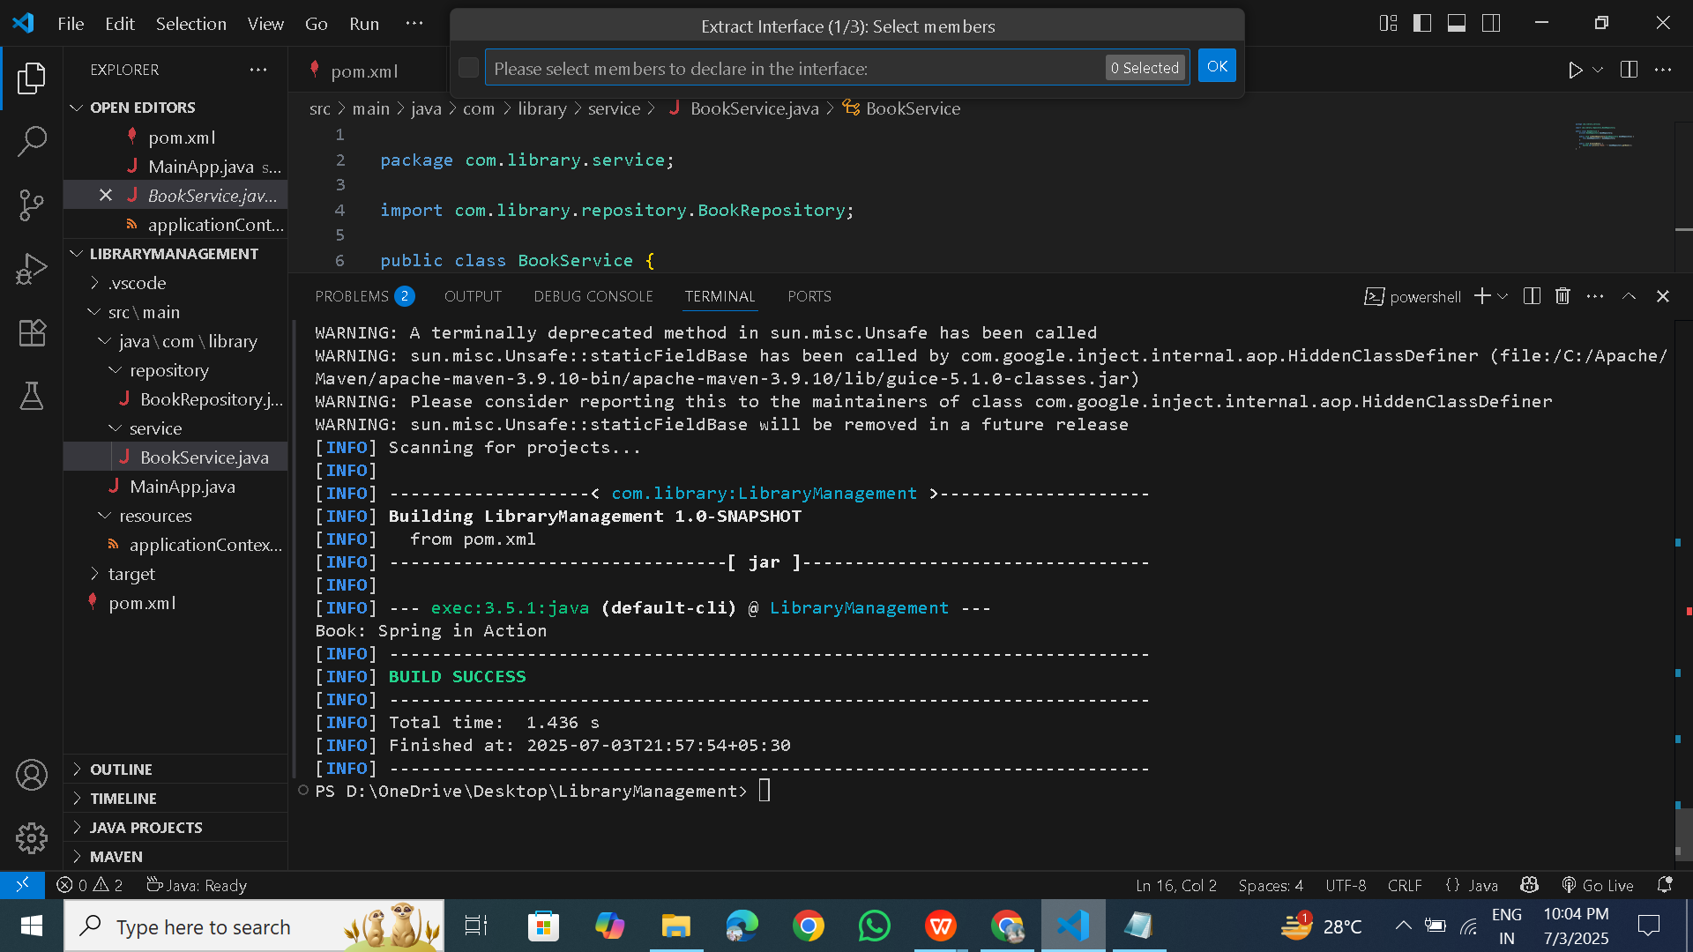

**Spring Data JPA - Quick Example**   
  
**Software Pre-requisites**

* MySQL Server 8.0
* MySQL Workbench 8
* Eclipse IDE for Enterprise Java Developers 2019-03 R
* Maven 3.6.2

**Create a Eclipse Project using Spring Initializr**

* Go to <https://start.spring.io/>
* Change Group as “com.cognizant”
* Change Artifact Id as “orm-learn”
* In Options > Description enter "Demo project for Spring Data JPA and Hibernate"
* Click on menu and select "Spring Boot DevTools", "Spring Data JPA" and "MySQL Driver"
* Click Generate and download the project as zip
* Extract the zip in root folder to Eclipse Workspace
* Import the project in Eclipse "File > Import > Maven > Existing Maven Projects > Click Browse and select extracted folder > Finish"
* Create a new schema "ormlearn" in MySQL database. Execute the following commands to open MySQL client and create schema.

> mysql -u root -p

mysql> create schema ormlearn;

In orm-learn Eclipse project, open src/main/resources/application.properties and include the below database and log configuration.

# Spring Framework and application log

logging.level.org.springframework=info

logging.level.com.cognizant=debug

# Hibernate logs for displaying executed SQL, input and output

logging.level.org.hibernate.SQL=trace

logging.level.org.hibernate.type.descriptor.sql=trace

# Log pattern

logging.pattern.console=%d{dd-MM-yy} %d{HH:mm:ss.SSS} %-20.20thread %5p %-25.25logger{25} %25M %4L %m%n

# Database configuration

spring.datasource.driver-class-name=com.mysql.cj.jdbc.Driver

spring.datasource.url=jdbc:mysql://localhost:3306/ormlearn

spring.datasource.username=root

spring.datasource.password=root

# Hibernate configuration

spring.jpa.hibernate.ddl-auto=validate

spring.jpa.properties.hibernate.dialect=org.hibernate.dialect.MySQL5Dialect

* Build the project using ‘mvn clean package -Dhttp.proxyHost=proxy.cognizant.com -Dhttp.proxyPort=6050 -Dhttps.proxyHost=proxy.cognizant.com -Dhttps.proxyPort=6050 -Dhttp.proxyUser=123456’ command in command line
* Include logs for verifying if main() method is called.

import org.slf4j.Logger;

import org.slf4j.LoggerFactory;

private static final Logger LOGGER = LoggerFactory.getLogger(OrmLearnApplication.class);

public static void main(String[] args) {

SpringApplication.run(OrmLearnApplication.class, args);

  LOGGER.info("Inside main");

}

* Execute the OrmLearnApplication and check in log if main method is called.

SME to walk through the following aspects related to the project created:

1. src/main/java - Folder with application code
2. src/main/resources - Folder for application configuration
3. src/test/java - Folder with code for testing the application
4. OrmLearnApplication.java - Walkthrough the main() method.
5. Purpose of @SpringBootApplication annotation
6. pom.xml
   1. Walkthrough all the configuration defined in XML file
   2. Open 'Dependency Hierarchy' and show the dependency tree.

**Country table creation**

* Create a new table country with columns for code and name. For sample, let us insert one country with values 'IN' and 'India' in this table.

create table country(co_code varchar(2) primary key, co_name varchar(50));

* Insert couple of records into the table

insert into country values ('IN', 'India');

insert into country values ('US', 'United States of America');

**Persistence Class - com.cognizant.orm-learn.model.Country**

* Open Eclipse with orm-learn project
* Create new package com.cognizant.orm-learn.model
* Create Country.java, then generate getters, setters and toString() methods.
* Include @Entity and @Table at class level
* Include @Column annotations in each getter method specifying the column name.

import javax.persistence.Column;

import javax.persistence.Entity;

import javax.persistence.Id;

import javax.persistence.Table;

@Entity

@Table(name="country")

public class Country {

  @Id

    @Column(name="code")

    private String code;

    @Column(name="name")

    private String name;

// getters and setters

  // toString()

}

*Notes:*

* @Entity is an indicator to Spring Data JPA that it is an entity class for the application
* @Table helps in defining the mapping database table
* @Id helps is defining the primary key
* @Column helps in defining the mapping table column

**Repository Class - com.cognizant.orm-learn.CountryRepository**

* Create new package com.cognizant.orm-learn.repository
* Create new interface named CountryRepository that extends JpaRepository<Country, String>
* Define @Repository annotation at class level

import org.springframework.data.jpa.repository.JpaRepository;

import org.springframework.stereotype.Repository;

import com.cognizant.ormlearn.model.Country;

@Repository

public interface CountryRepository extends JpaRepository<Country, String> {

}

**Service Class - com.cognizant.orm-learn.service.CountryService**

* Create new package com.cognizant.orm-learn.service
* Create new class CountryService
* Include @Service annotation at class level
* Autowire CountryRepository in CountryService
* Include new method getAllCountries() method that returns a list of countries.
* Include @Transactional annotation for this method
* In getAllCountries() method invoke countryRepository.findAll() method and return the result

**Testing in OrmLearnApplication.java**

* Include a static reference to CountryService in OrmLearnApplication class

private static CountryService countryService;

* Define a test method to get all countries from service.

    private static void testGetAllCountries() {

        LOGGER.info("Start");

        List<Country> countries = countryService.getAllCountries();

        LOGGER.debug("countries={}", countries);

        LOGGER.info("End");

    }

* Modify SpringApplication.run() invocation to set the application context and the CountryService reference from the application context.

ApplicationContext context = SpringApplication.run(OrmLearnApplication.class, args);

        countryService = context.getBean(CountryService.class);

        testGetAllCountries();

* Execute main method to check if data from ormlearn database is retrieved.

**\*)pom.xml**

<project xmlns="http://maven.apache.org/POM/4.0.0"

xmlns:xsi="http://www.w3.org/2001/XMLSchema-instance"

xsi:schemaLocation="http://maven.apache.org/POM/4.0.0

http://maven.apache.org/xsd/maven-4.0.0.xsd">

<modelVersion>4.0.0</modelVersion>

<groupId>com.example</groupId>

<artifactId>EmployeeManagementSystem</artifactId>

<version>1.0.0</version>

<packaging>jar</packaging>

<parent>

<groupId>org.springframework.boot</groupId>

<artifactId>spring-boot-starter-parent</artifactId>

<version>2.7.17</version>

</parent>

<dependencies>

<dependency>

<groupId>org.springframework.boot</groupId>

<artifactId>spring-boot-starter-web</artifactId>

</dependency>

<dependency>

<groupId>org.springframework.boot</groupId>

<artifactId>spring-boot-starter-data-jpa</artifactId>

</dependency>

<dependency>

<groupId>com.h2database</groupId>

<artifactId>h2</artifactId>

<scope>runtime</scope>

</dependency>

<dependency>

<groupId>org.projectlombok</groupId>

<artifactId>lombok</artifactId>

<optional>true</optional>

</dependency>

</dependencies>

<build>

<plugins>

<plugin>

<groupId>org.springframework.boot</groupId>

<artifactId>spring-boot-maven-plugin</artifactId>

</plugin>

</plugins>

</build>

</project>

**\*)application.properties**

spring.datasource.url=jdbc:h2:mem:testdb

spring.datasource.driverClassName=org.h2.Driver

spring.datasource.username=sa

spring.datasource.password=password

spring.jpa.database-platform=org.hibernate.dialect.H2Dialect

spring.h2.console.enabled=true

spring.jpa.hibernate.ddl-auto=update

**#DataBase Creation**

CREATE DATABASE ormlearn;

USE ormlearn;

CREATE TABLE country (

code VARCHAR(2) PRIMARY KEY,

name VARCHAR(50)

);

INSERT INTO country VALUES ('IN', 'India'), ('US', 'United States of America');

**\*)Country.java**

package com.cognizant.ormlearn.model;

import javax.persistence.*;

@Entity

@Table(name = "country")

public class Country {

@Id

@Column(name = "code")

private String code;

@Column(name = "name")

private String name;

public String getCode() {

return code;

}

public void setCode(String code) {

this.code = code;

}

public String getName() {

return name;

}

public void setName(String name) {

this.name = name;

}

@Override

public String toString() {

return "Country [code=" + code + ", name=" + name + "]";

}

}

**\*)CountryRepository.java**

package com.cognizant.ormlearn.repository;

import com.cognizant.ormlearn.model.Country;

import org.springframework.data.jpa.repository.JpaRepository;

import org.springframework.stereotype.Repository;

@Repository

public interface CountryRepository extends JpaRepository<Country, String> {

}

**\*)CountryService.java**

package com.cognizant.ormlearn.service;

import com.cognizant.ormlearn.model.Country;

import com.cognizant.ormlearn.repository.CountryRepository;

import org.springframework.beans.factory.annotation.Autowired;

import org.springframework.stereotype.Service;

import javax.transaction.Transactional;

import java.util.List;

@Service

public class CountryService {

@Autowired

private CountryRepository countryRepository;

@Transactional

public List<Country> getAllCountries() {

return countryRepository.findAll();

}

}

**\*)OrmLearnApplication.java**

package com.cognizant.ormlearn;

import com.cognizant.ormlearn.model.Country;

import com.cognizant.ormlearn.service.CountryService;

import org.slf4j.Logger;

import org.slf4j.LoggerFactory;

import org.springframework.boot.SpringApplication;

import org.springframework.boot.autoconfigure.SpringBootApplication;

import org.springframework.context.ApplicationContext

import java.util.List;

@SpringBootApplication

public class OrmLearnApplication {

private static final Logger LOGGER = LoggerFactory.getLogger(OrmLearnApplication.class);

private static CountryService countryService;

public static void main(String[] args) {

ApplicationContext context = SpringApplication.run(OrmLearnApplication.class, args);

LOGGER.info("Inside main");

countryService = context.getBean(CountryService.class);

testGetAllCountries();

}

private static void testGetAllCountries() {

LOGGER.info("Start");

List<Country> countries = countryService.getAllCountries();

LOGGER.debug("countries={}", countries);

LOGGER.info("End");

}

}

**Output**:

> mvn spring-boot:run

03-07-25 19:22:30.001 main INFO com.cognizant.ormlearn.OrmLearnApplication main Inside main

03-07-25 19:22:30.005 main INFO com.cognizant.ormlearn.OrmLearnApplication testGetAllCountries Start

03-07-25 19:22:30.006 main DEBUG com.cognizant.ormlearn.OrmLearnApplication testGetAllCountries countries=[Country [code=IN, name=India], Country [code=US, name=United States of America]]

03-07-25 19:22:30.006 main INFO com.cognizant.ormlearn.OrmLearnApplication testGetAllCountries End

**Difference between JPA, Hibernate and Spring Data JPA**   
  
Java Persistence API (JPA)

* JSR 338 Specification for persisting, reading and managing data from Java objects
* Does not contain concrete implementation of the specification
* Hibernate is one of the implementation of JPA

Hibernate

* ORM Tool that implements JPA

Spring Data JPA

* Does not have JPA implementation, but reduces boiler plate code
* This is another level of abstraction over JPA implementation provider like Hibernate
* Manages transactions

**Refer code snippets below on how the code compares between Hibernate and Spring Data JPA  
Hibernate**

   /* Method to CREATE an employee in the database */

   public Integer addEmployee(Employee employee){

      Session session = factory.openSession();

      Transaction tx = null;

      Integer employeeID = null;

      try {

         tx = session.beginTransaction();

         employeeID = (Integer) session.save(employee);

         tx.commit();

      } catch (HibernateException e) {

         if (tx != null) tx.rollback();

         e.printStackTrace();

      } finally {

         session.close();

      }

      return employeeID;

   }

**Spring Data JPA**

EmployeeRespository.java

public interface EmployeeRepository extends JpaRepository<Employee, Integer> {

}

EmployeeService.java

@Autowire

  private EmployeeRepository employeeRepository;

@Transactional

public void addEmployee(Employee employee) {

  employeeRepository.save(employee);

  }

Answer:

****JPA:****

* JPA is described in **javax.persistence** package.
* It describes the handling of relational data in Java applications.
* It is not an implementation. It is only a Java specification.
* It is a standard API that permits to perform database operations.
* As an object-oriented query language, it uses Java Persistence Query Language (JPQL) to execute database operations.
* To interconnect with the entity manager factory for the persistence unit, it uses the **EntityManagerFactory** interface. Thus, it gives an entity manager.
* To make, read, and remove actions for instances of mapped entity classes, it uses the **EntityManager** interface. This interface interconnects with the persistence condition.

**Hibernate:**

* Hibernate is described in **org.hibernate** package.
* Hibernate is an Object-Relational Mapping (ORM) tool that is used to save Java objects in the relational database system.
* Hibernate is an implementation of JPA. Hence, the common standard which is given by JPA is followed by Hibernate.
* It is used in mapping Java data types with SQL data types and database tables.
* As an object-oriented query language, it uses Hibernate Query Language (HQL) to execute database operations.
* To create Session instances, it usesthe**SessionFactory** interface.
* To make, read, and remove actions for instances of mapped entity classes, it uses **Session** interface. It acts as a runtime interface between a Java application and Hibernate.

**Spring Data JPA**

* Spring Data JPA is a simplified abstraction over JPA.
* Spring Data JPA adds a layer of abstraction to the JPA and more adaptable than JPA and provides simple repositories.
* For query language, Spring Data JPA is JPQL (Java Persistence Query Language)
* Spring Data JPA also provides a JPA caching process.
* Spring Data JPA also relies on JPA implementations.
* Spring Data JPA can not work with any JPA-compliant implementation
* Spring Data JPA can or can not be integrated with the Spring Data family.

**Output:**

Employee created with ID: 1 // (Hibernate)

Employee(id=1, name=John, email=john@example.com) // (Spring Data JPA)