Name:D.Vyshnavi
Roll_no:2503A52405
Batch_no:14
Task Description-1: (Classes – Data Validation)
Prompt: AI to generate a student class with attributes: name, roll-no, and marks. Add a method is pass () that returns whether the student has passed (marks ≥ 40).
Input:
class Student:
def __init__(self, name, roll-no, marks):
self.name = name
self. roll-no = roll-no
self. marks = marks

def is pass(self):
return self. marks >= 40

student1 = Student ("Rahul", 101, 75)
student2 = Student ("Priya", 102, 35)

print ("Student:", student1.name)
print ("Roll No:", student1.roll_no)
print ("Marks:", student1.marks)
print ("Pass:", student1.is pass ())

print (" Student:", student2.name)
print ("Roll No:", student2.roll_no)
print ("Marks:", student2.marks)
print ("Pass:", student2.ispass())
Output:
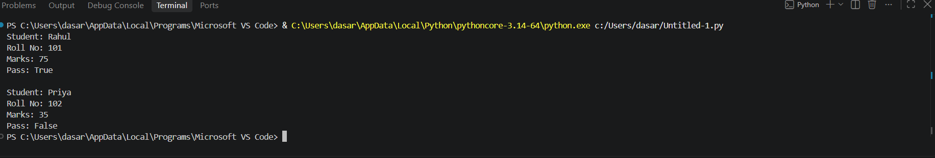
Task Description-2 (Loops – Pattern Generation)
Prompt: AI to generate a function that prints a right-angled triangle star pattern using a for loop. Then regenerate the same pattern using a while loop.
Input:
def triangle for(n):
for i in range (1, n + 1):
print ("*" * i)
triangle for (5)
def triangle while (n):
i = 1
while i <= n:
print ("*" * i)
i += 1
triangle while (5)
Output:

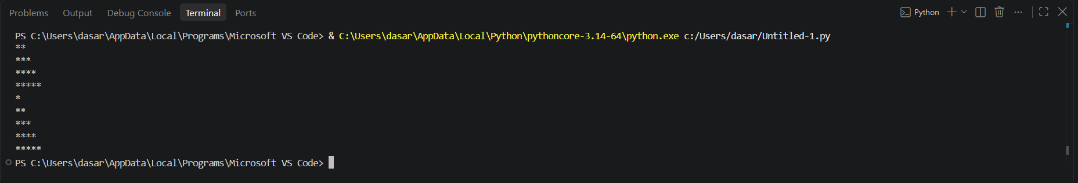
Task Description-3 (Conditional Statements – Number Analysis)
Prompt:AI to write a function that checks whether a given number is positive, negative, or zero using if-elif-else. Test the function with multiple inputs.
Input:
def check_number(number):
if number > 0:
return "Positive"
elif number < 0:
return "Negative"
else:
return "Zero"

numbers = [10, -5, 0, 25, -12]

for number in numbers:
result = check_number(number)
print(number, "is", result)

Output:
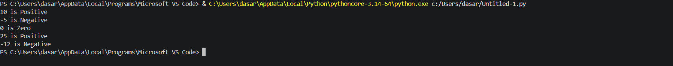

Task Description-4 (Nested Conditionals)
- Prompt: Generate a function check_discount(age, is_member) that determines discount eligibility:
- Age ≥ 60 → Senior discount
- Member → Additional discount
Use nested if statements.
Input:
def check_discount(age, is_member):
if age >= 60:
print("Senior discount eligible")

if is_member:
print("Additional member discount")
else:
print("No additional member discount")

else:
print("Not eligible for senior discount")

if is_member:
print("Member discount eligible")
else:
print("No discount")

print("Customer 1:")
check_discount(65, True)

print("\nCustomer 2:")
check_discount(70, False)

print("\nCustomer 3:")
check_discount(35, True)

print("\nCustomer 4:")
check_discount(30, False)
Output:
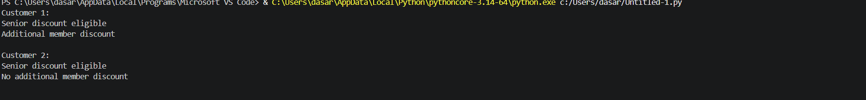

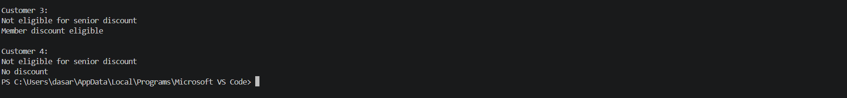

Task Description-5 (Class – Mathematical Opera)
Prompt: Ask AI to create a Circle class with methods to calculate area () and circumference () given the radius.
Input:
import math

class Circle:
def __init__(self, radius):
if radius < 0:
raise ValueError("Radius cannot be negative")
self.radius = radius

def area(self):
return math.pi * self.radius ** 2

def circumference(self):
return 2 * math.pi * self.radius

def __str__(self):
return f"Circle(radius={self.radius})"

c = Circle(5)
print(f"Radius: {c.radius}")
print(f"Area: {c.area():.2f}")
print(f"Circumference: {c.circumference():.2f}")

Output:

