Web Design Application – AI-Assisted HTML/CSS/JS
Generation

NAME:D. Vyshnavi
ROLL.NO:2503A52405
BATCH-NO:14

Task 1 – Portfolio Website Design
You are building a personal portfolio website to showcase your
work.
Requirements:
Create sections for About Me, Projects, and Contact.
Use AI to:
o Suggest color palettes and typography.
o Create a responsive layout with Grid/Flexbox.
o Add smooth scrolling navigation.
PROMPT:
Create a responsive personal portfolio website using HTML,
CSS and JavaScript.

Include About Me, Projects and Contact sections.
Use a professional color palette, modern typography,
CSS Grid/Flexbox and smooth scrolling navigation.
Make the website responsive for mobile and desktop.
CODE:
<!DOCTYPE html>
<html>
<head>
<title>My Portfolio</title>

<style>
* {
margin: 0;
padding: 0;
box-sizing: border-box;
}

html {
scroll-behavior: smooth;
}

body {
font-family: Arial, sans-serif;
background: #f4f7fb;
color: #333;
}

nav {
background: #172554;
padding: 20px;
display: flex;
justify-content: space-between;
align-items: center;
flex-wrap: wrap;
}

nav h2 {
color: white;
}

nav a {
color: white;
text-decoration: none;
margin: 10px;
}

section {
padding: 60px 10%;
text-align: center;
}

#about {
background: #dbeafe;
}

#projects {
background: white;
}

.project-container {
display: grid;
grid-template-columns: repeat(
auto-fit, minmax(200px, 1fr)
);
gap: 20px;
margin-top: 25px;
}

.project {
background: #eff6ff;
padding: 25px;
border-radius: 10px;
}

.project:hover {
transform: translateY(-5px);
transition: 0.3s;
}

#contact {
background: #dbeafe;
}

button {
background: #172554;
color: white;
padding: 12px 25px;
border: none;
border-radius: 5px;
cursor: pointer;
}

@media(max-width: 600px) {
nav {
flex-direction: column;
}

section {
padding: 40px 5%;
}
}
</style>
</head>

<body>

<nav>
<h2>My Portfolio</h2>

<div>
<a href="#about">About</a>
<a href="#projects">Projects</a>
<a href="#contact">Contact</a>
</div>
</nav>

<section id="about">
<h1>About Me</h1>
<br>
<p>Hello! I am a Computer Science student
interested in Artificial Intelligence and Web Development.</p>
</section>

<section id="projects">
<h1>My Projects</h1>

<div class="project-container">

<div class="project">
<h3>Smart Archive</h3>
<p>A cloud storage management project.</p>
</div>

<div class="project">
<h3>Vehicle Service Dashboard</h3>
<p>A dashboard for managing vehicle services.</p>
</div>

<div class="project">
<h3>Portfolio Website</h3>
<p>A personal website using HTML and CSS.</p>
</div>

</div>
</section>

<section id="contact">
<h1>Contact Me</h1>
<br>
<p>Email: student@example.com</p>
<br>
<button onclick="contactMessage()">
Contact
</button>
</section>

<script>
function contactMessage() {
alert("Thank you for visiting my portfolio!");
}
</script>

</body>
</html>
OUTPUT:
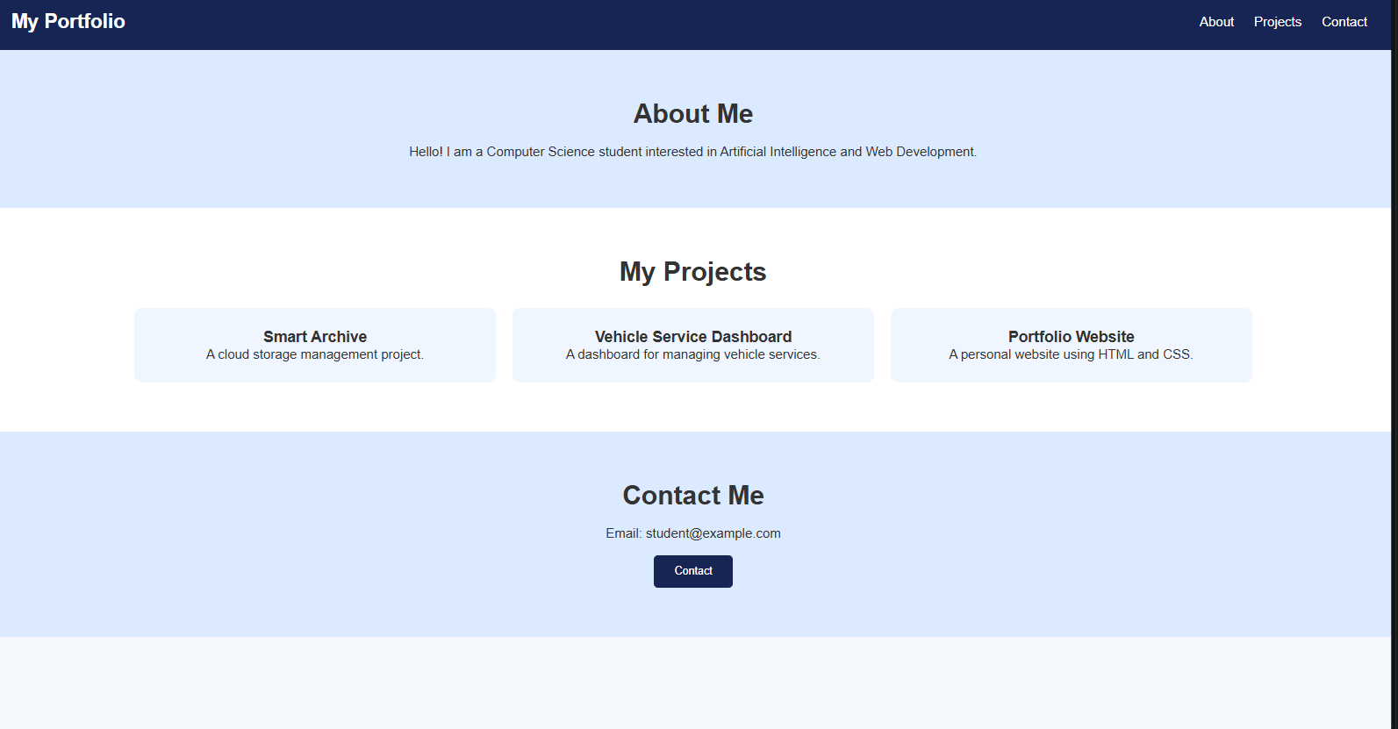
Task 2 – Online Store Product Page
Design a product display page for an online store.
Requirements:
Display product image, title, price, and &quot;Add to Cart&quot; button.
Use AI to:
o Style with BEM methodology.
o Make layout responsive.
o Add hover effects and &quot;Add to Cart&quot; alert.
PROMPT:
Create an online store product page using HTML, CSS and JavaScript.

Display a product image, title, price and Add to Cart button.
Use BEM naming methodology for CSS classes.
Make the page responsive and add hover effects.
When the Add to Cart button is clicked, display an alert.
CODE:
<!DOCTYPE html>
<html>
<head>
<title>Online Store</title>

<style>
* {
box-sizing: border-box;
}

body {
font-family: Arial, sans-serif;
background: #f1f5f9;
text-align: center;
padding: 30px;
}

.product {
background: white;
max-width: 350px;
margin: 30px auto;
padding: 25px;
border-radius: 12px;
box-shadow: 0 4px 12px #ccc;
}

.product__image {
width: 100%;
height: 220px;
object-fit: contain;
}

.product__title {
color: #1e293b;
margin: 15px;
}

.product__price {
color: #16a34a;
font-size: 24px;
font-weight: bold;
}

.product__button {
background: #2563eb;
color: white;
padding: 12px 25px;
border: none;
border-radius: 5px;
cursor: pointer;
margin-top: 15px;
}

.product__button:hover {
background: #1e40af;
transform: scale(1.05);
}

@media(max-width: 500px) {
.product {
width: 100%;
}
}
</style>
</head>

<body>

<h1>Online Shopping Store</h1>

<div class="product">

<img
class="product__image"
src="https://placehold.co/300x220?text=Headphones"
alt="Wireless headphones"
>

<h2 class="product__title">
Wireless Headphones
</h2>

<p class="product__price">₹1,499</p>

<button class="product__button"
onclick="addToCart()">
Add to Cart
</button>

</div>

<script>
function addToCart() {
alert("Product added to cart successfully!");
}
</script>

</body>
</html>
OUTPUT:
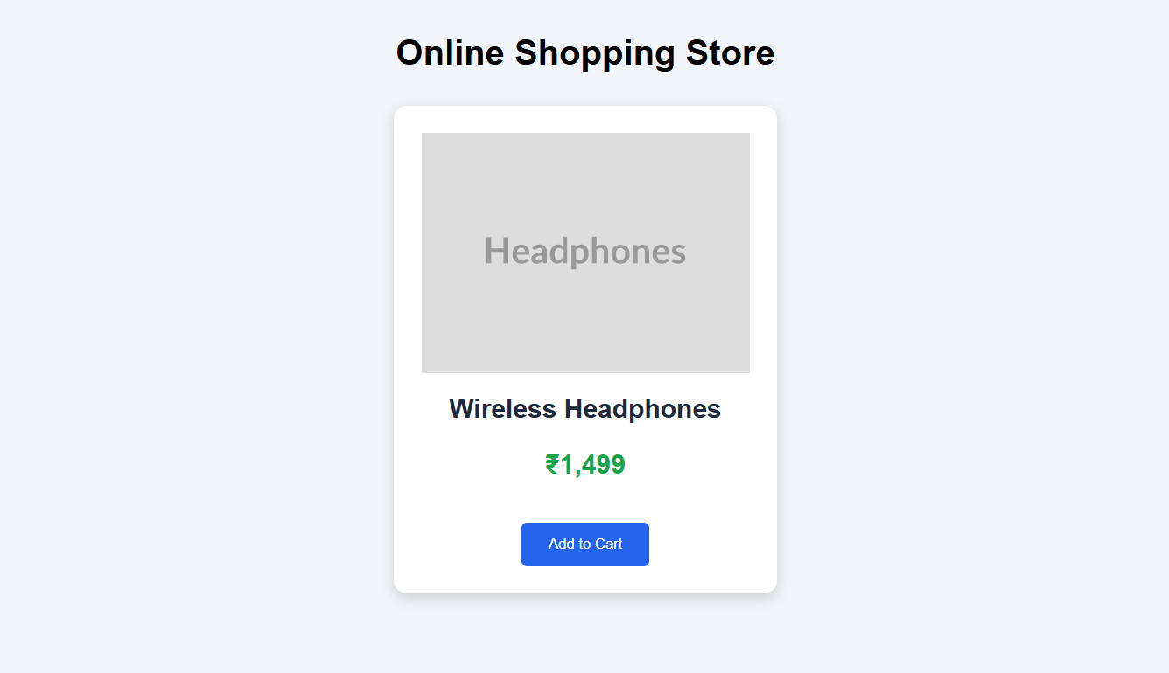
Task 3 – Event Registration Form
Build an event registration form for a conference.
Requirements:
Collect name, email, phone number, and session selection.
Use AI to:
o Add form validation with JavaScript.
o Make the form accessible with labels and ARIA.
o Style with a professional look.
PROMPT:
Create a conference event registration form using HTML,
CSS and JavaScript.

Collect name, email, phone number and session selection.
Add JavaScript form validation.
Use proper labels and ARIA attributes.
Create a professional and responsive design.
Display a success message after valid submission.
CODE:
<!DOCTYPE html>
<html>
<head>
<title>Event Registration</title>

<style>
body {
font-family: Arial, sans-serif;
background: #e0f2fe;
padding: 30px;
}

.form-container {
background: white;
max-width: 450px;
margin: auto;
padding: 30px;
border-radius: 12px;
box-shadow: 0 4px 10px #bbb;
}

h1 {
text-align: center;
color: #075985;
}

label {
display: block;
margin-top: 15px;
}

input, select {
width: 100%;
padding: 12px;
margin-top: 5px;
border: 1px solid #aaa;
border-radius: 5px;
}

button {
width: 100%;
background: #0284c7;
color: white;
padding: 12px;
border: none;
margin-top: 20px;
cursor: pointer;
border-radius: 5px;
}

button:hover {
background: #075985;
}

#message {
text-align: center;
color: green;
margin-top: 15px;
}
</style>
</head>

<body>

<div class="form-container">

<h1>Conference Registration</h1>

<form onsubmit="register(event)">

<label for="name">Full Name:</label>
<input type="text" id="name"
required aria-required="true">

<label for="email">Email:</label>
<input type="email" id="email"
required aria-required="true">

<label for="phone">Phone Number:</label>
<input type="tel" id="phone"
pattern="[0-9]{10}"
title="Enter a 10-digit phone number"
required>

<label for="session">Select Session:</label>

<select id="session" required>
<option value="">Choose Session</option>
<option value="AI">Artificial Intelligence</option>
<option value="Web">Web Development</option>
<option value="Cloud">Cloud Computing</option>
</select>

<button type="submit">
Register Now
</button>

</form>

<p id="message" role="status"
aria-live="polite"></p>

</div>
<script>
function register(event) {
event.preventDefault();
let name = document.getElementById("name").value;
let session = document.getElementById("session").value;

document.getElementById("message").innerHTML =
"Registration Successful! Welcome " +
name + ". Session: " + session
}
</script>
</body>
</html>
OUTPUT:
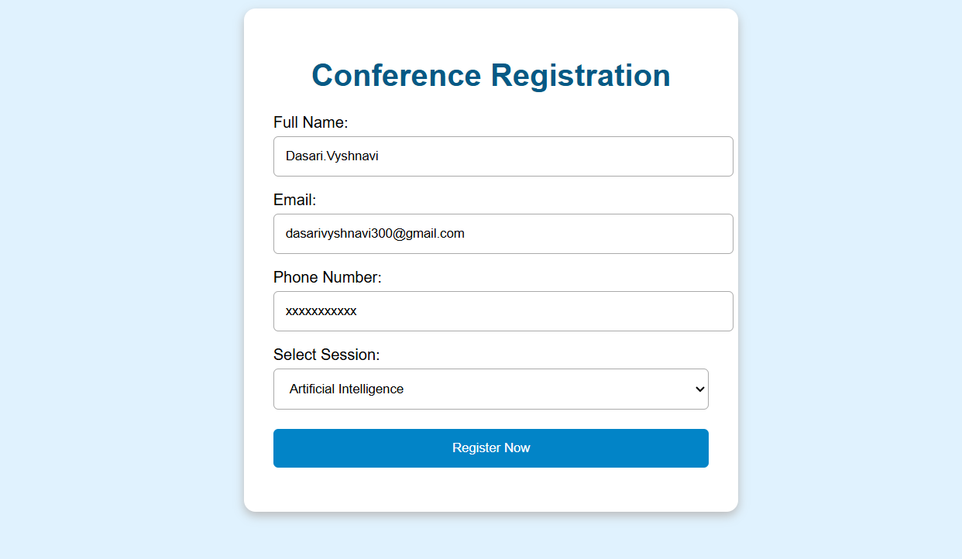
Task 4 – Resume Website
Build a one-page online resume.
Requirements:
Sections: Profile Summary, Skills, Education, Experience.
Use AI to:
o Propose professional typography styles.
o Align sections using CSS Grid.
o Add smooth scroll navigation between sections.
PROMPT:
Create a one-page resume website using HTML, CSS and JavaScript.

Include Profile Summary, Skills, Education and Experience.
Use professional typography and CSS Grid for alignment.
Add smooth scrolling navigation.
Make the website responsive.
CODE:
<!DOCTYPE html>
<html>
<head>
<title>My Resume</title>

<style>
html {
scroll-behavior: smooth;
}

body {
font-family: Arial, sans-serif;
margin: 0;
background: #f8fafc;
color: #333;
}

header {
background: #1e293b;
color: white;
text-align: center;
padding: 30px;
}

nav {
background: #334155;
padding: 15px;
text-align: center;
}

nav a {
color: white;
text-decoration: none;
margin: 12px;
}

.container {
display: grid;
grid-template-columns: 1fr 1fr;
gap: 20px;
padding: 30px;
}

.box {
background: white;
padding: 25px;
border-radius: 10px;
box-shadow: 0 2px 8px #ddd;
}

h2 {
color: #2563eb;
}

@media(max-width: 600px) {
.container {
grid-template-columns: 1fr;
}

nav a {
display: inline-block;
}
}
</style>
</head>

<body>

<header>
<h1>My Resume</h1>
<p>Computer Science Student</p>
</header>

<nav>
<a href="#profile">Profile</a>
<a href="#skills">Skills</a>
<a href="#education">Education</a>
<a href="#experience">Experience</a>
</nav>

<div class="container">

<section class="box" id="profile">
<h2>Profile Summary</h2>
<p>
I am a Computer Science student interested
in programming, AI and web development.
</p>
</section>

<section class="box" id="skills">
<h2>Skills</h2>
<ul>
<li>Python</li>
<li>HTML and CSS</li>
<li>JavaScript</li>
<li>SQL</li>
</ul>
</section>

<section class="box" id="education">
<h2>Education</h2>
<p>B.Tech – Computer Science</p>
<p>Specialization: AI and ML</p>
</section>

<section class="box" id="experience">
<h2>Experience</h2>
<p>Participated in hackathons.</p>
<p>Worked on academic projects.</p>
</section>

</div>

</body>
</html>
OUTPUT:

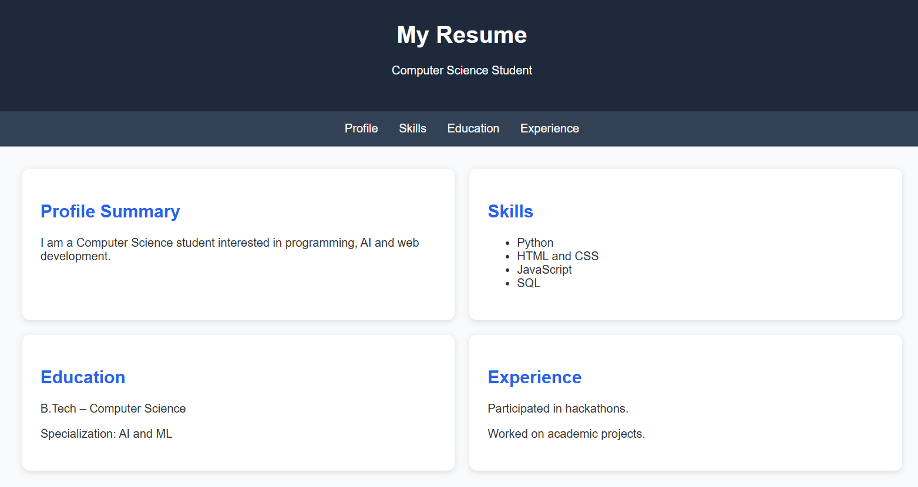
Task 5 – Restaurant Menu Page
Design a digital menu page for a restaurant.
Requirements:
Display menu items with name, description, and price.
Use AI to:
o Suggest a food-friendly color palette.
o Design a responsive card-based layout.
o Add hover effects on menu items.
PROMPT:
Create a restaurant menu webpage using HTML and CSS.

Display food items with names, descriptions and prices.
Use a food-friendly color palette such as orange, cream
and brown.

Create a responsive card-based layout using CSS Grid.
Add hover effects to menu cards.
CODE:
<!DOCTYPE html>
<html>
<head>
<title>Restaurant Menu</title>

<style>
* {
box-sizing: border-box;
}

body {
font-family: Arial, sans-serif;
background: #fff7ed;
margin: 0;
padding: 20px;
}

h1 {
text-align: center;
color: #9a3412;
}

.menu-container {
display: grid;
grid-template-columns: repeat(
auto-fit, minmax(220px, 1fr)
);
gap: 20px;
max-width: 1000px;
margin: 30px auto;
}

.menu-card {
background: white;
padding: 25px;
border-radius: 12px;
box-shadow: 0 3px 10px #ddd;
text-align: center;
transition: 0.3s;
}

.menu-card:hover {
transform: translateY(-8px);
box-shadow: 0 6px 15px #bbb;
}

.menu-card h2 {
color: #c2410c;
}

.price {
color: #15803d;
font-size: 22px;
font-weight: bold;
}

footer {
text-align: center;
color: #78350f;
margin-top: 40px;
}
</style>
</head>

<body>

<h1>Welcome to Food Paradise</h1>

<div class="menu-container">

<div class="menu-card">
<h2>Pizza</h2>
<p>Delicious cheese pizza with fresh toppings.</p>
<p class="price">₹250</p>
</div>

<div class="menu-card">
<h2>Burger</h2>
<p>Fresh vegetable burger with crispy fries.</p>
<p class="price">₹120</p>
</div>

<div class="menu-card">
<h2>Biryani</h2>
<p>Traditional spicy chicken biryani.</p>
<p class="price">₹200</p>
</div>

<div class="menu-card">
<h2>Pasta</h2>
<p>Creamy white sauce pasta.</p>
<p class="price">₹180</p>
</div>

<div class="menu-card">
<h2>Sandwich</h2>
<p>Fresh vegetable grilled sandwich.</p>
<p class="price">₹100</p>
</div>

<div class="menu-card">
<h2>Ice Cream</h2>
<p>Delicious chocolate ice cream.</p>
<p class="price">₹80</p>
</div>

</div>

<footer>
<p>Thank you for visiting Food Paradise!</p>
</footer>

</body>
</html>
OUTPUT:


