Vyshnavi krishna-22bce0603

Data cleaning:

1.converted the timestamps of table 2 in the same format as table1

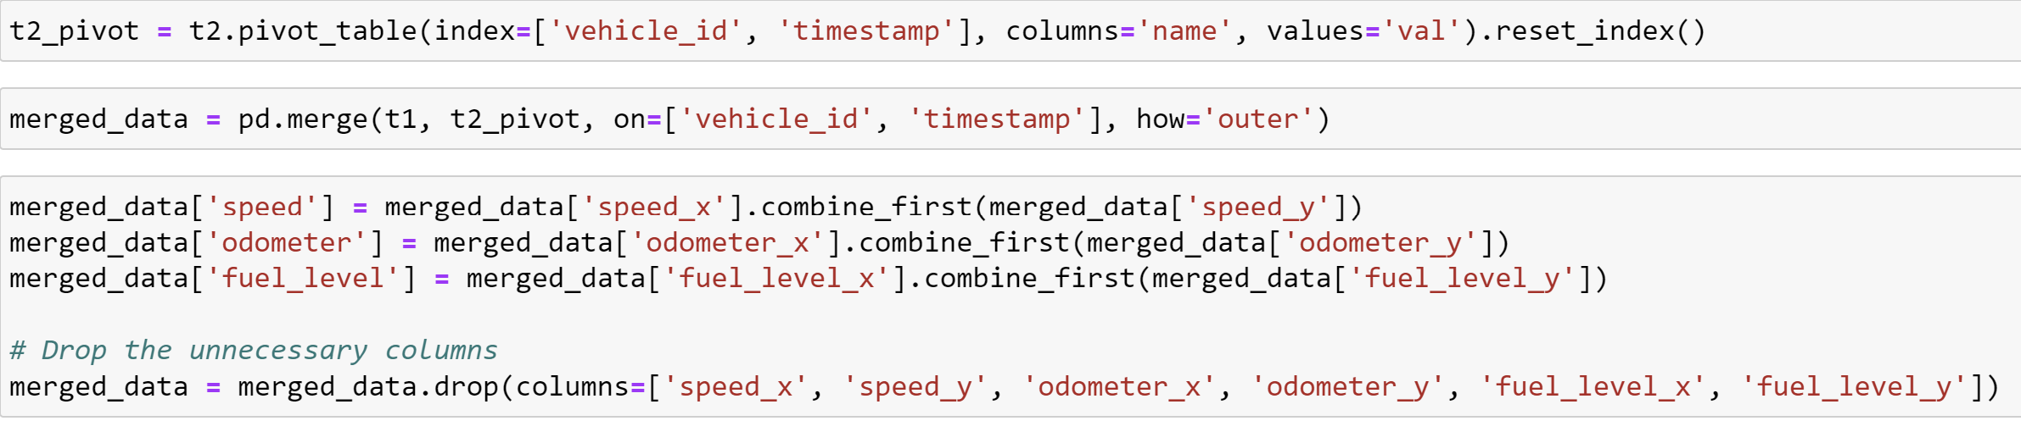

2.merge both the tables on name and timestamp constraint

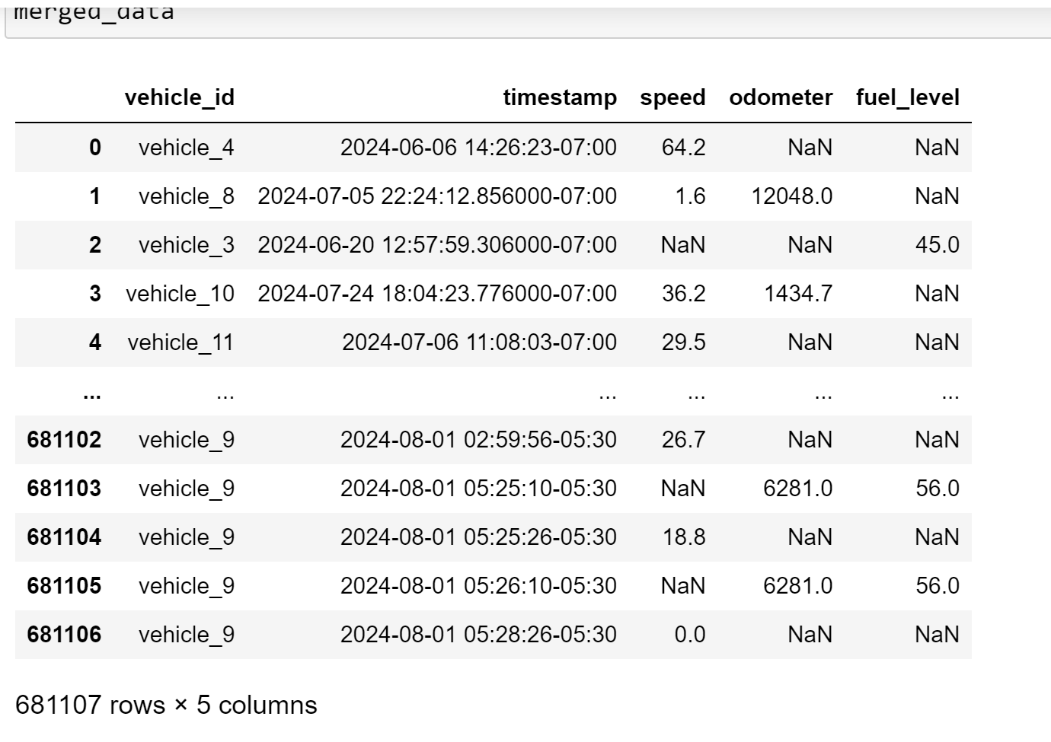

3.took the input of table 3



4.if the fuel level of vehicles in merged table is greater than the tank capacity mentioned,drop those rows

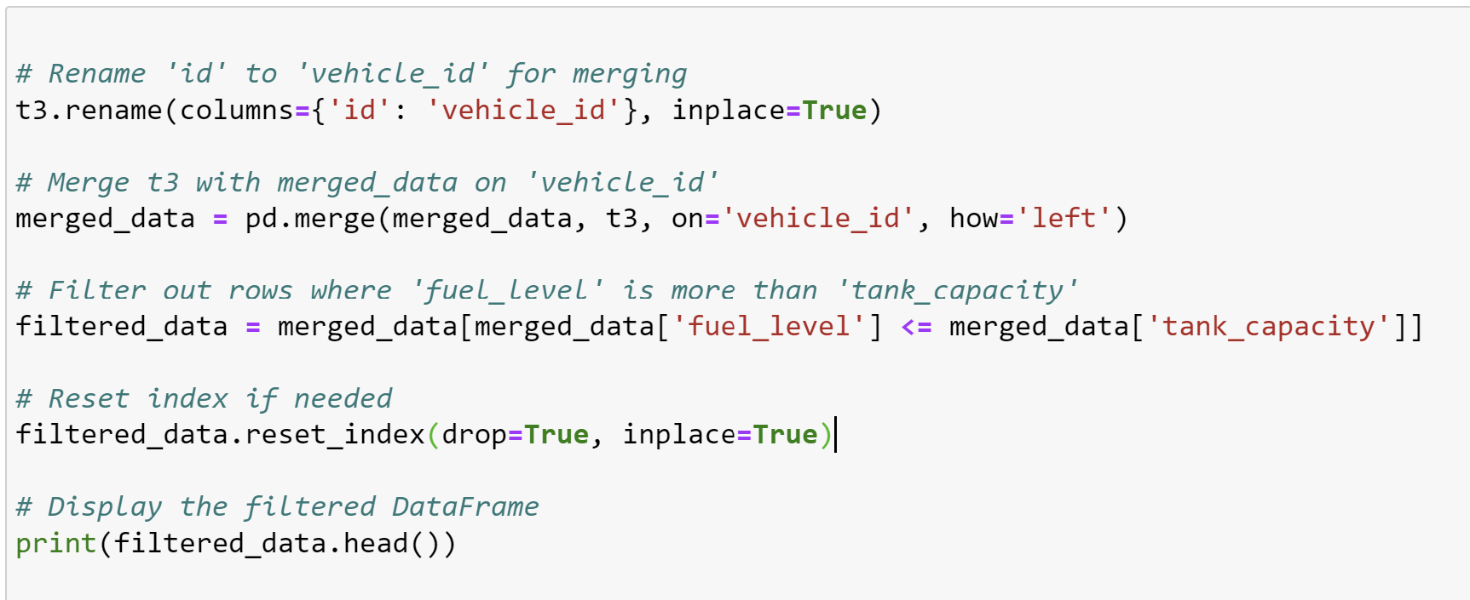

5.if the distance travelled in not zero but the fuel level is zero and vice versa then remove those rows

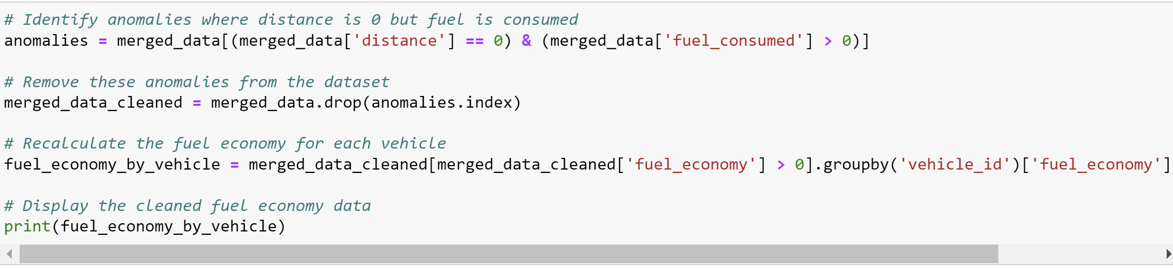

6.calculate the fuel consumed and distance travelled



7.calculate the fuel_economy using the formula

