**DESIGN:**

**BLOCK DIAGRAM:**

**ATMEGA38**

**LM35 Sensor**

**16X2 LCD**

In this **project**, Atmega is used to control the whole process. An LM35 temperature sensor is used for sensing environment temperature which gives 1 degree temperature on every 10mV change at its output pin. You can easily check it with voltmeter by connecting Vcc at pin 1 and Ground at pin 3 and output voltage at pin 2 of LM35 sensor. For an example if the output voltage of LM35 sensor is 250m volt, that means the temperature is around 25 degree Celsius.

**LM35 Temperature Sensor:**

LM35 is a 3 pin temperature sensor which gives 1 degree Celsius on every 10mVolt change. This sensor can sense up to 150 degree Celsius temperature. 1 number pin of lm35 sensor is Vcc, second is output and third one is Ground. LM35 is the most simplest temperature sensor and can be interfaced easily with any microcontroller

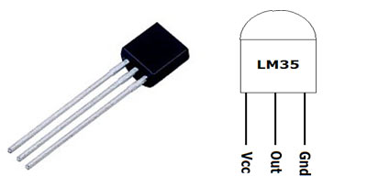

**LCD:**

**16X2 LCD** unit is widely using in embedded system projects because it is cheap, easily available, small in size and easy to interface. 16x2 have two rows and 16 columns, which means it consist 16 blocks of 5x8 dots. 16 pin for connections in which 8 data bits D0-D7 and 3 control bits namely RS, RW and EN. Rest of pins are used for supply, brightness control and for backlight.

