**REPORT**

**ABSTRACT:**

Thermometers are useful apparatus being used since long time for temperature measurement. In this project we have made an Arduino based digital thermometer to display the current ambient temperature on a 16x2 LCD unit in real time . It can be deployed in houses, offices, industries etc. to measure the temperature. We can divide this **thermometer** into three sections - The first section senses the temperature by using temperature sensor, second section converts the temperature value into a suitable numbers in Celsius scale which is done by Arduino, and last part of system displays temperature on 16X2 LCD.

In this project, we interfaced LM35 Temperature Sensor with Arduino to design a digital thermometer. The measured temperature will be directly displayed on a 16*2 LCD. LM35DZ is capable of reading the temperature in Centigrade scale. The output voltage of the sensor is directly proportional to the temperature in centigrade. LM35 can be used in the range of -55°C to +150°C with +/- 0.75°C accuracy. So let’s learn how to design a Digital Thermometer Using Arduino & LM35 Temperature Sensor.

**DESIGN:**

**BLOCK DIAGRAM:**

**LM35**

**ATMEGA**

**16X2 LCD**

In this **project**, Atmega is used to control the whole process. An LM35 temperature sensor is used for sensing environment temperature which gives 1 degree temperature on every 10mV change at its output pin. You can easily check it with voltmeter by connecting Vcc at pin 1 and Ground at pin 3 and output voltage at pin 2 of LM35 sensor. For an example if the output voltage of LM35 sensor is 250m volt, that means the temperature is around 25 degree Celsius.

**LM35 Temperature Sensor:**

LM35 is a 3 pin temperature sensor which gives 1 degree Celsius on every 10mVolt change. This sensor can sense up to 150 degree Celsius temperature. 1 number pin of lm35 sensor is Vcc, second is output and third one is Ground. LM35 is the most simplest temperature sensor and can be interfaced easily with any microcontroller

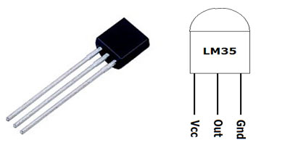

**LCD:**

**16X2 LCD** unit is widely using in embedded system projects because it is cheap, easily available, small in size and easy to interface. 16x2 have two rows and 16 columns, which means it consist 16 blocks of 5x8 dots. 16 pin for connections in which 8 data bits D0-D7 and 3 control bits namely RS, RW and EN. Rest of pins are used for supply, brightness control and for backlight.

