Daugiamatė Statistinė Analizė Lab 2, 6 variantas

Vytautas Kraujalis

2021-11-30

Table of Contents

# 1 Required packages

library(dplyr)  
library(factoextra)  
library(caret)  
library(glmnet)

# 2 Uzd. 1

set.seed(123)  
  
data <- read.table("mnist.txt", sep = ",", header = T) %>%   
 filter(label %in% c(1, 3, 5, 7)) # 6 var.: 1357

# 3 Uzd. 2

spausdinti_grafika <- function(skaicius, kuri_irasa){  
 image(t(matrix(data %>% filter(label == skaicius) %>% slice(kuri_irasa) %>% select(-label) %>% t() %>% as.vector(), 28, byrow = T))[1:28, 28:1])  
}  
  
# vienetai:  
png(file = "vienetai.png", width = 1200, height = 850)  
par(mfrow=c(2,2))  
spausdinti_grafika(1, 1)  
spausdinti_grafika(1, 2)  
spausdinti_grafika(1, 3)  
spausdinti_grafika(1, 4)  
dev.off()

## png   
## 2

# trejetai:  
png(file = "trejetai.png", width = 1200, height = 850)  
par(mfrow=c(2,2))  
spausdinti_grafika(3, 1)  
spausdinti_grafika(3, 2)  
spausdinti_grafika(3, 3)  
spausdinti_grafika(3, 4)  
dev.off()

## png   
## 2

# penketai:  
png(file = "penketai.png", width = 1200, height = 850)  
par(mfrow=c(2,2))  
spausdinti_grafika(5, 1)  
spausdinti_grafika(5, 2)  
spausdinti_grafika(5, 3)  
spausdinti_grafika(5, 4)  
dev.off()

## png   
## 2

# septynetai:  
png(file = "septynetai.png", width = 1200, height = 850)  
par(mfrow=c(2,2))  
spausdinti_grafika(7, 1)  
spausdinti_grafika(7, 2)  
spausdinti_grafika(7, 3)  
spausdinti_grafika(7, 4)  
dev.off()

## png   
## 2

# 4 Uzd. 3

pca <- prcomp(data %>% select(-label), scale = FALSE)  
fviz_eig(pca, ncp = 20, main = "Pagrindinių komponenčių (PC1 - PC20) dispersijos (%)", ylab = "Dispersija (%)", xlab = "Pagrindinė Komponentė")

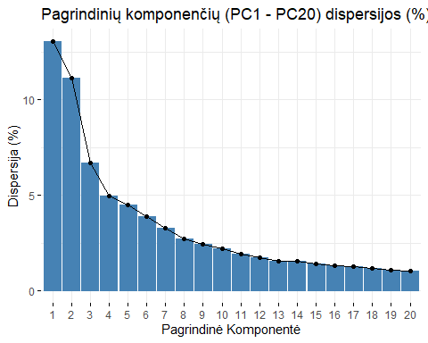

ggsave(filename = "pca_dispersijos.png", width = 14, height = 7, units = "in", bg = "white")

# 5 Uzd. 4

pca_var <- pca$sdev^2  
pca_var <- pca_var / sum(pca_var)  
  
print(paste0("Pirmos 4 pagrindinės komponentės sumiškai savyje turi ", round(sum(pca_var[1:4]) * 100, digits = 2), "% dispersijos."))

## [1] "Pirmos 4 pagrindinės komponentės sumiškai savyje turi 35.79% dispersijos."

dispersija <- 0  
kiek_pca <- 0  
while(dispersija < 0.9){  
 kiek_pca <- kiek_pca + 1  
 dispersija <- sum(pca_var[1:kiek_pca])  
}  
  
print(paste0("Tam, kad pasiektume 90% suminės dispersijos, mums reikia panaudoti pirmas ", kiek_pca, " pagrindines komponentes, su šiomis komponentinėmis, suminė dispersija sieka ", round(dispersija * 100, digits = 2), "%"))

## [1] "Tam, kad pasiektume 90% suminės dispersijos, mums reikia panaudoti pirmas 78 pagrindines komponentes, su šiomis komponentinėmis, suminė dispersija sieka 90.08%"

# 6 Uzd. 5

skaitmenys <- as.factor(data$label)  
fviz_pca_ind(pca,  
 col.ind = skaitmenys, # color by groups  
 legend.title = "Skaitmuo",  
 label = "none",  
 title = "PC1 ir PC2 sklaidos diagrama pagal skaitmenis"  
 )

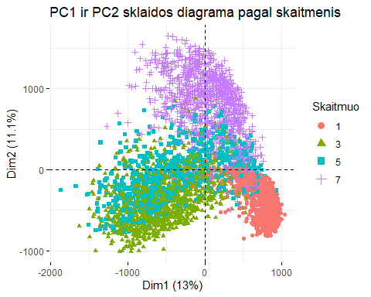

ggsave(filename = "PC_1_2_sklaida.png", width = 14, height = 7, units = "in", bg = "white")

# 7 Uzd. 6

uzpildyti_pixeliai <- data %>%   
 sapply(function(x){sum(x > 0)}) %>%   
 sort(decreasing = TRUE)  
  
uzpildyti_pixeliai <- uzpildyti_pixeliai[uzpildyti_pixeliai / nrow(data) > 0.1]  
uzpildyti_pixeliai <- uzpildyti_pixeliai[-1]

Kadangi yra stulpelių (pixelių), kurie jokiose eilutėse nebūna užpildyti, atfiltruosim tik tuos stulpelius, kurių užpildyti (reikšmė > 0) bent 10% iš stebėjimų. Iš gautų stulpelių atrinksime atsitiktines 3 poras ir atvaizduosime grafiškai.

Atrenkam 6 atsitiktinius stulpelius:

atsitiktines_poros <- sample(names(uzpildyti_pixeliai), 6, replace = F)

Atvaizduojame 3 atsitiktines poras:

atsitiktiniai_data <- data %>%   
 select(all_of(atsitiktines_poros), label) %>%   
 mutate(label = as.factor(label))  
atsitiktiniai_data_colnames <- colnames(atsitiktiniai_data)  
colnames(atsitiktiniai_data) <- c("V1", "V2", "V3", "V4", "V5", "V6", "label")  
  
atsitiktiniai_data %>%   
 ggplot(aes(x = V1, y = V2, color = label)) +  
 geom_point() +  
 xlab(atsitiktiniai_data_colnames[1]) +  
 ylab(atsitiktiniai_data_colnames[2])

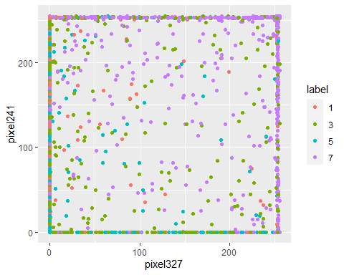

ggsave(filename = "atsitiktines_sklaidos_1.png", width = 14, height = 7, units = "in", bg = "white")  
  
atsitiktiniai_data %>%   
 ggplot(aes(x = V3, y = V4, color = label)) +  
 geom_point() +  
 xlab(atsitiktiniai_data_colnames[3]) +  
 ylab(atsitiktiniai_data_colnames[4])

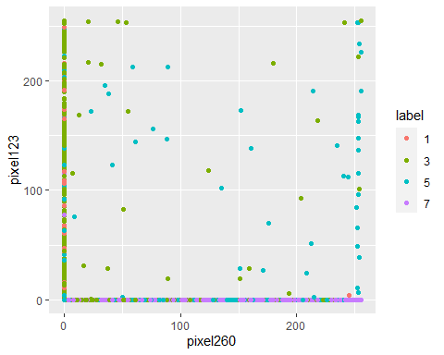

ggsave(filename = "atsitiktines_sklaidos_2.png", width = 14, height = 7, units = "in", bg = "white")  
  
atsitiktiniai_data %>%   
 ggplot(aes(x = V5, y = V6, color = label)) +  
 geom_point() +  
 xlab(atsitiktiniai_data_colnames[5]) +  
 ylab(atsitiktiniai_data_colnames[6])

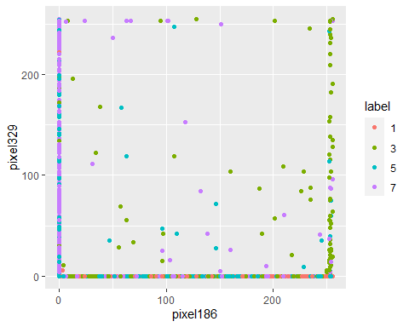

ggsave(filename = "atsitiktines_sklaidos_3.png", width = 14, height = 7, units = "in", bg = "white")

# 8 Uzd. 7

data <- data %>%   
 filter(label %in% c(1, 3)) %>%   
 mutate(label = as.factor(label))  
  
pca <- prcomp(data %>% select(-label), scale = FALSE)  
  
data_pcs <- pca$x %>%   
 bind_cols(label = data$label)  
  
# 2 klasių tikslumo ištraukimui iš sumaišymo matricos  
classAcc <- function(confusionMatrix) {  
 class1 <- round(confusionMatrix$table[1, 1] / sum(confusionMatrix$table[, 1]) * 100, 1)  
 class2 <- round(confusionMatrix$table[2, 2] / sum(confusionMatrix$table[, 2]) * 100, 1)  
 bendras <- confusionMatrix$overall["Accuracy"] * 100  
 acc <- c(class1, class2, bendras)  
 names(acc) <- c(colnames(confusionMatrix$table), "Bendras")  
 return(acc)  
}  
  
# Susidarom list'ą su 20 formulių  
formules <- NULL  
formules[[1]] <- "label ~ PC1"  
for(i in 2:20){  
 formules[[i]] <- "label ~ PC1"  
 for(j in 2:i){  
 formules[[i]] <- paste0(formules[[i]], " + PC", j)  
 }  
}  
  
formules <- lapply(formules, as.formula)

tikslumai <- NULL  
for(i in 1:20){  
 glm <- glm(formula = formules[[i]], data = data_pcs, family = "binomial")  
 prob_pred = predict(glm, type = "response", newdata = data_pcs %>% select(-label))  
 y_pred = ifelse(prob_pred > 0.5, 3, 1) %>%   
 as.factor()  
 confusion_matrix <- confusionMatrix(y_pred, data_pcs$label)  
 tikslumai[[i]] <- classAcc(confusion_matrix)  
}  
  
  
tikslumai_data <- do.call(rbind.data.frame, tikslumai) %>%   
 bind_cols(kiek_pca = 1:20)  
colnames(tikslumai_data) <- c("skaitmuo_1", "skaitmuo_3", "bendras", "kiek_pca")  
  
  
tikslumai_data %>%   
 tidyr::pivot_longer(c(-kiek_pca), names_to = "Kieno Tikslumas", values_to = "Tikslumas") %>%   
 ggplot(aes(x = kiek_pca, y = Tikslumas, color = `Kieno Tikslumas`)) +  
 geom_line() +  
 theme_minimal() +  
 xlab("Pagrindinių Komponenčių Kiekis") +  
 ylab("Tikslumas (%)")

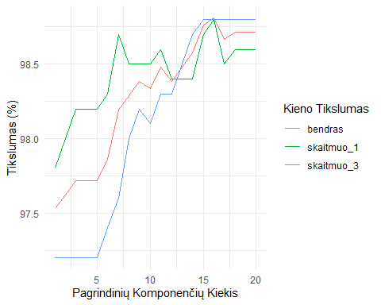

ggsave(filename = "tikslumas_pca.png", width = 14, height = 7, units = "in", bg = "white")  
  
  
glm <- glm(label ~ ., data = data_pcs[,c(1:20, 785)], family = "binomial")  
glm_tuscias <- glm(label ~ 1, data = data_pcs, family = "binomial")  
# Forward  
forward_glm <- step(glm_tuscias, direction = "forward", scope = formula(glm), trace=0)  
summary(forward_glm)

##   
## Call:  
## glm(formula = label ~ PC1 + PC6 + PC7 + PC8 + PC16 + PC11 + PC13 +   
## PC15 + PC12 + PC20 + PC9 + PC5 + PC10 + PC4 + PC14, family = "binomial",   
## data = data_pcs)  
##   
## Deviance Residuals:   
## Min 1Q Median 3Q Max   
## -4.5705 -0.0384 -0.0098 0.0058 1.9808   
##   
## Coefficients:  
## Estimate Std. Error z value Pr(>|z|)   
## (Intercept) 1.4421196 0.4398288 3.279 0.001042 **   
## PC1 -0.0124006 0.0012118 -10.233 < 2e-16 ***  
## PC6 0.0050536 0.0009631 5.247 1.54e-07 ***  
## PC7 -0.0043165 0.0010998 -3.925 8.67e-05 ***  
## PC8 -0.0039978 0.0010385 -3.850 0.000118 ***  
## PC16 0.0068052 0.0016223 4.195 2.73e-05 ***  
## PC11 0.0037038 0.0010448 3.545 0.000392 ***  
## PC13 -0.0022650 0.0011576 -1.957 0.050400 .   
## PC15 -0.0034864 0.0013118 -2.658 0.007868 **   
## PC12 0.0035853 0.0012632 2.838 0.004538 **   
## PC20 0.0043398 0.0014496 2.994 0.002755 **   
## PC9 0.0034400 0.0013232 2.600 0.009329 **   
## PC5 -0.0018997 0.0007620 -2.493 0.012664 *   
## PC10 0.0028300 0.0010981 2.577 0.009963 **   
## PC4 -0.0011987 0.0006533 -1.835 0.066548 .   
## PC14 -0.0020457 0.0012475 -1.640 0.101038   
## ---  
## Signif. codes: 0 '***' 0.001 '**' 0.01 '*' 0.05 '.' 0.1 ' ' 1  
##   
## (Dispersion parameter for binomial family taken to be 1)  
##   
## Null deviance: 2913.25 on 2103 degrees of freedom  
## Residual deviance: 142.65 on 2088 degrees of freedom  
## AIC: 174.65  
##   
## Number of Fisher Scoring iterations: 10

forward_glm$anova

## Step Df Deviance Resid. Df Resid. Dev AIC  
## 1 NA NA 2103 2913.2471 2915.2471  
## 2 + PC1 -1 2616.350401 2102 296.8967 300.8967  
## 3 + PC6 -1 45.647348 2101 251.2494 257.2494  
## 4 + PC7 -1 27.478649 2100 223.7707 231.7707  
## 5 + PC8 -1 14.408248 2099 209.3625 219.3625  
## 6 + PC16 -1 9.569141 2098 199.7934 211.7934  
## 7 + PC11 -1 10.733620 2097 189.0597 203.0597  
## 8 + PC13 -1 12.397102 2096 176.6626 192.6626  
## 9 + PC15 -1 9.337983 2095 167.3247 185.3247  
## 10 + PC12 -1 5.194648 2094 162.1300 182.1300  
## 11 + PC20 -1 3.116652 2093 159.0134 181.0134  
## 12 + PC9 -1 3.870922 2092 155.1424 179.1424  
## 13 + PC5 -1 3.400437 2091 151.7420 177.7420  
## 14 + PC10 -1 3.545717 2090 148.1963 176.1963  
## 15 + PC4 -1 2.788664 2089 145.4076 175.4076  
## 16 + PC14 -1 2.760514 2088 142.6471 174.6471

formules_forward <- NULL  
formules_forward[[1]] <- "label ~ PC1"  
for(i in 3:nrow(forward_glm$anova)){  
 formules_forward[[i-1]] <- paste0(formules_forward[[i-2]], forward_glm$anova[i,1])  
}  
  
formules_forward <- lapply(formules_forward, as.formula)  
  
  
tikslumai_forward <- NULL  
for(i in 1:length(formules_forward)){  
 glm <- glm(formula = formules_forward[[i]], data = data_pcs, family = "binomial")  
 prob_pred = predict(glm, type = "response", newdata = data_pcs %>% select(-label))  
 y_pred = ifelse(prob_pred > 0.5, 3, 1) %>%   
 as.factor()  
 confusion_matrix <- confusionMatrix(y_pred, data_pcs$label)  
 tikslumai_forward[[i]] <- classAcc(confusion_matrix)  
}  
  
  
tikslumai_forward_data <- do.call(rbind.data.frame, tikslumai_forward) %>%   
 bind_cols(kiek_pca = 1:length(formules_forward))  
colnames(tikslumai_forward_data) <- c("skaitmuo_1", "skaitmuo_3", "bendras", "kiek_pca")  
  
  
tikslumai_forward_data %>%   
 tidyr::pivot_longer(c(-kiek_pca), names_to = "Kieno Tikslumas", values_to = "Tikslumas") %>%   
 ggplot(aes(x = kiek_pca, y = Tikslumas, color = `Kieno Tikslumas`)) +  
 geom_line() +  
 theme_minimal() +  
 xlab("Pagrindinių Komponenčių Kiekis") +  
 ylab("Tikslumas (%)")

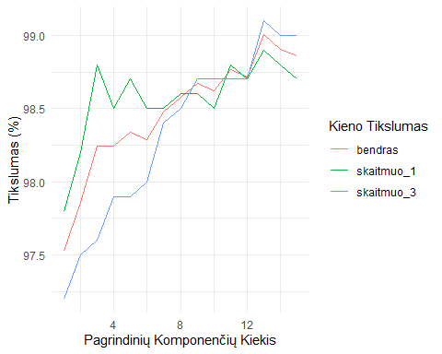

ggsave(filename = "tikslumas_pca_forward.png", width = 14, height = 7, units = "in", bg = "white")

# 9 Uzd. 8

forward_glm$anova$Step

## [1] "" "+ PC1" "+ PC6" "+ PC7" "+ PC8" "+ PC16" "+ PC11" "+ PC13"  
## [9] "+ PC15" "+ PC12" "+ PC20" "+ PC9" "+ PC5" "+ PC10" "+ PC4" "+ PC14"

# 10 Uzd. 9

atsitiktines_originalios_poros <- sample(names(uzpildyti_pixeliai), 20, replace = F)  
  
formules_originalios <- NULL  
formules_originalios[[1]] <- paste0("label ~ ", atsitiktines_originalios_poros[1])  
for(i in 2:length(atsitiktines_originalios_poros)){  
 formules_originalios[[i]] <- paste0(formules_originalios[[i-1]], "+", atsitiktines_originalios_poros[i])  
}  
  
formules_originalios <- lapply(formules_originalios, as.formula)  
  
tikslumai_originalios <- NULL  
for(i in 1:length(formules_originalios)){  
 glm <- glm(formula = formules_originalios[[i]], data = data, family = "binomial")  
 prob_pred = predict(glm, type = "response", newdata = data %>% select(-label))  
 y_pred = ifelse(prob_pred > 0.5, 3, 1) %>%   
 as.factor()  
 confusion_matrix <- confusionMatrix(y_pred, data$label)  
 tikslumai_originalios[[i]] <- classAcc(confusion_matrix)  
}  
  
  
tikslumai_originalios_data <- do.call(rbind.data.frame, tikslumai_originalios) %>%   
 bind_cols(kiek_pozymiu = 1:length(formules_originalios))  
colnames(tikslumai_originalios_data) <- c("skaitmuo_1", "skaitmuo_3", "bendras", "kiek_pozymiu")  
  
  
tikslumai_originalios_data %>%   
 tidyr::pivot_longer(c(-kiek_pozymiu), names_to = "Kieno Tikslumas", values_to = "Tikslumas") %>%   
 ggplot(aes(x = kiek_pozymiu, y = Tikslumas, color = `Kieno Tikslumas`)) +  
 geom_line() +  
 theme_minimal() +  
 xlab("Atsitiktinių Požymių Kiekis") +  
 ylab("Tikslumas (%)")

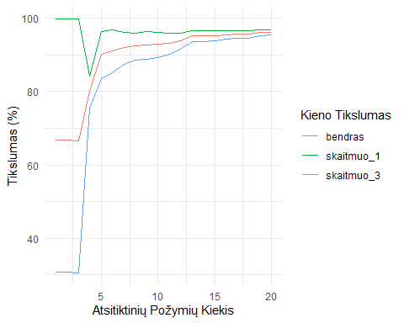

ggsave(filename = "tikslumas_originalios.png", width = 14, height = 7, units = "in", bg = "white")

# 11 Uzd. 10

glm <- glm(label ~ ., data = data %>% select(all_of(atsitiktines_originalios_poros), label), family = "binomial")  
glm_tuscias <- glm(label ~ 1, data = data, family = "binomial")  
# Forward  
originalios_forward_glm <- step(glm_tuscias, direction = "forward", scope = formula(glm), trace=0)  
summary(originalios_forward_glm)

##   
## Call:  
## glm(formula = label ~ pixel465 + pixel374 + pixel231 + pixel566 +   
## pixel576 + pixel294 + pixel379 + pixel153 + pixel653 + pixel581 +   
## pixel682 + pixel160 + pixel679 + pixel208 + pixel298, family = "binomial",   
## data = data)  
##   
## Deviance Residuals:   
## Min 1Q Median 3Q Max   
## -4.6793 -0.1459 -0.0333 0.0265 2.7637   
##   
## Coefficients:  
## Estimate Std. Error z value Pr(>|z|)   
## (Intercept) -1.161338 0.393487 -2.951 0.003163 **   
## pixel465 0.023228 0.002029 11.447 < 2e-16 ***  
## pixel374 0.019398 0.002347 8.265 < 2e-16 ***  
## pixel231 0.043406 0.007901 5.494 3.94e-08 ***  
## pixel566 0.016655 0.002737 6.086 1.16e-09 ***  
## pixel576 0.009425 0.001436 6.563 5.28e-11 ***  
## pixel294 -0.011864 0.001532 -7.743 9.70e-15 ***  
## pixel379 -0.013235 0.001507 -8.782 < 2e-16 ***  
## pixel153 0.009900 0.001412 7.013 2.33e-12 ***  
## pixel653 0.007573 0.001677 4.516 6.30e-06 ***  
## pixel581 0.022174 0.004296 5.161 2.45e-07 ***  
## pixel682 0.007399 0.001792 4.130 3.63e-05 ***  
## pixel160 -0.008603 0.002309 -3.726 0.000194 ***  
## pixel679 0.007149 0.002888 2.475 0.013328 *   
## pixel208 -0.002863 0.001392 -2.057 0.039699 *   
## pixel298 0.003095 0.001660 1.864 0.062299 .   
## ---  
## Signif. codes: 0 '***' 0.001 '**' 0.01 '*' 0.05 '.' 0.1 ' ' 1  
##   
## (Dispersion parameter for binomial family taken to be 1)  
##   
## Null deviance: 2913.2 on 2103 degrees of freedom  
## Residual deviance: 465.8 on 2088 degrees of freedom  
## AIC: 497.8  
##   
## Number of Fisher Scoring iterations: 9

originalios_forward_glm$anova

## Step Df Deviance Resid. Df Resid. Dev AIC  
## 1 NA NA 2103 2913.2471 2915.2471  
## 2 + pixel465 -1 951.811642 2102 1961.4355 1965.4355  
## 3 + pixel374 -1 665.141353 2101 1296.2942 1302.2942  
## 4 + pixel231 -1 215.045339 2100 1081.2488 1089.2488  
## 5 + pixel566 -1 154.920136 2099 926.3287 936.3287  
## 6 + pixel576 -1 85.484613 2098 840.8441 852.8441  
## 7 + pixel294 -1 88.227055 2097 752.6170 766.6170  
## 8 + pixel379 -1 89.211270 2096 663.4057 679.4057  
## 9 + pixel153 -1 60.410358 2095 602.9954 620.9954  
## 10 + pixel653 -1 46.547777 2094 556.4476 576.4476  
## 11 + pixel581 -1 42.865065 2093 513.5825 535.5825  
## 12 + pixel682 -1 21.356897 2092 492.2256 516.2256  
## 13 + pixel160 -1 11.887309 2091 480.3383 506.3383  
## 14 + pixel679 -1 6.478036 2090 473.8603 501.8603  
## 15 + pixel208 -1 4.547572 2089 469.3127 499.3127  
## 16 + pixel298 -1 3.513351 2088 465.7994 497.7994

formules_originalios_forward <- NULL  
formules_originalios_forward[[1]] <- paste0("label ~ ", originalios_forward_glm$anova[2,1])  
for(i in 3:nrow(originalios_forward_glm$anova)){  
 formules_originalios_forward[[i-1]] <- paste0(formules_originalios_forward[[i-2]], originalios_forward_glm$anova[i,1])  
}  
  
formules_originalios_forward <- lapply(formules_originalios_forward, as.formula)  
  
  
tikslumai_originalios_forward <- NULL  
for(i in 1:length(formules_originalios_forward)){  
 glm <- glm(formula = formules_originalios_forward[[i]], data = data, family = "binomial")  
 prob_pred = predict(glm, type = "response", newdata = data %>% select(-label))  
 y_pred = ifelse(prob_pred > 0.5, 3, 1) %>%   
 as.factor()  
 confusion_matrix <- confusionMatrix(y_pred, data$label)  
 tikslumai_originalios_forward[[i]] <- classAcc(confusion_matrix)  
}  
  
  
tikslumai_originalios_forward_data <- do.call(rbind.data.frame, tikslumai_originalios_forward) %>%   
 bind_cols(kiek_pozymiu = 1:length(formules_originalios_forward))  
colnames(tikslumai_originalios_forward_data) <- c("skaitmuo_1", "skaitmuo_3", "bendras", "kiek_pozymiu")  
  
  
tikslumai_originalios_forward_data %>%   
 tidyr::pivot_longer(c(-kiek_pozymiu), names_to = "Kieno Tikslumas", values_to = "Tikslumas") %>%   
 ggplot(aes(x = kiek_pozymiu, y = Tikslumas, color = `Kieno Tikslumas`)) +  
 geom_line() +  
 theme_minimal() +  
 xlab("Atsitiktinių Požymių Kiekis") +  
 ylab("Tikslumas (%)")

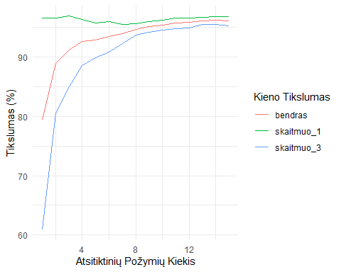

ggsave(filename = "tikslumas_originalios_forward.png", width = 14, height = 7, units = "in", bg = "white")

# 12 Uzd. 11

tikslumai_data

## skaitmuo_1 skaitmuo_3 bendras kiek_pca  
## 1 97.8 97.2 97.52852 1  
## 2 98.0 97.2 97.62357 2  
## 3 98.2 97.2 97.71863 3  
## 4 98.2 97.2 97.71863 4  
## 5 98.2 97.2 97.71863 5  
## 6 98.3 97.4 97.86122 6  
## 7 98.7 97.6 98.19392 7  
## 8 98.5 98.0 98.28897 8  
## 9 98.5 98.2 98.38403 9  
## 10 98.5 98.1 98.33650 10  
## 11 98.6 98.3 98.47909 11  
## 12 98.4 98.3 98.38403 12  
## 13 98.4 98.5 98.47909 13  
## 14 98.4 98.7 98.57414 14  
## 15 98.7 98.8 98.76426 15  
## 16 98.8 98.8 98.81179 16  
## 17 98.5 98.8 98.66920 17  
## 18 98.6 98.8 98.71673 18  
## 19 98.6 98.8 98.71673 19  
## 20 98.6 98.8 98.71673 20

tikslumai_forward_data

## skaitmuo_1 skaitmuo_3 bendras kiek_pca  
## 1 97.8 97.2 97.52852 1  
## 2 98.2 97.5 97.86122 2  
## 3 98.8 97.6 98.24144 3  
## 4 98.5 97.9 98.24144 4  
## 5 98.7 97.9 98.33650 5  
## 6 98.5 98.0 98.28897 6  
## 7 98.5 98.4 98.47909 7  
## 8 98.6 98.5 98.57414 8  
## 9 98.6 98.7 98.66920 9  
## 10 98.5 98.7 98.62167 10  
## 11 98.8 98.7 98.76426 11  
## 12 98.7 98.7 98.71673 12  
## 13 98.9 99.1 99.00190 13  
## 14 98.8 99.0 98.90684 14  
## 15 98.7 99.0 98.85932 15

tikslumai_originalios_data

## skaitmuo_1 skaitmuo_3 bendras kiek_pozymiu  
## 1 99.8 30.7 66.68251 1  
## 2 99.8 30.8 66.73004 2  
## 3 99.8 30.6 66.63498 3  
## 4 84.1 75.6 80.03802 4  
## 5 96.4 83.4 90.20913 5  
## 6 96.7 85.0 91.11217 6  
## 7 96.1 87.4 91.92015 7  
## 8 95.9 88.5 92.34791 8  
## 9 96.4 88.7 92.72814 9  
## 10 96.2 89.2 92.82319 10  
## 11 95.9 90.1 93.10837 11  
## 12 95.8 91.6 93.77376 12  
## 13 96.6 93.7 95.19962 13  
## 14 96.6 93.6 95.15209 14  
## 15 96.5 93.9 95.24715 15  
## 16 96.6 94.3 95.48479 16  
## 17 96.6 94.4 95.57985 17  
## 18 96.6 94.6 95.67490 18  
## 19 96.9 95.2 96.10266 19  
## 20 96.9 95.4 96.19772 20

tikslumai_originalios_forward_data

## skaitmuo_1 skaitmuo_3 bendras kiek_pozymiu  
## 1 96.5 60.9 79.42015 1  
## 2 96.5 80.6 88.87833 2  
## 3 96.9 85.0 91.20722 3  
## 4 96.3 88.6 92.58555 4  
## 5 95.7 89.8 92.87072 5  
## 6 95.9 90.8 93.44106 6  
## 7 95.5 92.2 93.91635 7  
## 8 95.6 93.7 94.67681 8  
## 9 95.9 94.2 95.05703 9  
## 10 96.2 94.5 95.38973 10  
## 11 96.5 94.7 95.67490 11  
## 12 96.5 94.9 95.76996 12  
## 13 96.6 95.4 96.05513 13  
## 14 96.8 95.4 96.15019 14  
## 15 96.8 95.2 96.05513 15

tikslumai_visi <- data.frame(  
 Bendras_Tikslumas = c(tikslumai_data$bendras, tikslumai_forward_data$bendras, tikslumai_originalios_data$bendras, tikslumai_originalios_forward_data$bendras),  
 Kiek_Pozymiu = c(tikslumai_data$kiek_pca, tikslumai_forward_data$kiek_pca, tikslumai_originalios_data$kiek_pozymiu, tikslumai_originalios_forward_data$kiek_pozymiu),  
 Atvejis = c(rep("PCA su atsitiktinėm PC", nrow(tikslumai_data)), rep("PCA su forward metodu", nrow(tikslumai_forward_data)), rep("Atsitiktiniai požymiai", nrow(tikslumai_originalios_data)), rep("Atsitiktiniai požymiai forward metodu", nrow(tikslumai_originalios_forward_data)))  
)  
  
tikslumai_visi %>%   
 ggplot(aes(x = Kiek_Pozymiu, y = Bendras_Tikslumas, color = Atvejis)) +  
 geom_line() +  
 theme_minimal() +  
 xlab("Požymių Kiekis") +  
 ylab("Bendras Tikslumas (%)")

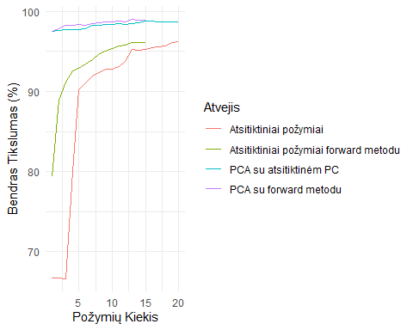

ggsave(filename = "tikslumas_visu.png", width = 14, height = 7, units = "in", bg = "white")

# 13 Uzd. 12

lasso_L1 <- glmnet(data %>% select(-label), data$label, family = "binomial", alpha = 1)  
ridge_L2 <- glmnet(data %>% select(-label), data$label, family = "binomial", alpha = 0)  
  
png(file = "lasso_l1.png", width = 1200, height = 850)  
plot(lasso_L1, label=TRUE,xvar="lambda", main="Lasso L1")  
dev.off()

## png   
## 2

png(file = "ridge_l2.png", width = 1200, height = 850)  
plot(ridge_L2,label=TRUE,xvar="lambda", main="Ridge L2")  
dev.off()

## png   
## 2

lasso_L1_pca <- glmnet(data_pcs %>% select(-label), data_pcs$label, family = "binomial", alpha = 1)  
ridge_L2_pca <- glmnet(data_pcs %>% select(-label), data_pcs$label, family = "binomial", alpha = 0)  
  
png(file = "lasso_l1_pca.png", width = 1200, height = 850)  
plot(lasso_L1_pca, label=TRUE,xvar="lambda", main="Lasso L1")  
dev.off()

## png   
## 2

png(file = "ridge_l2_pca.png", width = 1200, height = 850)  
plot(ridge_L2_pca, label=TRUE,xvar="lambda", main="Ridge L2")  
dev.off()

## png   
## 2

lambdas <- lasso_L1$lambda  
  
lambda <- NULL  
  
for(i in 1:length(lambdas)){  
 lassoCoef = coef(lasso_L1, s = lambdas[i])  
 nonzero_coef = lassoCoef[lassoCoef[,1] != 0,]  
 if(length(nonzero_coef) - 1 == 10){  
 lambda <- lambdas[i]  
 break  
 }  
}  
  
  
  
lassoCoef <- coef(lasso_L1, s = lambda)  
lassoCoef <- lassoCoef[lassoCoef[,1] != 0,]  
lambda

## [1] 0.1498659

lassoCoef

## (Intercept) pixel179 pixel375 pixel409 pixel462   
## 6.670124e-01 8.914077e-04 8.535919e-04 7.285605e-04 -9.622494e-04   
## pixel489 pixel490 pixel494 pixel517 pixel522   
## -7.135796e-03 -7.732842e-04 4.888314e-04 -6.193543e-05 5.149765e-04   
## pixel550   
## 4.514332e-04

lambdas <- lasso_L1_pca$lambda  
  
lambda_pca <- NULL  
  
for(i in 1:length(lambdas)){  
 lassoCoef = coef(lasso_L1_pca, s = lambdas[i])  
 nonzero_coef = lassoCoef[lassoCoef[,1] != 0,]  
 if(length(nonzero_coef) - 1 == 10){  
 lambda_pca <- lambdas[i]  
 break  
 }  
}  
  
  
  
lassoCoef <- coef(lasso_L1_pca, s = lambda_pca)  
lassoCoef <- lassoCoef[lassoCoef[,1] != 0,]  
lambda_pca

## [1] 0.01575323

lassoCoef

## (Intercept) PC1 PC6 PC7 PC8   
## 4.543868e-01 -5.777272e-03 1.076897e-03 -9.677499e-05 -3.201329e-04   
## PC11 PC13 PC30 PC565 PC591   
## 4.236738e-04 -1.635797e-04 -1.236879e-04 -7.053515e+11 3.061386e+11   
## PC623   
## 1.065933e+11