**How to start:**

*python 3.11

Open cmd in this dir

virtualenv venv

venv\scripts\activate

pip install -r requirements.txt

upload the .las file to this directory

set the name of the .las file to the field at the bottom of the code - viewer = LASViewer(root, **"2743_1234.las"**)

open “3d atvaizdavimas” in code editor and run the code

**How the code works (instruction):**

After running the code, you should see a tkinter table with the amount of points in the .las file, the smallest and largest x,y,z values, and last review information.

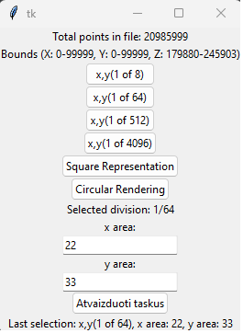

select how many parts you want to split the x,y matrix into.

select which x,y section you want to display. All z values falling within the selected space will be displayed.

An example selection looks like this:

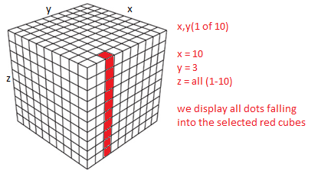

After submit you have to see a 3d photo with the selected point rendering.

You should get a similar image:

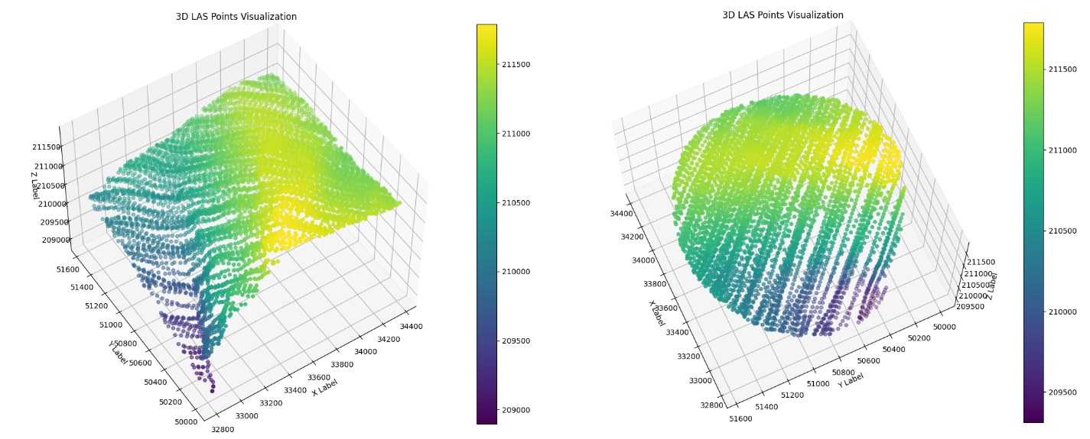

in the example (Square Representation and Circular Rendering) differences.

technical issues:

[vytasskipitis@gmail.com](mailto:vytasskipitis@gmail.com)

backup:

<https://github.com/vytautasskipitis/Matom-AI-task>