**Team**

Vytautas Asmantavicius

Nwai Thingyan

Q1

1. **The result of comparing 3 algorithms**

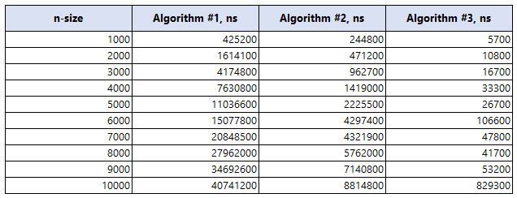

1. **Display result by graph**

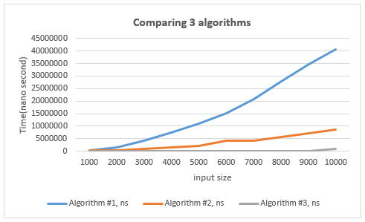

**Conclusion**

As n increases, Algorithm #1 demonstrates cubic growth, Algorithm #2 exhibits quadratic growth, and Algorithm #3 shows linear growth in runtime.

Q2. Fib(n) > (4/3)^n for n > 4

Vytautas

**Step 1.** Prove the base cases n = 5, n = 6

F(5) > (4/3)^5, LHS = 5, RHS = ~ 4.21, It is true

F(6) > (4/3)^6, LHS = 8, RHS = ~ 5.62, It is true

**Step 2.**

Assume it is true for n = k and n = k - 1, when k > 4, then it is also true for n = k + 1

**Step 3.**

F(k + 1) > (4/3)^(k+1)

Using F(k+1) = F(k) + F(k-1)

F(k) = (4/3)^k

F(k-1) = (4/3)^(k-1)

F(k + 1) > (4/3)^k + (4/3)^(k-1)

= (4/3)^k * 1 + (4/3)^k * (4/3)^-1

= (4/3)^k * (1 + (4/3)^-1))

= (4/3)^k * (1 + ¾)

= (4/3)^k * 7/4

= (4/3)^k * 1.75

Since (4/3)^(k+1) = (4/3)^k * 4/3 ~ (4/3)^k * 1.33, so 1.75 > 1.33, so:

F(k + 1) > (4/3)^k * 1.75 > (4/3)^(k+1)

F(k) > (4/3)^k is true for all k > 4

Nwai

**Step 1:** Base case:

Let n = 5, n = 6

Then, Fib(5) > (4/3)^5,

Fib(6) > (4/3)^6

**Step 2:** State induction hypothesis:

Assume the result are true for n = k and n = k - 1

Fib(k) > (4/3)^k

Fib(k-1) > (4/3)^(k-1)

**Step 3:** Induction step:

Prove the result for n = k+1

Fib(n) = Fib(n-1) + Fib(n-2)

Fib(k+1) = Fib(k) + Fib(k-1)

= (4/3)^k + (4/3)^(k-1)

= ((4/3)^(k-1)(4/3)) + (4/3)^(k-1)

= (4/3)^(k-1)((4/3) + 1))

= (4/3)^(k-1)7/3